MACHINE LEARNING SMS SPAM DETECTION MODEL
Andrew KIPKEBUT¹,
Kabarak University, P.O. Box Private Bag, Kabarak, 20157, Kenya
Tel: +254 0719499615, Email: akipkebut@kabarak.ac.ke

Abstract: Millions of shillings are lost by mobile phone users every year in Kenya due to SMs Spam, a social engineering skill attempting to obtain sensitive information such as passwords, Personal identification numbers and other details by masquerading as a trustworthy entity in an electronic commerce. The design of efficient fraud detection algorithm and techniques is key to reducing these losses. Fraud detection using machine learning is a new approach of detecting fraud especially in Mobile commerce. The design of fraud detection techniques in a mobile platform is challenging due to the non-stationary distribution of the data. Most machine learning techniques especially in SMs Spam deal with one language. It is in this background that the study will focus on a client side SMs Spam detection in Kenya’s mobile environment for both English and Swahili text messages using machine learning. Naive’s Bayes algorithm was used for this purpose because it is highly scalable in text classification. The contributors of Corpus include mobile service providers in Kenya and selected mobile phone users from Kabarak university Kenya. Machine learning and data mining experiments were conducted using WEKA (Waikato Environment for Knowledge Analysis). The results and discussions are presented in form of descriptive statistics and detection metrics. At the end an adroid based prototype implementation of the SMs Spam detection model is demonstrated that based on Naive Bayes machine learning algorithm .This model gave an overall classification accuracy of 96.1039% .

Keywords: Algorithm, Classification, Detection, Machine learning, Naïve bayes, WEKA.
Abstract

Millions of shillings are lost by mobile phone users every year in Kenya due to SMs Spam, a social engineering skill attempting to obtain sensitive information such as passwords, Personal identification numbers and other details by masquerading as a trustworthy entity in an electronic commerce. The design of efficient fraud detection algorithm and techniques is key to reducing these losses. Fraud detection using machine learning is a new approach of detecting fraud especially in Mobile commerce. The design of fraud detection techniques in a mobile platform is challenging due to the non-stationary distribution of the data. Most machine learning techniques especially in SMs Spam deal with one language. It is in this background that the study will focus on a client side SMs Spam detection in Kenya’s mobile environment for both English and Swahili text messages using machine learning. Naive’s Bayes algorithm was used for this purpose because it is highly scalable in text classification. The contributors of Corpus include mobile service providers in Kenya and selected mobile phone users from kabarak university kenya. Machine learning and data mining experiments were conducted using WEKA (Waikato Environment for Knowledge Analysis). The results and discussions are presented in form of descriptive statistics and detection metrics. At the end an adroid based prototype implementation of the SMs Spam detection model is demonstrated that based on Naive Bayes machine learning algorithm .This model gave an overall classification accuracy of 96.1039% .

Keywords: Algorithm, Classification, Detection, Machine learning, Naïve bayes, WEKA.
1.1 Introduction
The goal of machine learning is to improve the performance of a computer program with experience. There are a lot of tasks that can be solved using machine learning, including speech recognition, playing games, automatic driving of a vehicles, medical diagnosis and data mining (Liu &Hong-min, 2009). A range of algorithms have been invented for machine learning, that uses the fields of artificial intelligence, probability, statistics, information theory, neurobiology and others. Some of these algorithms include decision trees, Support Vector machines (SVM), Artificial Neural Networks, Naïve Bayes algorithm, Decision trees among others. Machine learning is a fascinating field of artificial intelligence where investigation on how computer agents can improve their perception, cognition, and action with experience. Mansfield Devine (2017) defined SMS phishing (SMS Spam) as a form of criminal activity that uses social engineering techniques in an attempt to harvest credentials such as passwords, PINs (personal identification numbers) and other details by masquerading as a trustworthy entity in an electronic communication using Short Message Service (SMS) via portable devices. Machine learning can be used to detect this social engineering criminal activity especially in a mobile commerce SMs Spam environment.

1.2 Statement of the problem
In Kenya, SMs Spam can be multilingual, it can be done using English or Swahili language or a mixture of both. A Sms smap attack can also target a community using their own local language. SMS spam is real and a growing problem largely due to the availability of very cheap bulk pre-pay SMS packages and the fact that SMS stimulate higher response rates as it is a trusted and a personal service. The Short Messaging Service (SMS) mobile communication system is attractive for criminal gangs for a number of reasons i.e. it is easy to use, fast , reliable and affordable technology (Delany S. J , Buckley M,& Greene D ,2012). It is becoming cost effective to target SMS because of the availability of unlimited pre-pay SMS packages, in countries such as India, Pakistan, China, Kenya and increasingly the US. There is a growing presence of frauds on electronic transactions, therefore a need for a system able to detect and fight these social engineering fraudsters. Financial losses due to Smish fraud has affected not only individual mobile users and merchants but also business organizations. If the bank loses money, customers eventually pay as well through higher interest rates, higher membership fees and high penalties therefore the problem cuts across the entire business system. Fraud may also affect the reputation and image of a merchant causing non-financial losses that, though difficult to quantify in the short term, may become visible in the long period. For example, if a phone owner is a victim of fraud through SMS Spam from a fake company that masqueraded as the genuine company, the genuine company may no longer be trusted. Generally Fraud detection in an electronic platform is notably a challenging problem because fraud strategies change in time and habits keeps changing. Few examples of frauds available, therefore very hard to identify fraudulent behavior, and not all frauds are reported and if reported there are large time lapses and few SMS transactions can be timely investigated.
The presence of lack of a unifying model is perceived as a hindrance to the further development of the field of machine learning especially in Sms spam detection. Many approaches proposed, regardless of their effectiveness, focus on a specific aspect or language and most of them do not have integrated approach and are not exhaustive.

1.3 Main objective

The main objective of this research into design a Client side SMs Spam detection model using machine learning algorithm for Naïve Mobile Commerce users in Kenya.

1.4 Specific objectives
- To develop Spam detection model that can be used to detect Spam messages in kenya .
- Demonstrate the use of machine learning in classifying messages as either Spam or not.
- To test the machine learning model through the use of a prototype.

2.0 LITERATURE REVIEW

Mobile phones have completely changed the way people communicate and interact. You can call, send text messages, read emails, play games as well as read and edit documents on the fly. Today, the mobile phone has become part and parcel of many people’s lives. Leaving the house without your cell phone is like leaving your brain at home, some people may not function without the phone. You rather leave your physical wallet than leave your phone. Clearly, the mobile phone is one of the phenomenal inventions of this time.

According to Ahonen Tomit (2011) Short Message Service (SMS) is a text messaging service component of most telephone, World Wide Web (WWW), and mobile telephony systems. SMS has become a very popular way for mobile phone users to send and receive simple text messages to each other using mobile phones and portable devices. With SMS, users could send to or receive from a single person, or several persons, personal messages, email notifications, information services, job dispatches, weather updates, stock alerts, and news alert among other services.

According to Joo J.W, Moon S.Y, &SinghS, 2017) SMs Spam has continued to grow and evolve in popularity as a social engineering tool for cybercriminals. SMs Spam can trick the user into clicking on a link in a text message which can lead the user to entering personal data

The objective is to gain access to sensitive information like usernames and passwords. Additionally, many SMs Spam messages will include links with malware waiting on the other side for anyone who clicks on them. If you click on the infected web site link , it may download malware, which compromises your mobile device or the web site will ask you to input personal information such as, social security number, credit card type, credit card number and PIN etc. If you call the phone number given, it will sound very official and will ask you to input personal information such as, social security number(Kenya equivalent of ID), credit card type, credit card number and your digital wallet pin. The fraudster will use this information to duplicate a debit/credit/ATM card and begin to use it. The downloaded malware software may allow the fraudster to remotely control your phone and use your phone to access your banking information. Fraudsters can use the information collected to perform identity theft. ASMs Spam text message is determined on the basis of the basic attribute of the text message. Whether the text message includes a Universal Resource Locator(URL) or a telephone number or just plain sentences (Kang, S. &Kim, S., 2013)as shown in figure 2.0.



Figure 2.0: An SMs Spam example (source, Researcher).

2.1 Naïve Bayes classifier
As stated by Russell Stuart&Norvig Peter (2003) Naive Bayes classifiers are a family of simple probabilistic classifiers based on Bayes' theorem with strong independence assumptions between the features. It has been studied extensively since the 1950s., and was introduced under a different name into the text retrieval community in the early 1960s, it remains a baseline method for text categorization, the problem of judging messages as belonging to one category or the other (such as spam or legitimate) with word frequencies is used as features. With appropriate pre-processing, it is competitive in the classification domain with more advanced methods including support vector machines (Rennie J, Shih L ,Teevan J,& Karger D, 2003).
Naive Bayes classifiers are highly scalable, requiring a number of parameters linear in the number of features/predictors in a learning problem. Maximum-likelihood training can be done by evaluating a closed-form expression (Stuart Russell et al., 2003) which takes linear time, rather than by expensive iterative approximation as used for many other types of classifiers.
Naive Bayes (NB) is a classifying algorithm as shown in figure 2.1 uses data about prior events to estimate the probability of future events. Typically it’s best applied to problems in which the information from numerous attributes should be considered simultaneously in order to estimate the P of an outcome. While many algorithm typically ignore features with weak effects, this technique uses all available info to subtly change predictions (Raghav Bali, ‎Dipanjan Sarkar ,& ‎Brett Lantz ,2013). In emails Bayesian filtering works by evaluating the probability of different words appearing in legitimate and spam mails and then classifying them based on that probabilities.
Most of the current spam email detection systems use keywords to detect spam emails.These keywords can be written as misspellings eg: baank or bannk instead of bank. Misspellings are changed from time to time and hence spam email detection system needs to constantly update the blacklist to detect spam emails containing misspellings (Renuka & Hamsapriya,2010).
A Naive Bayes classifier will converge quicker than other models, it requires less training, it is easy to build and particularly useful for very large data sets. Along with simplicity, Naive Bayes is known to outperform even highly sophisticated classification methods. Although the independence assumption may seem sometimes unreasonable, its performance is usually reasonably good, even for those cases (Alfonso Romero, 2010).It is called Naïve classifier because its assumes independent features.
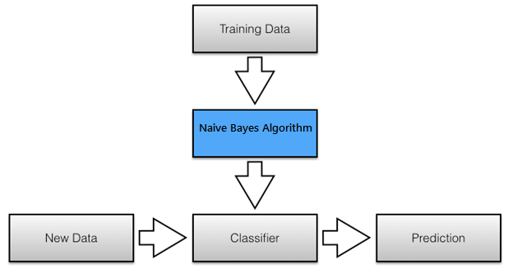
Figure 2.1 Naïve classifier approach (Sebastian Raschka, 2014)
.

2.2 Conceptual Design

Yadav et al.,(2011) provides an approach is similar to Deng & Peng (2006) in that they propose a client side Naive Bayes filter which uses the occurrence of keywords that appear in spam messages to determine a spam score. Messages that score above a certain threshold are labeled as spam. Their solution also requires user feedback to confirm and correct errors made by the classifier and therefore their filter can learn new spam keywords from client reports to a central server, which are in turn pushed out to other clients. The research will be informed by the conceptual design in figure 2.2. The data is pre processed which includes formatting of the data, then trained using Naïve Bayes ML algorithm after which its tested and lastly classified to determine which class they belong to. Finally an android based graphical user interface will be implemented on the user phone to detect these fraudulent messages.

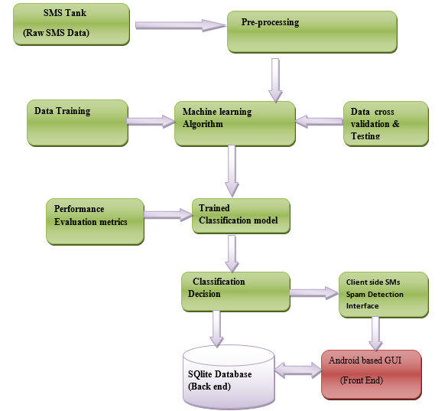

Figure 2.2 : Conceptual Design Source Researcher

3.0 METHODOLOGY

This chapter provides a description of the approaches that were adopted in carrying out the research . Naive Bayes algorithm that uses Bayes theorem as shown in formula below was used for detecting whether a message is Spam or not.

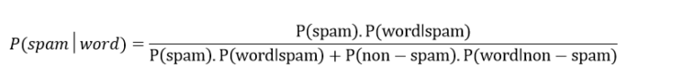

-P(spam/word) is probability that an sms has particular word given the message is spam.

-P(spam) is probability that any given message is spam.

-P(word/spam) is probability that the particular word appears in spam message.

-P(non−spam) is the probability that any particular word is not spam.

-P(word/non−spam) is the probability that the particular word appears in non-spam
Several measurement methods were typically used for comparing results of classification Some of these methods included precision, recall, accuracy, true positive, false negative, true negative and false negative-rates (B.K. Bharadwaj & S. Pal, 2011).Machine learning experiments were employed in this research using WEKA. WEKA (Waikato Environment for knowledge analysis) an Open source data mining tool written in Java programming that can be used for collection of machine learning algorithms data, data pre-processing, classification, regression , clustering and visualization. It contains a collection of visualization tools and algorithms for data analysis and predictive modeling, together with graphical user interfaces (Hall M, Frank E, Holmes G, Pfahringer B, Reutemann P, & Witten I. H, 2009).

The android based client side SMs Spam detection implementation of this research was done using open source machine learning libraries and android studio IDE with SQlite database for the backend. The final implementation also includes the following main functionalities:-
- Listening of incoming messages from the phone.
- Training of the model .
- Spam detection .

3.1 Prototype development.
The SMs Spam detection prototype development will involve an iterative SDLC (Software development life cycle ) , a process of dividing software development into distinct steps that contains finite activities , the steps include ,Problem definition, Data collection , Data preparation, spot check on algorithm, Training of the model ,Evaluation of model performance , data visualization and implementation. On these activities there is a lot of flexibility. The greatest thing in using automated tools is that you can always go back a few steps (iteration) and insert a new transform of the dataset and re-run experiments in the intervening steps to see what interesting results come out and how they compare to the experiments executed before.
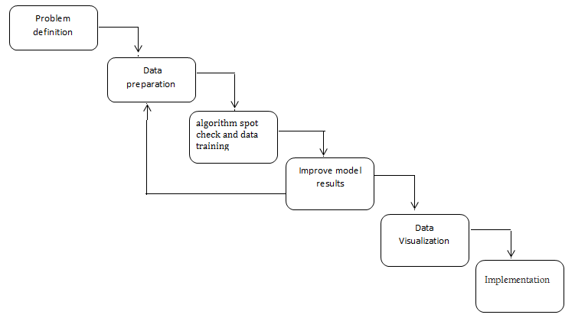

Figure 3.1 Iterative software development life cycle.

Machine learning algorithms learn from data. It is critical that you feed them the right data for the problem you want to solve. Data Preparation Process is important for better results; this step can be summarized in three steps: data selection, Data pre- processing, and data transformation (Jason Brownlee, 2013).Selecting Data is concerned with selecting the subset of all available data that you will be working with. Preprocessing of data involves formatting, cleaning and sampling: In transforming data the algorithm and the knowledge of the problem domain will influence this step and it is likely to revisit different transformations of the preprocessed data as the problem is solved, it involves scaling, attribute decompositions and attribute aggregations, this step is also referred to as feature engineering. Once the problem has been defined, the test harness is essential. A test harness is whereby the trained data is tested against the algorithm to assess its performance. Test harness focuses on evaluating different algorithms and thinking deeply about the problem. The output results will be important as it will give an indication of how learnable the SMs Spam problem is. Performance measures is also important at this stage, it gives a score that is meaningful to the problem domain. For example a more detailed breakdown of performance may include the false positives on a spam classification problem. From the transformed data, researcher selected a test set and a training set inform of an attribute-relation file format(arff).

The algorithm was trained on the training dataset and was evaluated against the test set. This involves selecting a random split of data (66% for training, 34% for testing).Another important step is algorithm spot checking. This is useful because it allowed quick judgment on the learnable structure in the data and estimate the effectiveness of the algorithm. Spot checking also helps sort out any issues in the test harness and makes sure that the performance measure is appropriate (Jason Brownlee, 2013) ,after spot checking is results improvement which involves algorithm tuning(changing input parameters) and extreme feature engineering.
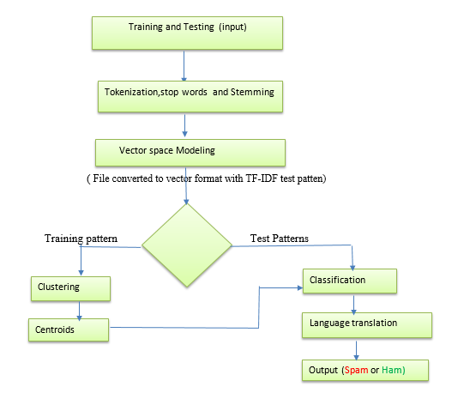

Fig 3.2 Flow chart of the proposed prototype

The flow chart in Fig 3.2 involves training and testing of the data , Tokenization , stop words and stemming, Vector space modeling using TF-IDF transformation. This will result into a training pattern and a test pattern that will be used for classification. Clustering was also done in order to group the messages as either spam or Not , this was done using K – means Clustering algorithm.

4.0 RESULTS FINDINGS AND DISCUSSIONS

This chapter gives an overview of the results , findings and discussions .An experiment was done to examine 1001 SMS as Spam or not a Spam.This analysis was done with reference to the three objectives aforementioned in the research objectives. These findings were used to explain the results and future work. WEKA tool was used to read stored SMS data from a file and was further structured for the learning algorithm interpretation as shown in Table 4.1 . It was also used to evaluate the performance by measuring the time to completion as well as accuracy of the filters .In training phase, the dataset provided consists of ham and spam SMS as shown in Fig 4.1 After the training, the system is used to test and classify incoming text messages in real-time. Further, the performance of classifiers was analyzed for optimality (M. Bilal Junaid & Muddassar Farooq, 2011).

4.2 Dataset preprocessing

The dataset (vector space) used was collected from different users as per the methodology in chapter 3 .This dataset consist of 1001 instances. The key attribute include ,class(nominal) , messages(string), Length of the message (numeric) and seven spam keyword According to this thesis a message belongs to either spam or ham class , the researcher used classAssigner C-last attribute selector for this purpose. Spam has 224 instances whereas ham has 777 instances, the figure 4.1 shows a snapshot of the raw messages in Microsoft excel.
The table below list the provided dataset in different file formats , the amount of sample in each case and the total number of samples, these messages are not in chronological order.
Table 4.1 Data set List

Application | File format | #spam | #Ham | Total
General | Plaintext | 224 | 777 | 1001
WEKA | ARFF | 224 | 777 | 1001

Figure 4.1 An extract of labeled raw messages

Label | Messages
spam | You have won yourself ksh 100, 000 for being a loyal Equity bank customer. Click http://equitybanknig-plc.com/ for more details.
ham | Please call me . Thank you.

Most of the data in the real world are incomplete containing aggregate, noisy and missing values and ambiguous (Rushdi, S. and Robet, M, 2013). Pre-processing of text messages is important before training, as mentioned earlier, the researcher used WEKA tool to facilitate the experiments. Because of the nature of the algorithm adopted, each message is represented structurally for training and classification. The raw datasets are presented in Attribute-Relation File Format (ARFF) ﬁle .WEKA tool understands these formats as shown below
@relation smsspam

@attribute class{spam,ham}
@attribute messsages string
@attribute length numeric
@attribute dear{0,1}
@attribute money{0,1}
@attribute number{0,1}
@attribute won{0,1}
@attribute bank{0,1}
@attribute customer{0,1}
@attribute congratulations{0,1}

@data
spam,"You have won yourself ksh 100, 000 for being a loyal Equity bank customer. Click http://equitybanknig-plc.com/ for more details.",19,0,0,0,1,1,1,0,0
ham,”Please call me . Thank you.”,6,0,0,0,0,0,0,0,0

As shown in fig 4.2 the rows of the original spreadsheet are then converted into lines of text where the elements are separated from each other by commas. In this ARFF file the researcher changed the first line, which holds the attribute names, into the header structure that makes up the beginning of an ARFF file as shown in fig 4.2 i.e. @relation tag with the dataset’s name, @attribute tag for the text message, @ attribute class, and @data was added. The full training data set containts 1001 messages with an approximate ratio of 1:3 (Spam: Ham),the testing data on the other hand contain 1/3 of the training data set which is approximately 333 instances. The longest messages collected consisted of upto 40 words , mean 13.797 and std deviation of 8.562 as shown in Table 4.2.1. This was very important information because it affected the time to training and test data, longer messages took more time in evaluating the model.

Table 4.2.1. Messages length statistics
Statistic | Value
Minimum | 1
Maximum | 40
Mean | 13.787
StdDev | 8.562

4.3 The Classification process.

Classifiers in WEKA are the models for predicting nominal or numeric quantities. The learning schemes available in WEKA used in this thesis include the Naïve bayes and decision trees (J48) algorithms. The researcher started with J48 algorithm followed by Naïve bayes algorithm. The following are the descriptive evaluation measures for Sms spam filters used in this thesis as shown in Table 4.3

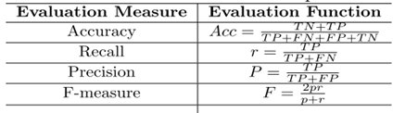

Table 4.3 Evaluation measures for SMS Spam filters

Where accuracy, recall, precision, F-measure, FP, FN, TP and TN are deﬁned as follows:

(i) Accuracy(acc): shows the fraction of messages that are correctly classiﬁed. It is important that the accuracy is high to have a low amount of legitimate messages being wrongly classiﬁed as well as to catch as much spam as possible.

(ii) Recall(r): fraction of the spam messages that are actually classiﬁed as such, which of course should preferably be as high as possible to stop as many of them as it can.

(iii) Precision(P): the fraction of the message classiﬁed as spam to be actually spam

(iv) F-measure( F): Weighted average of precision and recall

(v) False Positive Rate (FP): The number of mis-classiﬁed non spam text messages (false alarm (aka Type I error)

(vi) False Negative Rate (FN): The number of mis-classiﬁed text messages (false negative = miss (aka Type II error)

(vii) True Positive (TP): The number of spam text messages that are correctly classiﬁed as spam

(viii) True Negative (TN):The number of non-spam messages that is correctly classiﬁed as non-spam

These Methods as well as processing time gives the necessary information needed to properly compare the different ﬁlters in respect to hardware requirements as well as the classiﬁcation rates. Intel ® Pentium processor 1.10 GHZ and 4GB RAM specifications was used to conduct all the experiments.

4.4.3 Tokenization of words
Tokenizing process was applied in every word in documents. In this step every punctuation mark or spacing (example: ' - ) ( \ / = . , : ; ! ?.) was transform into delimeter ‘#’ that separate every word as token where every token was transform into lowercase as shown in figure 4.4.3. The purpose of tokenization is to calculate the number of words for feature selection and classification ( Gordon V. Cormack, 2008).To make the provided document classifiable using machine learning ,a feature extraction was done which involved converting the normal text to a set of features .This was achieved using String To Word vector (STWV) function paired with Inverse document Frequency (IDF Transform) and TF (Term frequency) Transform to reflect how important a particular word is to a class. .STWV assumes each word in the document is a feature and the number of occurrences in each instance is the feature value. Further all words were converted into lowercase using lower case tokens property in WEKA. This messages are featured as string attributes, so as to break them into words in order to allow learning algorithms and to induce classifiers with rules such as:
if (" bank" in message) Then class (message) == spam.

SMS | Tokenized SMS
Dear KCB Mpesa customer ,loan is now available at 10%, Get 10000, 20000, 30000 , Call 0788000521 :KCB Bank | #Dear# KCB#Mpesa#customer#loan#is#now #available#at #10%#Get#10000#20000# 30000 #Call#0788000521#KCB#Bank#

Figure 4.4.3 . Example of tokenization.

4.4.4 Stemming and Lemmatization of words
The goal of stemming was to reduce the word space dimension as well as to improve the precision for the classifiers by overcoming the data sparseness problem in case the training data may be too small in comparison to the word space dimension. Stemming of words and lowercase representation of letters shows indeterminate results in information retrieval and filtering (Gordon V. Cormack, 2008) for spam filtering of SMS for example words such as “availability” ,”available “ were all stemmed to its morphological root “avail”. This was done to shrink the word space and decrease words that have same meaning, porter stemming algorithm was used for this purpose.
Table 4.4.4 Example of Potter Stemming
dear KCB mpesa customer ,loan is now available at 10%.

dear | Kcb | mpesa | Customer | , | loan | is | now | Avail | at | 10% | .

In contrast to stemming, lemmatization aims to obtain the canonical (grammatically correct) forms of the words, the so-called lemmas (M. Toman, R. Tesar, and K. Jezek,2006). In implementation the researcher found out that both stemming and lemmatization have significant impact on the performance of text classification.

4.4.5 Stop words removal
Stop words are words that are particularly common in a text corpus and thus considered as rather un-informative (e.g., words such as so, and, or, the, I, we …”), they only increase the computation resources required to process text files .The approach to stop word removal involved a creation of a stop list by sorting all words in the entire text message by frequency. The stop list after conversion into a set of non-redundant words was then used to remove all those words from the input documents that are ranked among the top n words in this stop list. The rearcher used the stop words from https://www.ranks.nl/Stopwords for english language and created stop words list for the swahili language which include words like “yako”, “sasa” ,”la” , “baadaye”, “kwa “ ile” among others

Table 4.4.5 Example of stop word removal.

You have won yourself ksh 100 000 for being a loyal Equity bank customer.

won | Yourself | Kshs | 100000 | Loyal | equity | bank | customer

4.5 Data Testing

With the training data set provided earlier, A test data (Artff file) containing 322 instances (1/3 of total total 1001 instances) with missing class(?) was used to test the full training data

Stemming was done using potter stemmer algorithm, This generated 1115 keyword based attributes that include Cash, safaricom ,win, bank among others,the figure 4.8 gives the summary of keywords which includes its mean, standard deviation weighted sum and precision for each class.The naives bayes algorithm correctly classified 962 instances and incorrectly classified 39 of the 1001 instances which gives a percentage of 96.1039% and 3.8961% respectively. It leads to an accuracy of 96.1039% as shown in Table 4.5.1. and Table 4.5.2. From the confusion matrix the bayes naiver learner was able to get 207 +755 correct classifications, and makes 22+17 mistakes as seen in figure 4.5 .
Attribute | Class
 | Spam (0.22) | Ham(0.78)

Safaricom
Mean | 0.0214 | 0
Std deviation | 0.627 | 0.5327
Weight sum | 224 | 777
Pecision | 3.1928 | 3.1928
Table 4.5.1 A sample of keyword -attribute statistics

Table 4.5.2 Evaluation on training Set
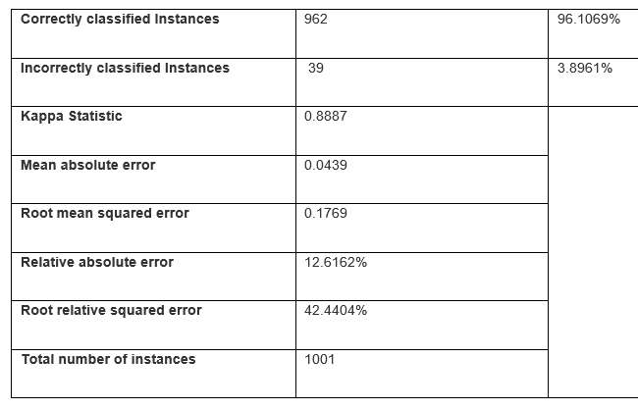

Table 4.5.3 Detailed accuracy by Class

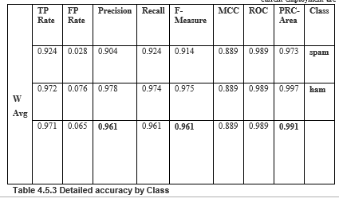

The confusion matrix for the training set is given on figure 4.5

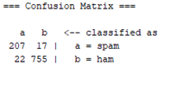

4.6 System Design and Imlementation

4.7.1 : Overview

In this chapter an overview of the SMs Spam detector system modules is represented as per naïve bayes algorithm . After having evaluated the naïve bayes machine learning probabilistic model .The researcher implemented the algorithm as per the reasons aforementioned in the previous chapters. The application architecture is shown in figure 4.7 .The architectures involves the initial stage of receiving incoming raw messages which are train and tested as per the previous chapters, the training phase involves pre processing (stop words, tokenization and stemming ) and transformation (TF and ID transformation) using Naive bayes algorithm.To achieve this implementation it was important to understand well not only how the classiﬁer was designed, but also the pre-processing procedure. The algorith is implemented at the client- side portable device android device with GSM capabilities. The user must allow the application to listen to incoming messages through phone settings=> apps=>choose smish detector=> under permissions=> select sms .

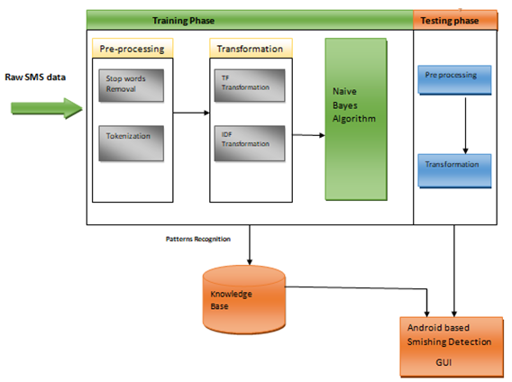

Fig 4.7 Android based System architecture

The system GUI conforms to User interface design principles.It satisfies the following user interface design principles
- Clear
- Consistent
- Efficient
- Responsive
- Reliable

The incoming text message is first translated into english from Swahili text messages using when required, if the message is in english then their is no need of translation. Figure 4.8 Shows how this is done, If a message is detected as SPAM the user has an option of saving it or dismissing it, If the save option is selected the user can view the saved message in a different folder for future reference which also include the Spam contacts associated with the Spam messages received.

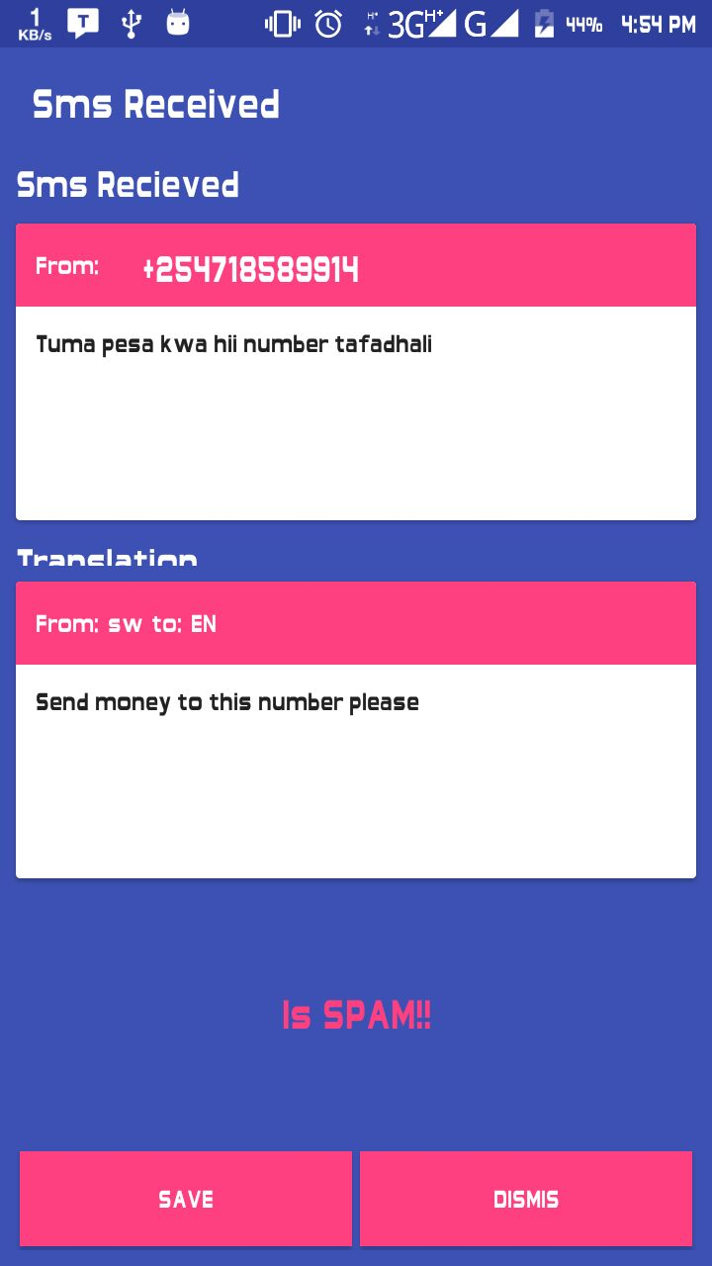

Fig 4.8 The translation example

4.9 Conclusion

SMS spam ﬁltering is an important issue in mobile commerce security and machine learning techniques; The quality of performance Naıve Bayes classiﬁer is also based on datasets used. In this thesis Na¨ıve Bayes classiﬁer has shown highest precision in Sms Spam detection . By looking at the words that are present within the message, the classifier was able to correctly classify the message as either Spam or Not. Using a model such as this mobile users can detect Spam messages using their phones therefore reducing fraud. This model can be improved by looking at the messages that were mis-classified and understanding why this happened.

4.9.1 Recommendations
- Some WEKA Visualizations features were not very clear eg the J48 visualization tree,This is because the tree was too large, other commercial software such as scikit-learn, RapidMiner may be used for this purpose.
- To avoid loss of money through SMs Spam, the government of kenya needs to provide user training/education on Social engineering attacks especially on mobile phone.
- To speed up the training and testing , the researcher recommends thorough preprocessing of data.Use of a computer atleast of 1.10 GHZ , 4GB RAM or above especially when handling large data is highl;y recommended
- Profiling of frequent sms Spam phone number may also help to curb this menace
- A Client side detection may not be enough. An adoption of a server side detection mechanism from the service providers such as Safaricom, Airtel and Telkom will help to reduce the damage of SMs Spam .

4.9.2 Areas of Further research
This study focussed on SMs Spam detection using naive bayes machine learning algorithm.However there are almost infinite text classification ways to detect SMS Spam that needs to be researched on. In this study the accuracy of the model can be improved with considering large data set and restrict the algorithm model to ignore normal dictionary words and instead use frequently used spam words in any language including Slang language (ghetto language) and local vernacular languages.

REFERENCES

A Almomani, BB Gupta, T Wan, A Altaher (2013) Phishing Dynamic Evolving Neural Fuzzy Framework for Online Detection Zero-Day Phishing Email. Indian J. Sci. Technol. 6, no. 1, 3960–3964 .

A- Kwee, et al (2009), "sentence-Level Novelty Detection in English and Mafay." in advances in knowledge and discovery and Data mining vol. 5476. T. Theeramunkong. et al. Eds., cd: Springer Berlin Heidelberg., pp. 40-51.

Boser, B. E., Guyon, I. M., &Vapnik, V. N. (1992, July). A training algorithm for optimal margin classifiers. In Proceedings of the fifth annual workshop on Computational learning theory (pp. 144-152). ACM.

B..Blankertz, G. Dornhege, C. Schafer, R. Krepki, J. Kohlmorgen, K.-R. Muller, V. Kunz-mann, F. Losch, and G. Curio (2003). BCI bit rates and error detection for fast-pace motor com-mands based on single-trial EEG analysis. IEEE Transactions on Neural Systems and Re-habilitation Engineering, 11:127–131.

Bijuraj, L. V. (2013). Clustering and its Applications. In Proceedings of National Conference on New Horizons in IT-NCNHIT (p. 169).
B.K. Bharadwaj and S. Pal. “Mining Educational Data to Analyze Students’ Performance”, International Journal of Advance Computer Science and Applications

(IJACSA), Vol. 2, No. 6, pp. 63-69, 2011.

Piatetsky-Shapiro, G.; Smith, P. &Uthurusamy, R. (2006) Advances in Knowledge Discovery and Data Mining. AAAI/MIT Press, MA.

Kang, J.-Y., Yoon, J., Kim, Y (2013) Phishing/Pharming Examples and Countermeasure Analysis. The Korean Institute of Information Scientists and Engineers 12(2), 171–180.

Qiang Yang and Xindong Wu (2006). 10 challeng problems in data mining research. International Journal of Information Technology and Decision Making, 5(4):597–604.
Stringhini, G., Kruegel, C., &Vigna, G. (2010, December).Detecting spammers on social networks. In Proceedings of the 26th annual computer security applications conference (pp. 1-9). ACM.

Sumathi, S., &Sivanandam, S. N. (2006). Introduction to data mining and its applications (Vol. 29).Springer.

T. Furey, N. Cristianini, N. Duffy, D. Bednarski, M. Schummer, and D. Haussler (2000). Support vector machine classification and validation of cancer tissue samples using microarray ex-pression data. Bioinformatics, 10:906–914.

T. Joachims (2001). The Maximum-Margin Approach to Learning Text Classifiers.PhD thesis, Computer Science Dept., University of Dortmund.

Tagg, C. (2009). A corpus linguistics study of SMS text messaging (Doctoral dissertation, University of Birmingham).

Tseng, C.-Y., & Chen, M.-S.(2009). Incremental svm model for spam detec-tion on dynamic email social networks.In CSE (4) (pp. 128{135).IEEE Computer Society.

Wang, C., Zhang, Y., Chen, X., Liu, Z., Shi, L., Chen, G., Qiu, F., Ying, C., & Lu, W. (2010).A behavior-based SMS antispam system. IBM Journal of Research and Development , 54 , 3:1{3:16.
Wu, L., Du, X., & Wu, J. (2014).MobiFish: A lightweight anti-phishing scheme for mobile phones. 2014 In 23rd International Conference on Computer Communication and Networks (ICCCN) (pp. 1–8).

Wu, N., Wu, M., & Chen, S. (2008). Real-time monitoring and filtering system for mobile SMS. In Proceedings of 3rd IEEE Conference on Industrial Electronics and Applications (pp. 1319 {1324)..

Zhang, J., & Wang, Y. (2012).A real-time automatic detection of phishing URLs. In: 2012 2nd International Conference on Computer Science and Network Technology (ICCSNT), IEEE (pp. 1212–1216).

