"The Effects of Pre-performance Research and Analysis on Vocal Music Performance"
HILDA KINYUA
PRECIOUS BLOOD SCHOOL RIRUTA
Background to the Problem
In general terms, performance is an event in which a person or group of people is engaged in carrying out an action exhibiting a skill, usually I presence of another person or group of people known as audience. Performance may be in the form of singing, acting or drama, dance, poetry recital, miming and various other forms of entertainment. But to mount such events, invariably it takes skill, a demonstration of which separates expertise from average standards and mediocrity. Music performance in particular requires various resources such as the voice, instruments, directors (conductors), music pieces (scores) or a combination of all these. An effective performer also needs to possess a good level of musical knowledge and ability, as well as the correct attitude or philosophy. There is a great deal of literature dealing with performance and some of the changes that have occurred over time. Kamien (2000), whose main mission is to document historical facts ,composers influences and contributions to music societal responses and other factors , also discusses the various stylistic characteristics of each period of music- from the Middle Ages, through the Renaissance, Baroque, Classical and Romantic periods ,ending his survey in the twentieth century ,examining Jazz, the American musical rock. In each of these periods he outlines cultural trends and the role of music and musicians in the society. Addressing a different historical outlook, Hoofer (1991) focuses on Art music. He describes it as having psychological rather than functional importance. This kind of music, he says, appeals to the intellectual and psychological sensibilities of a person. Other books dealing with music history discuss music styles, structures, social contexts, analysis and many other associated issues.
In the case of vocal music, the creation, performance and social context associated with the music has undergone various changes in terms of its preparation and presentation. According to Kamien (2002) in the Middle Ages, public singing was the reserve of male clergy in keeping with its use in the Roman Catholic Liturgy, while in the 16th Century it was mainly undertaken by the wealthy nobility, perhaps as a sign of their affluence and the facility of gaining music instruction. The Baroque period (1600 to 1750 AD) brought a change from this trend, with the opening of the first public opera house in Venice, in 1637. In the classical (1750 to 1820) Romantic (1820 to 1900 AD) and 20th Century (1900 to 1945 AD) periods, performance continued to be tailored according to the needs and ideals of the times, against an increased demand from audiences and the advances of technology.
Performance of the music of various historical periods requires the singer to study, interpret and understand the structural and contextual details of each piece so as to give it the proper rendition. Understandably, there are several important steps necessary in the preparation and execution of performances. Ware (1998) describes singing as a journey in which one needs to prepare by asking four important questions:
- Why do I want to take this Journey?
- How much time and effort can I commit?
- What resources do I have or need to assist me? And
- Who will be my companions?
The most favored response for the first question is one that shows a genuine interest in singing and a willingness to improve. As Ware (ibid) asserts, dedicated, self-directed students tend to make steady progress towards their desired destination and enjoy each step of the way. The second question is aimed at preparing the singer for the many hours needed to study texts and scores, do vocal warm-ups and exercises, listen and learn from model singers and evaluate their progress. The third requirement according to the same author is a combination of internal and external resources that shape the singer’s attitudes, experiences, knowledge and skills. They may include equipment such as a pitch instrument, a mirror (preferably a full-length one) and a portable recording device. Finally, one needs to have a healthy view of fellow singers who can offer much needed support during learning and performance.
When one has acquired these attitudes and made a decision to embark on the journey of singing it is important to get acquainted with the voice, which is the main instrument or sound producer in singing. The voice is part of a network of organs which work together to produce sound.

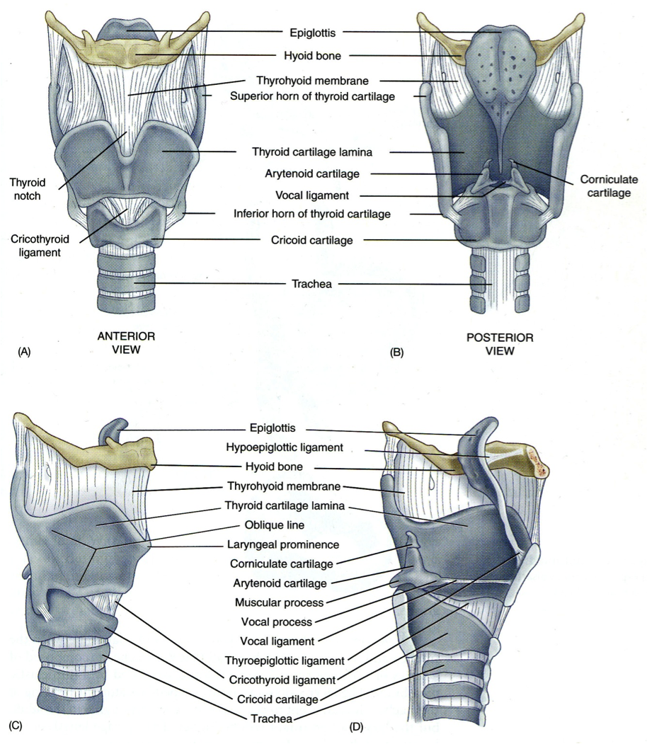
Figure 1.1 Structure of the voice
Source; Ware (1998)
As with other instruments or sound producers, the voice has an actuator, a vibrator and a resonator. The process begins with a mental decision to sing. This is the work of the brain and neurological systems which send impulses to the respiratory system to inhale and release the air which is necessary fuel for singing. Following this, the air is passed over the vocal folds, which vibrate to produce a sound referred to as a “buzz-tone’’. Next, the resonance cavities of the nose, mouth and throat amplify the “buzz-tone’’ which makes it more audible. Finally, the articulator, which consists of the tongue, jaws, lips and soft palate shape this sound into something recognizable. (Ware, 1998 p.7)
These elements are responsible for variations in vocal power and timbre. A singer should be aware of their capabilities before selecting a piece for performance so as to ensure that one performs pieces best suited to their quality of voice production. While selecting pieces, it is also important to consider the audience, room and environment, for which the pieces are to be presented. Some of the considerations may include performance purpose, venue, gender, age, occasion ad weather.
Once these factors are in place, preparations for the performance are initiated. These include learning the music, studying its form, areas of difficulty, specific performance directions as well as internalizing it and interacting with its message so as to be an effective communicator of the same message to the audience. It is the role of the performer to link the composer to the audience. He or she brings life to the written music and passes on its message to the listener. He or she also acts as an entertainer, incorporating other aspects of Art such as drama, comedy and mimicry where they enhance the message of a piece.
It has been observed, however, that performers often overlook these important aspects in the preparation for and execution of a performance. The results are often dull, ill-prepared and non-communicative performances that leave an audience’s expectations unfulfilled. Alldis, Rabinowitz & Hamond, (2009) note that.
“People are sometimes frightened of over- preparing as they think the material will somehow get stale. But that should not be a worry as every time you perform the piece it changes; the atmosphere is different, the audience changes and your understanding of the piece improves. By preparing as much as possible, you will be able to deal with anything that happens and you will have more confidence and enjoy it more.’’(The Observer, 10th May 2010)
The engagement into this study was prompted by the observation that there is need for guidance in the area of preparation for performance. Realizing how important preparation and effective execution of performance is to the audience and the performer, this study was undertaken to document the core activities involved in this age-old, but important tradition.
The problem
As earlier stated, performance of vocal music is quite popular in Kenya, perhaps anchored in the background of traditional music and performance of associated dances. One of the largest musical events in the country is the Kenya National Music Festival. This is a one of a kind event that attracts students, teachers, trainers and music enthusiasts from all parts of the country. Solo and ensemble singing also form a significant part of music instruction in high schools and colleges that offer music as a subject in their curriculum. In addition, choral and solo singing is an important part of worship in many churches across the country. Generally speaking music students, teachers, trainers, choir masters/mistresses and professional musicians all desire to present well-rehearsed and balanced performances in their areas of influence. However, most performers tend to rush in their preparation and therefore may end up with less than satisfactory performances.
Based on the historical merits and value of pre-performance preparations, the main focus of this study was to determine to what extent Kenyan Art music performers engage in pre-performance study and background information and to raise discussions on how focused pre-performance study aspects of a piece of music directly impact the quality of performance of the piece of music. In order to perform music of any kind accurately, it is important to understand the music, the historical/cultural context, performance traditions and conventions, the personality of the composer who created the music, the period in history from which it is drawn, the composer’s style of composition, as well as contextual trends that may have shaped his/her creativity.
Part of statutory requirements for a performance degree is to mount a recital of learned pieces representative of various styles and traditions. Consistent with the tradition, the main issue for the current study was threefold. It involved selecting vocal pieces reflective of various performance demands and preparing and mounting a public recital of selected pieces. Thereafter, pre-performance technical issues /challenges associated with the pieces would be identified and suggestions made on ways and means to address the said challenges.
The works selected were also written at different points of composers’ musical careers at which points they may have been influenced by several factors such as age and life experience. In order to determine the different demands that each piece presents to performer, it was important to study them in detail.
The study was guided by the desire to find out in what ways focused research and background information impact the rendition of solo vocal performances. By finding out the unique musical characteristics of each selected piece, and the inherent technical demands in approaching their performance, one could then make some proposed recommendations or suggestions on how various challenges can be overcome.
The Objectives
The study aimed at establishing whether vocal performers at various levels carry out research as part of the preparation for performance. Secondly, to analyze and outline the characteristics of selected pieces by various composers, assessing the technical requirements for the performance of the selected soprano pieces. Finally it aimed at providing suggestions and recommendations on how a performer can overcome the challenges in each of the pieces
The study was mounted on the premise that poor analytical skills hamper performance of any music and that to understand the deeper aspects of music, a performer needs to understand its style, tradition and background.
This study was undertaken to clearly articulate the importance of in-depth research as a prerequisite for effective performance. One important aspect of pre-performance research was the observation of the selected songs, and the specific technical demands of each. The study sought to discuss pertinent issues associated with interpretation of the selected songs. It also sought to provide suggestions on how a performer can adequately overcome the challenges posed by the technical demands of each song, in order to give an effective performance of the selected pieces, or other pieces using a similar approach.
While the study focused on performance techniques for the soprano voice, the findings of the study will add to literature on musical analysis for vocal performance in general, whether solo or choral. This will be useful to teachers and students of voice. The analysis rubric provided here will go a long way in guiding the process of interpreting music for performance and can be modified to suit other mediums of performance and other voices.
The scope of the study entailed only a sample of ten pieces out of the large number of pieces that were available. Questionnaires were administered to selected individuals at various stages of experience and exposure to performance. The respondents were drawn mainly from music students and teachers in Nairobi, although there were a few from other parts of the country such as Kisumu and Kakamega. The pieces were subjected to an analysis rubric to suggest that the observations made can be applied in performance of other pieces.
The investigator sought to establish differences found in the music of contemporaries who lived in the same period in history, that is, Ludwig Van Beethoven (1770-1827) and Wolfgang Amadeus Mozart (1756-1791) – who both lived in the classical period, as well as composers from other periods. These were George Fredric Handel (1685-1759) from the Baroque period, Giovanni Battista Pergolesi (1710-1736) from the Rococo sub-period and Eric Thiman (1900-1975), from the 20th century.
These composers were from different nationalities including Germany (Handel and Beethoven) Austria (Mozart), Italy (Pergolesi) and England (Thiman). This national variance has a significant contribution in terms of the language of composition vis-à-vis the language of performance, character of the music and other peculiar national origin aspects.
As the study was to be undertaken within the confines of an academic programme, time was a constraint and therefore in-depth studies were only done on the selected pieces, aware that for each of the composers there are other vocal works.
The analysis carried out on the pieces was focused on the technical characteristic of the songs and therefore it did not attach any parameters for qualifying the aesthetic appeal of the songs.
Review of related literature
This was done and presented under four subheadings namely: Composers’ backgrounds and their styles of music composition, the role of Musical Intelligence (Gardener, 1995) in the interpretation of performance, musical performance considerations and audience expectations and its effect on performance. Discussion of methodological issues for this project falls outside the traditional mode as it combines a practical component, that is, performance and qualitative research. It is divided into two phases.
First there was the analysis of sample scores using the qualitative approach. The pieces were analysed though an analysis rubric to determine the technical demands of each. A questionnaire was also administered to selected respondents to determine the propensity towards pre performance research.
The second phase was the actual performance of the pieces to illustrate the effects of the research on the performance.
The Results of the Study
The findings of the study were as follows:
- Each piece shows very unique characteristics in terms of form, the relationship between singer and accompaniment and in the challenges they present. It is therefore very important to include analysis of pieces as part of preparation for performance.
- The study was specific to songs for performance by soprano voice. The selected songs presented technical demands on the performer. It is therefore noted that care should be taken when selecting music for performance so as to select pieces suitable for the voice or other performing media.
- Voice coaches and music teachers can play a broader role in developing the analytical aspects of performance. They should also focus on helping their students find solutions to performance challenges that they may encounter.
- A performer should strive to find out as much information as possible from the score or other sources before embarking on choosing and performing the piece.
The results of this study showed that interpretation or study of music prior to its performance forms a fundamental process towards understanding and an ultimately informed rendition of solo vocal pieces. It also showed that such a study will enhance an understanding of deeply rooted issues as phrasing, idiomatic expression, and diction, appropriateness of historical context, the role and part of accompaniment. However, as this is an intensive and time consuming exercise, performers may not engage in it satisfactorily. As a result, performances may be given that are lacking in depth, understanding and expertise and this may produce dull, lifeless performances, sometimes taken out of context. It is therefore important to develop this as an important procedure in preparation of performances. This will in turn produce more meaningful and enjoyable performances
Recommendations
The following recommendations are made in view of the findings of the study:
That analysis of music pieces should be incorporated in the preparation for performance as this will help place the piece in its context by gaining information concerning its composer, the period in which it was written and its purpose or target audience.
Performers should aim at giving a meaningful performance whenever they are called upon. This requires preparation, rehearsals and proper stage etiquette. All this will be enhanced if the performer takes time to find out specific challenges in the music pieces and find ways to overcome them before they begin the performance.
Voice coaches and music teachers should incorporate this important research stage in their training programmes. This will enable upcoming performers to develop analytical skills as they develop vocal and other performance skills.
Each performer should develop or acquire an analysis rubric that guides the study or interpretation of music prior to the performance. Such a rubric or schedule enables the performer to study the music in detail and develop a clear, empirical way of gaining information concerning each piece.
Suggestions for further Research
This study was carried out specifically for a soprano singer. A study to cater for the other vocal ranges as well as instruments such as piano, flute and guitar is needed.
A study needs to be carried out to determine the reasons why performers may not undertake in depth analysis and interpretation of music pieces prior to performance.
The pieces studied in this piece were from several selected composers with varying musical background, training and exposure affect their style of composition, especially when composers in the same period seem to have very different styles.
While there may be studies carried out elsewhere in the world, a study should be mounted in Kenya to find out the place of research in performance.

REFERENCES
Alldis, D., Rabinowitz, K., & Hamond, M. (2009, May 10th).Tips on stage performance when singing. The Observer. Retrieved from http://m.guardian.co.uk/music.
Bennet, R. (1995). Music Dictionary. London: Cambridge University Press.
Bless, C., & Achola, P.W. (1987). Fundamentals of Social Research Methods. University of Zambia.
Blythe, A. (1995). Opera on Video: An Essential Guide. London: Kyle Cathie Ltd.
Chang, R. (1984). Art Journal. New York: The College Art Association.
Cooper, B. (2008). Beethoven. London: Oxford University Press.
Colles, H. C. (1912). The Growth of Music: A Study in Music History. London: Oxford University Press.
Cresswell, J. (1994). Research design. London: Sage publications, Inc.
Cross, M. (2001). Beethoven and His World: A Biographical Dictionary. Oxford University Press.
Einstein, A. (1946). Mozart – His work. London: Cassell and Company.
Fuchs, V. (1963). The Art of Singing and Voice Technique. London: Calder and Boyar.
Gardner, H. (2002). Three Faces of Intelligence. Daedalus. Vol. 131 no. 1.Retrieved from http:/www.jstor.org/stable/20027746
Gardner, H. (1983). Frames of Mind: Theory of Multiple Intelligences. New York: Basic Books.
Goldfarb, A., Walters, S., & Wilson, E. (1994). Theatregoers guide: A McGraw Hill Handbook for Students. New York: McGraw Hill, Inc.
Goleman, D. (1995). Emotional Intelligence. New York: Bantam Books.
Grout, D. J. (1996). A History of Western Music (5thed.). London: W. W. Norton and Company.
Halliwel, R. (1998). The Mozart Family: Four Lives In a Social Context. New York: Clarendon Press.
Hewitt, G (1979). How to Sing. New York: Taplunger Publishing Co.
Hospers, J (Ed.) (1969) (Introductory Readings in Aesthetics, New York: The Free Press.
Jacobs, A. (1985) New Penguin Dictionary of Music. Thetford, United Kingdom: Puffin.
Kamien, R. (2002). Music: An Appreciation, Boston: McGraw Hill.
Lundin, R. W. (1953). An Objective Psychology of Music, New York: John Wiley and Sons.
Musungu, G. J. (2010). Elements of Cross-Cultural music composition: The creation of Esidialo- A Samia marriage suite. Unpublished Doctor of Musicology Thesis. Pretoria: University of South Africa.
Njoora, T. K. (2010). Music and Meaning: Some reflections through personal compositions in Muziki: Journal of Music Research in Africa. (Vol. 7) July 2010. South Africa. University of South Africa.
Nyaga, J. N. (2010). Kenyan folk song as a source of compositional inspiration: A study of the use of selected folk songs in Art Music. Unpublished M.Mus. Thesis. Nairobi: Kenyatta University.
Otto, E. D. (1955). Handel: A documentary Biography. London: Adams and Charles Black Limited.
Randel, D. M. (Ed.). (1986). The New Harvard Dictionary of Music, London: Harvard University Press.
Sadie, S. (Ed.). (1998). The New Grove Dictionary of Opera. New York: Grove’s Dictionaries of Music.
Schmidt, I. (1989). Basics of Singing (2nd Ed.). New York: MacMillan Inc.
Schoen, M. (1940). The Psychology of Music. New York: Roland Press Company.
Solomon, M. (1995). Mozart: A life (1st Ed.). New York: Harper Collins.
Sternberg, R. (1985). Beyond IQ: A Triachic Theory of Human Intelligence. New York: Cambridge University Press.
Thayer, A., Deiters H., & Reimann, H. (1921). The Life of Ludwig Van Beethoven. (Vol. 1). New York: The Beethoven Association.
Tipton, C. (2005). Vocal Problems and Practical Suggestions. Unpublished manual for vocal students. Kenyatta University Department of Music and Dance.
Young, P. M. (1947). Handel (Master Musician series). JM Dent and sons.
Ware, C. (1998). Adventures in Singing, Boston: McGraw Hill.
Tips on How to Perform On Stage Singing. Become a singing master. Retrieved from http://www.become-a-singing-master.com/
How to prepare for a Singing Performance. Retrieved from http://www.ehow.com/how_7135_prepare-singing-performance.html
Multiple Intelligences. Retrieved from http://www.accelerated-learning.net/

