Synthesis, Characterization of ZnO Nanoparticles and their Application in Removal of Heavy Metals from Waste water
Lucy CHEBOR ¹, Lusweti KITUYI ²

¹Kabarak University, P.O. Box Private Bag, Kabarak - 20157, Kabarak, Kenya
Tel: +254 720216779, Email: lucychebor@yahoo.com

²University of Eldoret, P. O. Box 1125 - 30100, Eldoret, Kenya
Tel: +254 716 471 201, Email: joluki@yahoo.com

Abstract: Water scarcity and its contamination with toxic metal ions represent a serious worldwide problem in the 21st century and conditions are particularly bad in developing countries. In an effort to reduce the environmental and health effects of heavy metals in wastewater, various techniques have been employed. However, most of these techniques are expensive and ineffective in complete removal of heavy metals from the waters. Nanotechnology is a promising field in waste water treatment. This study aimed at assessing the efficiency of synthesized ZnO nanoparticles in adsorption of heavy metal ions from waste water. The objectives of this study were to synthesize ZnO nanoparticles, characterize and apply them y it in adsorption of heavy metals from waste waters. Precipitation technique was used to synthesize ZnO nanoparticles by synthesis of two samples L₁ and L₂ which were characterized using power X-ray diffraction (PXRD), fourier transform infra-Red (FTIR), scanning electron microscopy (SEM) and energy dispersive X-ray spectroscopy (EDX), methods of analysis. The PXRD results showed diffraction peaks which were indexed to ZnO reference as per JCPDS file 80-0075. The size of ZnO nanoparticles was found to be 26 nm. FTIR spectra showed a broad band at around 430 cm⁻¹ with shoulder shape, characteristics of Zn-O bond. The images obtained by SEM showed rod shaped clusters of nanoparticles which were distributed well within a range of 100 nm which is a favorable property to exhibit better photo catalytic activity. The EDX results showed elemental composition of ZnO nanoparticles which showed 54% Zn, 44.07% O and 1.93% Mn impurities for L₁ and 55.34% Zn, 42.3% O and 2.37% Mn impurities for L₂.The results of heavy metal ions adsorption showed an increase in percentage removal with increase in adsorbent dose and contact time. There was a decrease with increase in heavy metal concentration. Thus, ZnO nanoparticles can be used as an adsorbent of waste water from textile and metallurgical industries. Future studies could focus on possibilities of improving and commercializing this material through designing a treatment facility that incorporates commercial nano ZnO on large scale waste water treatment.
Key Words: Heavy Metals, Adsorption, ZnO, Nanoparticles.
1. Introduction
It is well known that heavy metals such as cadmium and zinc in environments pose a serious threat to plants, animals and even human beings because of their bioaccumulation, nonbiodegradable property and toxicity even at low concentrations (Trivedi & Axe, 2000). In general, the pollution caused by heavy metals has detrimental effect on the environment all over the world. For example, a variety of toxic effects on aquatic organisms can be produced by endangering ecosystems; human health can be directly or indirectly influenced by multiple channels such as touching with skin, drinking water, and food chain. In addition, in agro-ecological environment, especially in soils, the phenomenon of heavy metals pollution is now quite common. Heavy metals cause great harm to the crop growth, yield and quality. So the removal of heavy metals, such as mercury, lead, zinc, copper, cadmium, and arsenic, from natural waters or soils has attracted considerable attention (Yantasee et al., 2007). The conventional technologies for the removal of heavy metal ions from aqueous solution include chemical precipitation, ion exchange, reverse osmosis, electrochemical treatment and adsorption (Elouear et al., 2008). Among the different treatments described above, adsorption technology is attractive due to its merits of efficiency, economy and simple operation (Crini, 2005). The common adsorbents primarily include activated carbons, zeolites, clays, biomass and polymeric materials (Elouear et al., 2008). However, these adsorbents described above suffer from low adsorption capacities and separation inconvenience. Therefore, efforts are still needed to exploit new promising adsorbents.
Nanoparticles have two key properties that make them particularly attractive as sorbents. On a mass basis, they have much larger surface areas than bulk particles. Nanoparticles can also be functionalized with various chemical groups to increase their affinity towards target compounds. It has been found that the unique property of nanoparticles is to develop high capacity and selective sorbents for metal ions and anions. Photo-catalytic nanomaterials allow ultraviolet light also used to destroy pesticides, industrial solvents and germs (Yantasee et al., 2007).
Zinc oxide nanoparticles have been used to remove arsenic from water, even though bulk zinc oxide cannot adsorb arsenic. Some adsorption processes for wastewater treatment have utilized ferrites and a variety of iron containing minerals, such as akaganeite, feroxyhyte, ferrihydrite, goethite, hematite, lepidocrocite, magnetite and magnetite (Bhattacharyya & Gupta, 2008).
The use of iron ferrite and magnetite in wastewater treatment has a number of advantages over conventional flocculent precipitation techniques for metal ion removal. The high surface area to mass ratios of nanoparticles can greatly enhance the adsorption capacities of sorbent materials. In addition to having high specific surface areas, nanoparticles also have unique adsorption properties due to different distributions of reactive surface sites and disordered surface regions (Wu et al., 2009).

2. Materials and Methods
ZnO nanoparticles were synthesized using precipitation method by synthesizing two sets of ZnO nanoparticles. In the first set, 100 ml of 1M ZnSO₄ solution was added to 100 ml of 2M NaOH solution in drops. When the addition was complete, the mixture was kept at room temperature under constant stirring using magnetic stirrer for a period of 2-4 hours (Zhang et al., 2010).
The resultant precipitate obtained was filtered then rinsed with distilled water. The formed white precipitate of Zn(OH) ₂ was allowed to settle, filtered using filter paper of pore size 0.4 µm in a suction pump, washed with distilled water several times and dried in hot oven at 150⁰C for 45 minutes. The synthesized ZnO nanoparticles were further irradiated at 180 W with microwave radiation in a microwave oven for 30 minutes and the sample was named L₁. The procedure was repeated to synthesize ZnO nanoparticles in different experimental conditions. ZnSO₄, NaOH and oxalic acid were used as stabilizing agents. Thus one more sample was obtained and referred to as L₂.

3. Characterization of ZnO nano particles

The synthesized ZnO nanoparticles were subjected to (PXRD), (FTIR). Atomic absorption spectrometer (AAS) spectra AA-200 was used to analyze samples for levels of heavy metal species; Cd²⁺, Cu²⁺ and Ni²⁺ before and after treatment with ZnO nanoparticles. During analysis, the following parameters were varied; heavy metal concentrations, dose of the adsorbent and the pH of solutions.
The extent of removal in terms of percentage was calculated using the following relationship.
$$\% Removal= \frac{C_{1}-C_{2}}{C_{2}} x 100$$
whereC₁ is initial concentration and C₂ is final concentration.
The effect of various experimental parameters on adsorption of heavy metals in the aqueous suspension by ZnO nanoparticles were studied by varying the experimental conditions; concentration of the heavy metals, amount of the sample (L₁ and L₂) and pH.

4. Results and Discussion

Powder X-Ray Diffraction (PXRD)
The X-ray diffraction pattern of ZnO nano photocatalysts was recorded at 2Ө angle. Figure 1 shows the XRD patterns of the synthesized ZnO nanoparticles.
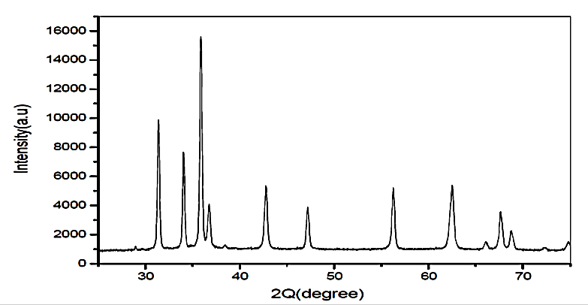

Figure 1: XRD patterns of the synthesized ZnO nanoparticles

The diffraction peaks at 31.7, 34.4, 36.2, 47.4, 56.4, 62.5, 67.6, and 68.7 can be indexed to ZnO as per the standard JCPDS file 80-0075. Powder diffraction patterns are characteristic of a particular substance and its “fingerprint” which can be used to identify a compound. Powder diffraction data from known compounds have been compiled into a database by the JCPDS. The synthesized sample can be confirmed to be ZnO nanoparticle. Clear crystallinity of the ZnO nanoparticles was observed. The samples had similar patterns. This suggests that the oxalic acid added as stabilizing agent had no effect on the wurzite structure of ZnO (Herrmann & Helmoltz, 2010).
Similar results were obtained by Gu et al. (2004) who obtained XRD peaks at scattering angles (2θ) of 31.3670, 34.0270, 35.8596, 47.1635, 56.2572, 62.5384, 67.6356, and 68.7978, corresponding to reflection from 100, 002, 101, 102, 110, 103, 200 and 112 crystals. They indexed the XRD patterns to ZnO nanoparticles reference JCPDS file 80-0075 as well.
The average crystallite size of ZnO nanoparticles was estimated according to the diffraction reflection by using Debye-Scherrer equation (Holzwarth & Gibson, 2011):

$$T=\frac{0.9λ}{βcosθ}$$
Where
λ - the wavelength of incident X- ray (1.5406A⁰)
β - the full width for half maximum (FWHM),
Ө - the Bragg’s angle for the peak

Β - can be calculated using the equation$β=(2θ_{2}-{2θ}_{1})$, obtained to be 0.2755 radians.

The average crystallite sizes of synthesized ZnO nanoparticles were found to be around 26 nm. Similar results were obtained by Shanthi and Muthuselvi (2012), who characterized synthesized nano-ZnO using PXRD for their three samples prepared and sizes obtained which were about18 nm, 16 nm and 12 nm.

The FTIR analysis
Figure 2 shows the FTIR spectrum of the synthesized ZnO nanoparticles by precipitation method, which was acquired in the range of 400-4000 cm⁻¹. The red and black curves represent L₁ and L₂, respectively.
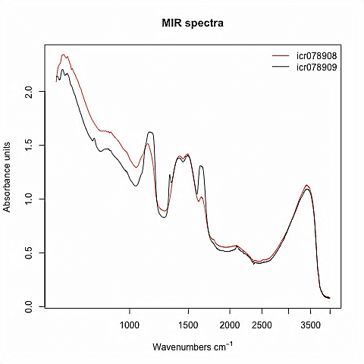

Figure 2: Observed FTIR pattern
FTIR of the ZnO nanocatalyst indicates the presence of water molecule adsorbed on the surface due to bands at around 3400 cm⁻¹ which may be assigned to OH⁻⁻ stretching vibration of adsorbed H₂O or due to residual Zn(OH)₂ present in the powder. The absorption band at 430 cm⁻¹ correlated to metal oxide bond (Zn-O) (Shanthi and Muthuselvi, 2012).

Kant and Kumar (2012) carried out similar study and FTIR spectra of ZnO obtained showed absorption band at 432.0 cm⁻¹ which was attributed to (Zn-O) stretching frequency. Likewise peaks at 3401.3 cm⁻¹ represent (OH) stretching mode. Shanthi and Muthuselvi (2012) also carried out a similar study and their analysis showed a broad band between 419-430 cm⁻¹. The spectra showed bands at (3250 and3500 cm⁻¹) which was assigned to OH stretching vibrations.

SEM Analysis

Figures 3 and 4 show the SEM diagram for samples L₁and L₂ at high magnification.

.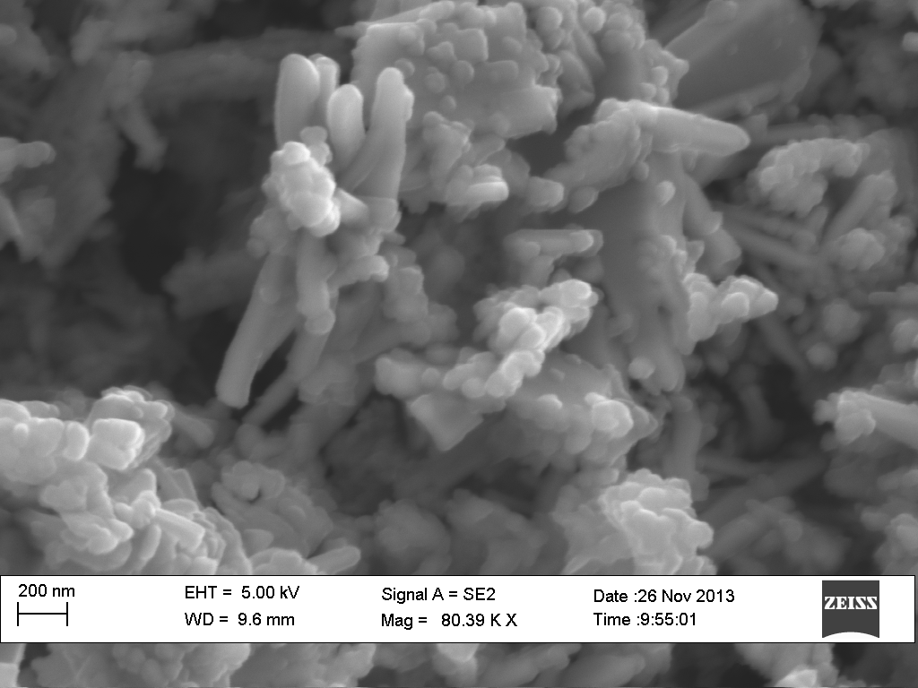 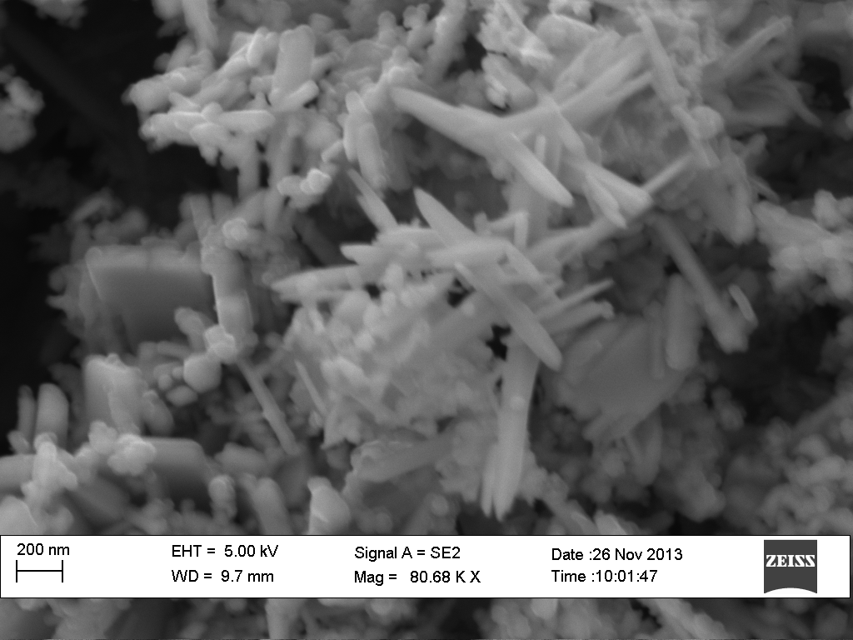
Figure 3: Magnified L₁ SEM diagram

Figure 4: Magnified L₂ SEM diagram

These images show that the ZnO nanoparticles obtained formed rod shaped clusters distributed within the range of 100 nm. The diagrams also show that the surface was not uniform but porous in nature. Thus the nanocatalyst has considerable number of pores hence a good possibility for the heavy metals to be trapped and adsorbed onto these pores and it is a good sign for effective adsorption of heavy metals (Joshi & Shrivastava, 2012).The photographs also show different surfaces for L₁and L_{2.} The L₁showed round ended while L₂ showed sharp ended nanoclustures. Therefore the stabilizing agent had an influence on the morphology of the samples.
Similar studies were made by Soltaninezhad and Amrnifar (2011). They studied surface morphology of ZnO nanoparticles produced by spray pyrolysis. The pictures observed showed particles that were spherical in shape. However, Joshi and Shrivastava (2012) determined the surface texture which was found to be rough and porous in nature.
Also Shanthi and Muthuselvi, (2012) under a similar study, characterized nano ZnO synthesized by precipitation and the SEM pictures which indicated sphere and cube like nanoparticles which were distributed within the range of 100nm.
Due to these close similarities, the ZnO nanoparticles were confirmed. The difference in distribution range is attributed to the level of accuracy during synthesis and also method of synthesis (Joshi & Shrivastava, 2012).

EDX Analysis

Figures 5 and 6 show the EDX spectra for sample L₁and L₂.

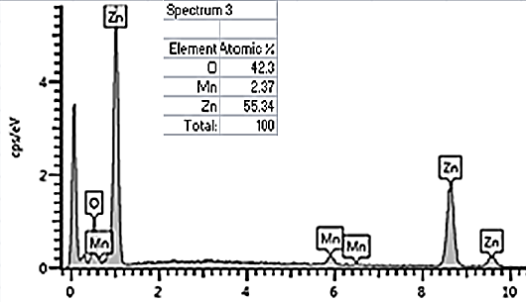

Figure 5: EDX pattern ZnO L₁

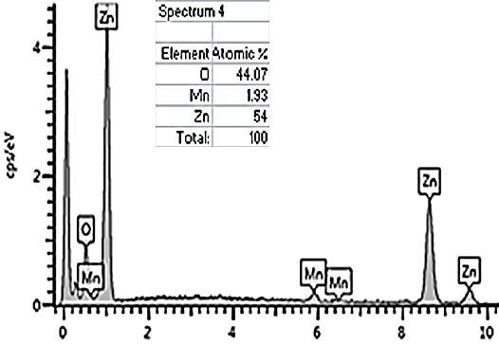

Figure 6: EDX pattern ZnO L₂

The EDX spectra indicated that the samples were made up of Zn, O and traces of Mn impurities. The peak at the intense peak is assigned to the bulk ZnO and the less intense on to the surface ZnO. The peak at 0.5 Kev can only be attributed to O and not Mn due to overall position of the peaks. The elemental composition of the nanomaterial was found to be 55.34% Zn, 42.3% O and 2.37% Mn for L₁and 54% Zn, 44.0% O and 1.93% Mn for L₂.
Similar work has been done by Joshi and Shrivastava (2012) who characterized nano ZnO synthesized by precipitation technique. Their EDX spectra showed a peak at 0.5 Kev for oxygen 1 Kev for ZnLα, 8.6 for ZnKα and 9.6 Kev for ZnKβ. The elemental composition was found to be 71% Zn, 18.5% CO and 10% C with carbon as the impurity.

Heavy Metals Analysis

Effect of initial heavy metals concentration on Adsorption capacity of ZnO nanoparticles

To evaluate the capacities of ZnO to remove heavy metals, batch experiments were performed with fixed adsorbent dosage of 250 mg at various initial concentrations (100-400 mgL⁻¹).The effect of the initial Cd²⁺ , Ni²⁺ and Cu²⁺ concentration on the adsorption and adsorptivity (percentage of heavy metals adsorbed) is shown in figure 7.
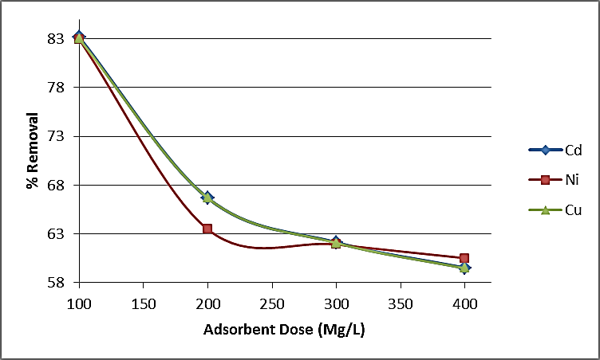
Figure 7: Effect of initial heavy metal levels on adsorption capacity of ZnO nanoparticles
The adsorptivity decreased with increasing heavy metal concentrations. Further, sorbents active sites were saturated and further increase in the concentration would have no effect on the metal uptake. The maximal levels of uptake adsorption reached for ZnOnanoparticles wereCd²⁺ (83.1%), Cr²⁺(82.9%) and Cu²⁺ (83.0%) at initial concentration of 100 mgL⁻¹.

Effect of adsorbent dose on percentage removal of heavy metals

The adsorbent dosages were varied from 100 mg to 500 mg, while all the other variables such as contact time, pH and temperature were kept constant at 90 minutes, 7.0 and 25⁰C, respectively. Experiments were performed with fixed heavy metal ion concentration of 100 mg/L. The results are shown in Figure 8.
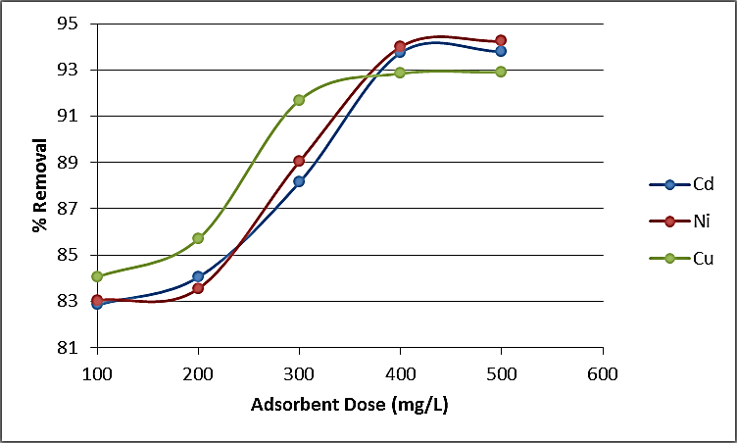
Figure 8: Effect of adsorbent dose on percentage removal of heavy metals
Adsorbent dose is an important parameter in the determination of adsorption capacity and this increased from 100 mg to 500 mg, the adsorption sites available for heavy metal ions also increased and consequently better adsorption took place. For a fixed initial concentration of heavy metals, the amount of metal retained by gram of ZnO nanoparticles increased with the amount of ZnO nanoparticles (increase in the number of active sites).When more was added, retention was almost total. The same cations were distributed on greater amount of surface and therefore resulted in reduction of adsorption amount on adsorbent (Kansal et al., 2006).
The results agree with those found by Engates and Shipley (2011) who carried out a study to determine adsorption of Pb²⁺, Cd²⁺, Cu²⁺ and Ni²⁺ by ZnO nanoparticles, by studying adsorption of single and multi-metal ions by ZnO nanoparticles. They found a 100% removal efficiency of Pb²⁺, Cd²⁺ and Ni²⁺ ions at 0.1 g L⁻¹within 120 min. of 50 mg, pH 8 and 24 hours contact time.

Effect of pH on Heavy Metal adsorption
The effect of pH on the surface species is responsible for the adsorption of ions from the solution. Effect of pH on the adsorption capacity of ZnO nano particles was evaluated by agitating 200 mgL⁻¹ metal ion solution with 250 mg of ZnO for 90 minutes at pH ranging from 2.0 to 8. The quantities of heavy metals adsorbed on ZnO adsorbent is represented in figure 9.
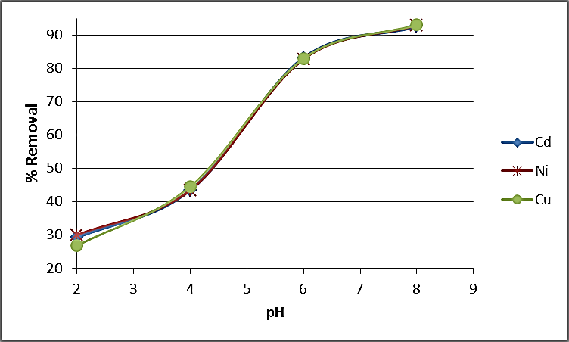
Figure 9: Effect of pH on ZnO nano particles heavy metals adsorption

The results on adsorption percentages of Cd²⁺, Ni²⁺, and Cu²⁺ at pH 2 showed that the maximum amounts of metals adsorbed were; Cd²⁺ (28.5 %), Ni²⁺ (29.1%) and Cu²⁺ (26.5%). Increasing the pH to 8, the adsorbed amounts were; Cd²⁺ (92.1%), Ni²⁺ (92.8%) and Cu²⁺ (92.0). The results agree with Yuan et al. (2013) who found that adsorption of metal ions Pb²⁺, Cu²⁺ and Cd²⁺ gradually increased with an increase of the pH of the medium, and maximum removal efficiency was observed at pH 8.
Thus, at high pH the surface charge of ZnO nanoparticles is more negative due to presence of OH⁻ groups that leads to formation of hydroxyl complexes. Formation of such hydroxyl compounds at higher pH is responsible for the uptake of the metal ions from solution. In contrast, the low degree of sorption at low pH can be attributed to the competition of cations (metal ions) and protons (H⁺) for the same sites, as well as the repulsion between ions of the same surface charge (Kumar et al., 2013).

5. Conclusion
The XRD results of the synthesized sample were confirmed to be ZnO nanoparticle. The size of ZnO nanoparticles were found to have an average crystal size of 26 nm which is within the range of 1-100nm for nanoparticles. The FTIR spectrum of the synthesized ZnO nanoparticles synthesized was in the range of 400-4000 cm⁻¹.The band range of 430cm⁻¹ correlated to zinc oxide bond (Zn-O).
The adsorptivity of ZnO nanoparticles was found to decrease with increase in heavy metal concentrations. The maximal levels of uptake adsorption reached for ZnO nanoparticles were Cd²⁺ (83.1%), Cr²⁺ (82.9%) and Cu²⁺ (83.0%) at initial concentration of 100 mgL⁻¹ and contact time of 90 minutes. Increase in adsorbent dosage increased adsorption percentage for the three metal ions.
At pH 2, the maximum amounts adsorbed were; Cd²⁺ (28.5 %), Cr²⁺ (29.1%) and Cu²⁺ (26.5%). Increasing the pH to 8, the adsorbed amounts were; Cd²⁺ (92.1%), Cr²⁺ (92.8%), and Cu²⁺ (92.0).

6. Recommendations

In future, researchers should focus on the development of novel nanomaterials/nanocomposites with a high surface area, sufficient surface functional groups and high sorption ability, for the removal of different heavy metal ions and organic dyes. The microbial threats to human health and safety are also a serious public concern. Thus, further improvements must be made in the direction of the development of materials with greater stability (resistance to pH changes and concentrations of chemicals present in contaminated water) and the capacity for the simultaneous removal of multiple contaminants, such as toxic metal ions, organic dyes and bacterial pathogens.
Considering the economics of adsorbents, it is necessary to synthesize low-cost effective and recyclable adsorbents for their extensive application in our daily life. Treatment technologies should be developed for the purification of water in order to meet the demand of increased environmental pollution.

References
Bhattacharyya, K.G.and Gupta, S.S. (2008). Influence of acid activation on adsorption of Ni (II) and Cu (II) on kaolinite and montmorillonite: Kinetic and thermodynamic study, Chem. Eng. J. 136, 1–13.
Crini, G. (2005). Recent developments in polysaccharide-based materials used as adsorbents in wastewater treatment. Progress in polymer science, 30(1), 38-70.
Elouear, Z., Bouzid, J., Boujelben, N., Feki, M., Jamoussi, F., & Montiel, A. (2008). Heavy metal removal from aqueous solutions by activated phosphate rock. Journal of Hazardous Materials, 156(1), 412-420.
Engates, K. E. and Shipley, H. J. (2011). Adsorption of Pb, Cd, Cu, Zn, and Ni to titanium dioxide nanoparticles: effect of particle size, solid concentration, and exhaustion. Environmental Science and Pollution Research, 18(3), 386-395.
Gu F., Wang S.F., Lu M.K., Zhou G.J., Xu D., and YuanD.R. Langmuir., (2004) 20: 3528.
Herrmann, V. and Helmoltz, P. (2010). Influence of stabilizers in ZnO nanodispersions on the performance of the nano particles. Phys Status Solid, 207(7), 1684 – 1688
Holzwarth, U. and Gibson, N. (2011). The Scherrer equation versus the'Debye-Scherrer equation'. Nature Nanotechnology, 6(9), 534-534.
IBM Corporation (2001). IBM Zurich Research Laboratory: Lab Overview. [Online].Available: http://www.zurich.ibm.com/imagegallery/stm/index2.html
Joshi, K.M. and Shrivastava V.S. (2012). Removal of methylene blue dye aqueous solution using photo catalysis, Int.J.nano Dim, 2(4): 241-252
Kansal, S.K., Singh M. and Sudc, D. (2006). Studies on photodegradation of two commercial dyes in aqueous phase using different photocatalysts. J Hazardous material, in press.
Kant, S. and Kumar, A. (2012). Comparative analysis of structural, optical and photocatalytic properties of ZnO prepared by sol-gel method. VBRI press. India, 3(4) 350-354
Kumar, K.Y., Muralidhara, H.B., Arthoba, N.Y., Balasubramanyam, J. and Hanumanthappa, H. (2013).Hierarchically assembled mesoporous ZnO nanorods for the removal of lead and cadmium by using differential pulse anodic stripping voltammetric method. Powder Technol. 239: 208–216.
Shanthi, S. and Muthuselvi, U. (2012) A study of morphology of synthesized NanoZnO and its application in photodegradation of malachite green dye using different sources of energy 4 39-52
Singh, S., Barick, K. C. and Bahadur, D. (2011).Novel and efficient three dimensional mesoporous ZnO nano assemblies for environmental remediation. Int.J. Nanosci. 10: 1001-1005.
Soltaninezhad, M. and Aminifar, A. (2011).Study of nanostructures of ZnO as photocatalysts for degradation of organic pollutants. Int.J. Nano Dim, 2(2) 137-145
Trivedi, P., & Axe, L. (2000). Modeling Cd and Zn sorption to hydrous metal oxides. Environmental Science & Technology, 34(11), 2215-2223.
Wu, P.X., Wu, W.M., Li, S.Z. Xing, N. Zhu, N.W, Li, P. Wu, J.H. Yang, C. and Dang, Z. (2009). Removal of Cd²⁺ from aqueous solution by adsorption using Femontmorillonite, Journal of Hazardous Materials, 169; 824–830.
Yantasee, W., Warner, C. L., Sangvanich, T., Addleman, R. S., Carter, T. G., Wiacek, R. J., ... & Warner, M. G. (2007). Removal of heavy metals from aqueous systems with thiol functionalized superparamagnetic nanoparticles. Environmental science & technology, 41(14), 5114-5119.
Yantasee,W. Warner,C.L. Sangvanich,T. Addleman,R.S. Carter, T.G, Wiacek,R.J. Fryxell,G.E. Timchalk,C. and Warner, M.G. (2007). Removal of heavy metals from aqueoussystems with thiol functionalized superparamagnetic nanoparticles, Environ. Sci. Technol. 41, 5114–5119.
Yuan, Q., Li, N., Chi, Y., Geng, W., Yan, W., Zhao, Y., Li, X. and Dong, B. (2013) Effect of large pore size of multifunctional mesoporous microsphere on removal of heavy metal ions. J. Hazard. Mater. 254–255: 157–165.
Zhang, J., Fu, D., Xu, Y. and Liu, C. (2010). Optimization of parameters on photo-catalytic degradation of chloramphenicol using TiO₂ as photo-catalyst by response surface methodology. Journal of Environmental Sciences, 22; 1281 – 1289.

