**INFLUENCE OF EMPLOYEE DEMOGRAPHIC CHARACTERISTICS ON JOB SATISFACTION AMONG SECONDARY SCHOOLS’ SECURITY PERSONNEL IN BARINGO COUNTY, KENYA**

**Sharon Jerotich Koech**

Post-Graduate Student School of Business and Economics

Kabarak University

E-mail: [sharonkoech@yahoo.com](mailto:sharonkoech@yahoo.com)

Ronald K. Chepkilot

School of Business and Economics

Maina Waiganjo School of Business and Economics

Kabarak University

**ABSTRACT**

Job satisfaction among security personnel in schools plays an important role in influencing productivity, performance, commitment, and the quality as well as the safety of staff, students and property. In Baringo County, there is apparent job dissatisfaction among security personnel in secondary schools going by the high turnover rates and the manifestations of unprecedented unrests reported in recent years in schools. Although there are numerous factors that influence security personnel’s’ job satisfaction, there is a need to identify the factors and address them adequately to improve the satisfaction and enhance the quality of security services provided to secondary schools. Therefore, the purpose of the study was to examine the influence of Employee characteristics on the job satisfaction of security personnel in public secondary schools in Baringo County, Kenya. The study employed a descriptive cross-sectional survey design. The study population comprised 508 security personnel and 169 principals in public secondary schools in Baringo County. Slovin’s formula was used to get the sample of 224 security personnel. Random sampling technique was used to select 10% of the school principals to participate in the study. A questionnaire and an interview guide were used to collect data. Quantitative data was collected and analysed by use of both descriptive (means, percentages as well as frequencies) and inferential statistics. From the research findings, majority of the respondents were from Sub-County schools. Moreover, there were fewer heads of security guards while the majority were ordinary security guards. Most of the respondents, were male while a few were female. Regarding age, majority of the respondents were aged 32 years and above. A large number of them had worked for their schools for four years or more. Additionally, majority had a KCSE level of education while many had a KCPE level of education. A good number found their work manageable and some of them found it average. Lastly, there were mixed reactions concerning age and experience with workload, with respondents across all ages indicating that they found the work either overloading or manageable. From the demographic characteristics of the respondents, it is evident that schools attract old and retired security workforce. This cohort may not have other options for employment. Old security personnel may be incapacitated when assessing and responding to severe security situations. It was noted that majority of security personnel in schools were male. Therefore, it is difficult for them to frisk female visitors as well as female students for any threats. The researcher recommends that all schools recruit sufficient female security personnel. This will also assist management to comply with the human resource requirement of the two-thirds gender rule, retirement age among others as per the Employment Act.

**Keywords:** *Demographic Characteristics, Job Satisfaction, Secondary Schools, Security Personnel, Baringo County*

**Introduction**

Security personnel play a critical function in maintaining a safe and peaceful environment in institutions of learning. Therefore, it follows that violence and lawlessness are unlikely to occur in learning institutions with security personnel. The tasks of these personnel include to watch over the school property, to identify and look into any suspicious events, observe and defend entry, scrutinize every person that comes in and out, safeguard school assets, look into, document and report incidences of lawlessness in school, report any violations to the school authority prevent violence of any kind, enforce the school rules, and exert force where necessary. They serve as a visual security measure and act as the first line of defence in the prevention of violence (Coaston-Shelton, 2009). They also serve as first responders with tasks ranging from the general monitoring of space, property inspection to the prevention of fire, theft, harassment, detecting disorderly conduct, vandalism and bullying (Jaarsveld, 2011). They also give training on emergency preparedness and they handle work place violence (Nalla & Cobbina, 2017). However, in most cases security personnel face challenges in their jobs which include poor working conditions, workplace violence, low wages, tasks outside their job descriptions, safety in the work place, long working hours, drug abuse, lack of training, unfair recruitment, lack of respect and boredom (Opondo & Ajowi, 2015; Saliu, Gbadeyan & Olujide, 2015). These challenges tend to demotivate the security personnel and affect their workplace wellness as well as their family relationships.

Security personnel need to experience job satisfaction to be motivated to do their work and address security challenges effectively. As such, by identifying the aspects of security guard’s work that explain their level of job satisfaction, it is possible to explore factors that can improve job satisfaction (Nalla & Cobbina, 2017). Employees who are satisfied with their jobs bring benefits to both the employer and the employee. Lower job turnover rates, decreased absenteeism, and increased productivity are some of the identified benefits of satisfaction with one’s job (Coaston-Shelton, 2009). According to Lytle (2014), job satisfaction could influence the way in which policing services are provided. It could also impact on whether security personnel perform better to meet the needs of the schools or they simply meet the minimum standards required by the organization.

The work of Scott, Swortzel, and Taylor, (2005) indicate that employee demographic characteristics should be considered in examining job satisfaction, in order to understand the possible factors that lead to job satisfaction and dissatisfaction. Employee characteristics can be viewed as employee dispositions (Jex, 2002). These employee characteristics tend to include several aspects of a person which may not be the same for all employees. Anyango (2015) sees these characteristics as entailing employee disposition in terms of age, gender, marital status, school type, rank, and years of working experience, expectations, education, gross pay and professional training. The author observes that individuals are usually unique in many facets. Differences in individuals are also depicted in their way of perception of job satisfaction.

There are several studies on gender differences in job satisfaction across different fields. However, there is insufficient focus in the security sector. Gender differences with regard to job satisfaction represent an important research area. There have been conflicting results on the relationship between gender and employee job satisfaction. Some studies have shown that male employees are more satisfied with their jobs, while others indicate that female workers were more satisfied. For example, a study done on Extension agents by Scott et al (2005) observed that there is a low relationship between gender and employee job satisfaction. However the study by Sseganga and Garrett (2005) established that gender does not significantly influence the job satisfaction of university faculty members. A study by Amarasena, Ajward and Ahasanul (2015) found that male faculty members and female academic staff members have almost same level of job satisfaction. The authors also observed that a significant difference is not present between the degree of satisfaction of male and female faculty members. Kipkebut (2010) found that female employees in Kenyan universities were more dissatisfied with the intrinsic aspects of their jobs as compared to their male colleagues.

On the aspect of age, it is widely acknowledged that age has an influence on employee job satisfaction. Many studies agree that job satisfaction is positively correlated with age. In most cases Employees of a younger age tend to feel that they still have opportunities to improve themselves hence they cannot be committed to a profession as opposed to older employees who aim at settling down. A study by Coaston-Shelton (2009) found that age had a significant but indirect relationship with work stress which indicated that older security officers experienced less stress in their jobs but were not necessarily satisfied in their jobs. However, Amarasena et al (2015) in their study did not find statistically significant difference among job satisfaction of faculty members in public universities in Sri Lanka in terms of age. This is in agreement with Scott et al (2005) who also found no significant relationships between age and the job satisfaction constructs for Extension agents.

Education has also emerged as an important variable in the study of job satisfaction. Organizations make explicit specification on required education level of prospective employees depending on purpose of the job as well as other organizational needs and considerations. Syed and Jama (2012) noted that in every individual’s life, education is a vital dimension, as well as the irrefutable claim that education ensures a nation’s development. Accordingly, the author believes that to generate best outcomes for all stakeholders, an educational system needs to be planned strategically According to Sababu (2010), an employee’s education, training and development are meant to improve job performance. The author opined that training helps an employee to develop a high level of discipline and also solve problems which would otherwise be difficult. Training allows for upward promotion of employees which leads to achieving job satisfaction. An employee who is trained for the job is likely to experience job satisfaction than one who has no training at all. On the contrary, Safura, Azumah, Ayisha and Tetteh, (2017) found that education have insignificant positive effect on satisfaction with work autonomy. There is significant negative link between education and satisfaction with work environment (at 1%), satisfaction with organisational decision making (at 1%), satisfaction with leadership care (at 1%), interpersonal relationship (at 5%), self-worth (at 10%), social recognition (at 1%), and supervision (at 10%). Education has insignificant negative effect on work characteristics, and workload.

Previous studies have indicated a consistent trend in job satisfaction according to length of service. For instance, Anyango (2015) notes that an employee’s experience is a function of the environment under which an organization operates and it affects job satisfaction of its employees. An important benefit of employee job experience is that it allows an employee to have job knowledge which is useful for job performance. The work of Karacan (2011) on job satisfaction of security guards showed that employees who had job experience of over nine years in their job had a higher degree of satisfaction. Similarly, Chepkemboi, Yitambe and Makunyi (2019) found a significant statistical association between years of experience and job satisfaction among nurses. Increase in work experience led to increased satisfaction among respondents. The more one works in the healthcare sector the more one gets familiarized with the work requirements thus more satisfied. In a study carried on nurses, Kahiga (2017) observed that nurses with a work experience of more than 20 years were more satisfied.

On the relationship between rank and job satisfaction, Gaunya, Oruta and Lidava (2016) argue that the participants’ rank may provide them with status and good connections within the national police service environment which may increase job satisfaction. The authors observed that rank was not significant predictors of job satisfaction. However, Eyupoglu and Saner (2009*)* investigated whether rank is a predictor of their job satisfaction. Their results demonstrated that overall, the employee’s rank contributed moderately to the level of job satisfaction. According to Kamweti (2011) considers rank allocation or promotion to be an important element in employees’ morale. Several organizations use the system of job ranking to differentiate between positions and standardize compensation in sets of responsibilities and skills that are equivalent. Through ranking, the seniority of an employee in a specific occupational classification is stated. A system of employee grade that is standardized helps in safeguarding of fair compensation for similar work level across various departments and divisions (SousaPoza & Sousa-Poza, 2000).

According to Mwangi (2017) a higher job rank created reluctance of employees to leave an organization, signifying continuance commitment. However, if an employee stayed at any rank for too long they were willing to leave the organization. Also, employees who had been promoted to higher ranks gained a sense of affective commitment to their organizations. The study therefore recommends that employers recognize outstanding employees through promotions whenever possible in order to boost their morale and ensure their commitment to their jobs and organizations.

In terms of workload, Kamweti (2011) contended that work overload as well as excessive job demands remains a significant cause of job frustrations, stress and burn out in organizations. Perceived work pressure can lead to dissatisfaction with the employees. The author recommended that management should ensure optimum staffing to facilitate realistic workload to minimize stress on the existing capacity. A recent study by Tengah and Otieno (2019) on factors influencing job satisfaction among Nurses in public health facilities in Mombasa, Kwale and Kilifi Counties, Kenya established that nurses’ work load significantly influences their job satisfaction. Chisaka and Gichinga (2018) in a study of job satisfaction factors influencing teachers perfomance in public primary schools: a case study of Mombasa county found work load to be a significant factor of job satisfaction.

On the type of school Kimeni (2014) notes that the variables of age, type of school, number of years of teaching experience and mother’s occupation don’t have great influence in determining teacher’s attitudes towards teaching and job satisfaction. Most of the studies have been done in USA and Europe but none of them examined the effect of age, marital status, pay, gender, education, professional training, experience and expectations on job satisfaction among school security personnel. Therefore, the influence of these employee characteristics on job satisfaction in public secondary schools is unknown. A study by Mulinge and Mueller (1998) examined agricultural officers in Nakuru district. The study compared private and public sectors and found that public sector employees were less satisfied with their jobs compared to the private sector employees. Thus, as the Kenyan Government continues with CSR, there is a need to understand how employees perceive the effect of reforms on the nature of their jobs. Understanding reform effects may help to favourably shape employees' feelings of job satisfaction with significant advantages.

**2.0 MATERIALS AND METHODS**

The researcher utilised the cross-sectional descriptive survey research design. The study was carried out in public secondary schools in Baringo County, Kenya. Baringo County was chosen because there is a paucity of knowledge on the influence of employee characteristics on the job satisfaction of security personnel in schools in the area. At the time of the study, the County had 169 public secondary schools, 169 principals and 508 school security personnel. Stratified sampling technique was used to ensure that all the six sub-counties (namely Eldama Ravine, Mogotio, Baringo South, Tiaty, Baringo Central and Baringo North) were included in the study. The sample size of the security personnel was determined using the Slovin’s formula (Dionco-Adetayo, 2011) as shown below.

n = N__

1 + NE²

Where: n = sample size

N = population size

1 = is a constant value

E = margin of error * desired

Hence:

n = 508/1+508 (0.05)2

n = 508/2.27=223.7 = 224

Therefore, the sample size of the security personnel, allowing a 5% error margin, was 224 given that the accessible population was 508. The sample size was as shown in Table 1 below.

**Table 1: Distribution of Security Personnel Sample by Sub-counties**

|  |  |  |
| --- | --- | --- |
| **Sub-county** | **Population of security**  **Personnel** | **Sample size of security personnel** |
| Eldama Ravine | 114 | 50 |
| Mogotio | 76 | 34 |
| Baringo South | 70 | 31 |
| Tiaty | 26 | 11 |
| Baringo Central | 126 | 56 |
| Baringo North | 96 | 42 |
| **Total** | **N = 508** | **n = 224** |

In the study, the questionnaire was used to collect data from the respondents. The data gathered from questionnaires were validated, edited and then coded. The validation process enabled the researcher to determine the return rate of questionnaires. Editing and coding of the collected information was done before the data was entered into the Statistical Package for Social Scientists tool (SPSS). The quantitative data collected were analysed using both descriptive statistics (specifically percentages and frequencies) and inferential statistics (correlation and regression analysis). Spearman rank correlation and multiple linear regression were used to test hypotheses at alpha level (α = 0.05). The Spearman rank order correlation was used because it is ideal for establishing the strength and direction of association of variables. Regression analysis displays how well the variables of the study are able to predict a particular outcome.

**3.0 RESULTS AND DISCUSSION**

This study investigated the influence of employee characteristics on the job satisfaction of school security personnel in Baringo County. Table 1 shows the Correlation between employee demographics and the level of Job Satisfaction.

**Table 2 Correlation between Demographics and Level of Job Satisfactions**.

The level of job satisfaction variable was a score of eleven likert items that measure the construct job satisfaction. The items were on a scale of very dissatisfied (1) to very satisfied (5) hence the respondents job satisfaction score was obtained by summing entries for each liker then get a proportion by dividing with the maximum score (55). Level of job satisfaction was hence a continuous variable showing percent point of job satisfaction. Demographic gender was nominal hence a point bi-serial correlation was adopted to show the relation between gender and level of job satisfaction. The other demographics were ordinal hence spearman rank correlation was adopted.

From the correlation table above, the study established that there was a small and significant negative association of job satisfaction with school regions. This indicated that there were schools regions where job satisfaction was low compared to others. Similarly, the study established that there were school categories significantly associated with low job satisfaction. Gender, level of education, number of years worked in the school and workload however were found to have a small insignificant association with level of job satisfaction. The study also established that there were age categories significantly associated with low job satisfaction.

To disentangle these differences in job satisfaction across variables groups of the demographics, t tests were used whenever the demographic variable had two groups and ANOVA adopted whenever the demographic variable had more than two groups.

**Job Satisfaction across Gender**

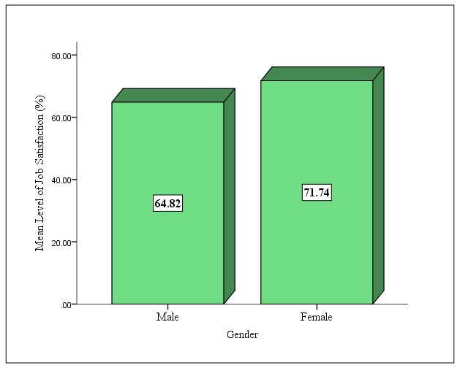

The study established that on average females were associated with higher (71.74 %) job satisfaction levels as compared with males (64.82%). A t test was adopted to assess whether if this difference was significant. The test confirmed that the difference was significant (Sig. 0.038). These findings are presented on the table below.



**Job Satisfaction across Age Brackets**

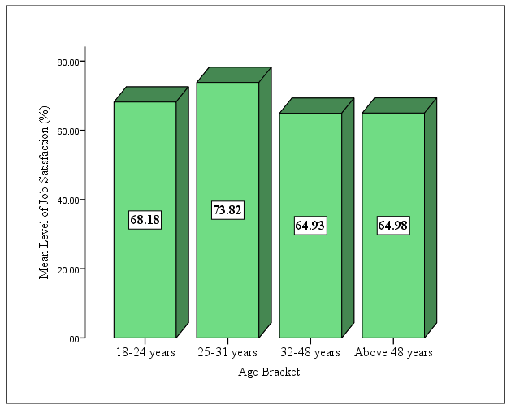

The study established that on average, personnel aged 25-31 years were the most satisfied with a level of 73.83%. To test whether there was differences on the level of job satisfaction across the different age brackets, ANOVA test was adopted, with Tukey HSD ad hoc test for multiple comparisons. The multiple comparison test on the level of satisfaction across the various age brackets revealed that in as much there were small differences, the differences were not significant. These findings are presented in the table below.



**Job Satisfaction and Level of Education**

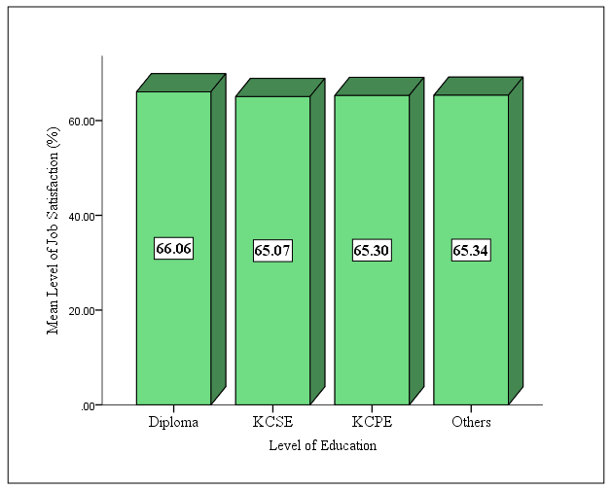

The study established that personnel with different academic qualifications had different levels of job satisfaction. To assess if the differences were significant, ANOVA test was use, with Tukey HSD post-test for multiple comparisons. The study established that on average, there was no statistically significant differences on level of job satisfaction across personnel of various levels of education. These findings were presented in the table below.



**Job Satisfaction and Number of Years Worked in the School**

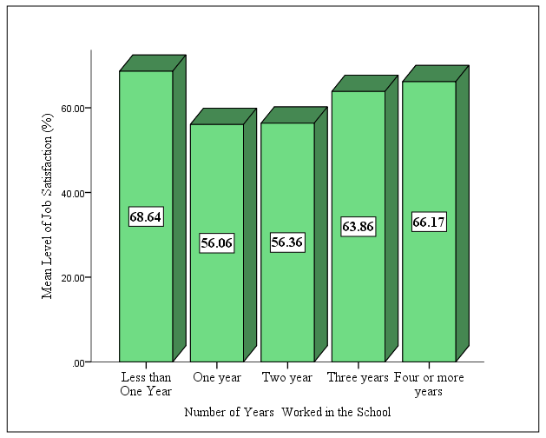

This study found that on average, personnel who had worked for less than a year in the school had the highest level of job satisfaction (68.64%) followed by those who had worked for four or more years with 66.17%. To assess if the differences in job satisfaction across work experience bands was significant, ANOVA test was adopted with Tukey HSD post-hoc for multiple comparisons.



The study established that on average, personnel with less than one year experience had significantly higher level of job satisfaction compared to those with two years. Similarly, personnel with four or more years had significantly higher level of job satisfaction compared to those with two years. These findings were presented in the table above.

**Job Satisfaction and School Category**

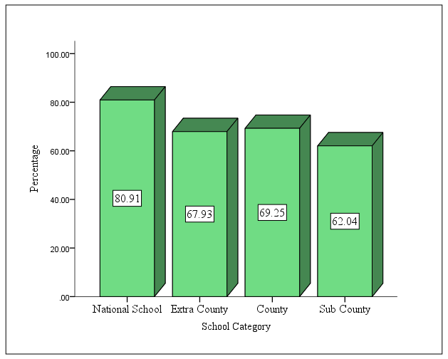

This study established that on average, personnel in national school were more satisfied with their job compared to their counterpart in other school categories. To assess whether level of satisfaction varied across the various school categories, ANOVA test with Tukey HSD post-hoc test for multiple comparisons was adopted. The test revealed that on average, personnel from national schools had significantly higher level of job satisfaction compared to personnel from sub county schools. Personnel from also both county and extra county schools had significantly higher level of job satisfaction compared to personnel from sub county schools. However, there was no significant difference on the level of job satisfaction among the personnel from national, county and extra county schools. These findings were presented in the table below.



**Job Satisfaction and Workload**

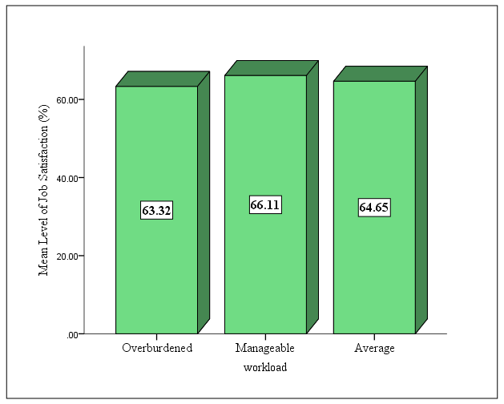

The study found that on average, personnel who had manageable workload were more satisfied with their job as compared to those who were overburdened or average. To test whether the differences on level of satisfaction varied significantly across the different workload categories, ANOVA test was adopted with Tukey HSD post-hoc test for multiple comparisons. The study established that inasmuch as those who had manageable workload had higher level of job satisfaction, the differences were not significant. These findings were presented in table below.

*Level of Job Satisfaction (%): Tukey HSD*

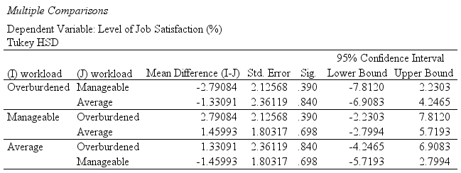

**CONCLUSIONS**

From the discussions above, it is clear that there is a strong need to understand the demographic factors that contribute towards job satisfaction among school security personnel. School boards of management should therefore create a favourable working environment that is in line with their expectations. The following conclusions can be drawn from the study.

1. There was a small and significant negative association of job satisfaction with school regions. School regions influence job satisfaction of security personnel.
2. There were school categories significantly associated with low job satisfaction. School category influence job satisfaction of security personnel.
3. Gender, level of education, number of years worked in the school and workload however were found to have a small insignificant association with level of job satisfaction. Hence gender, level of education, number of years worked in the school and workload does not influence job satisfaction of security personnel.
4. There were age categories significantly associated with low job satisfaction. Therefore age influence job satisfaction of security personnel in schools.

**RECOMENDATIONS**

Based on the findings of the study, the following recommendations were made with the view of enhancing the job satisfaction of security personnel in public secondary schools in Baringo County, Kenya.

1. Although the conclusion that gender, level of education, number of years worked in the school and workload were found to have a small insignificant association with level of job satisfaction among the security personnel, it was noted that majority of security personnel in schools were male. It therefore makes it difficult for them to frisk female visitors as well as female students’ bags. The researcher recommends that all schools recruit female security personnel. It will also assist management in decision making and compliance to important aspects of human resource management for example the two thirds gender rule, as per the Kenya’s employment Act.
2. The study established that there were school categories significantly associated with low job satisfaction. All secondary schools should be given equitable resources in order to cater the needs of all non- teaching staff. This can be done through providing a uniform scheme of service.
3. The study also established that age categories were significantly associated with low job satisfaction. From the respondents, it is evident that schools attract old and retired security workforce who may not have other options for employment. Old security personnel lack the intelligence and may be incapacitated when assessing security situations. The researcher recommends that schools recruit security personnel who are young considering the unique nature of security work.

**References**

Amarasena, T. S. M., Ajward, A. R., & Haque, A. A. K. M (2015). The effects of demographic factors on job satisfaction of university faculty members in Sri Lanka. *International*

*Journal of Academic Research and Reflection,* 3(4), 89-108.

Anyango (2015. Effects of Employee Voice and Characteristics on Job Satisfaction of Security Guards In Western Kenya. Doctoral Thesis. Maseno Univevrsity

Chepkemoi, M., Yitambe, A.,and Makunyi, E. G. (2019) Influence of Individual Factors on

Nurses’ Job Satisfaction in Selected Public Hospitals in Kericho County, Kenya. *The International Journal of Engineering and Science*, 8 (10) 31-40..

Chisaka, M. Z., & Gichinga, L. (2018). Job Satisfaction Factors Influencing Teachers

Performance In Public Primary Schools: A Case Study Of Mombasa County, *The Strategic Journal of Business & Change Management.* 5 (4) 1467 - 1486

Coaston-Shelton, A. (2009). *Identifying the Correlates of Job Satisfaction for School Resource Officers* (Doctoral dissertation). University of Cincinnati.

Eyupoglu, S. Z., & Saner, T. (2009a). Job satisfaction: Does rank make a difference? *African*

*Journal of Business Management,* 3(10), 609- 615.

Wanjiku, J. K. (2011). Factors that influence job satisfaction in Kenya commercial bank.

Masters Thesis. University of Nairobi.

Lytle, S. K. (2014). *Job Satisfaction: Officers Policing Aboriginal Communities in Canada* (Master’s Dissertation). University of Regina, Regina, Saskatchewan.

Jaarsveld, L. V. (2011). *An Investigation of Safety and Security Measures at Secondary Schools in Tshwane, South Africa* (Master’s Thesis).University of South Africa.

Karacan (2011) Karacan, E. (2011) Job satisfaction of private security guards. *Kocaeli Üniversitesi Sosyal Bilimler Enstituüsuü Dergisi,* *22*(2), 203-239.

Kipkebut, D. J. (2010). Organizational commitment and Job satisfaction in higher educational

institutions: the Kenyan case. Unpublished Ph D thesis; Middlesex University: London.

Nalla, M. K., & Cobbina, J. (2017). Environmental factors and job satisfaction: The case of

private security guards. *Security Journal*, 1-12.

Opondo, A. A., & Ajowi, J. O. (2015). Influence of the Working Conditions of the Support Staff on their Work Performance in Secondary Schools in Rarieda Sub-County, Kenya. *Academic Journal of Interdisciplinary Studies, 4*(1), 228-246.

Saliu, A. Y., Gbadeyan, R. A., & Olujide, J. O. (2015). Organizational Commitment and Job

Satisfaction of Security Operatives in Selected Tertiary Institutions in Kwara State. *Asia Pacific Journal of Multidisciplinary Research*, *3*(4), 43-49.

Syed, Z., & Jama, W. (2012). Universalistic perspective of HRM and organizational performance: meta-analytical study. *International Bulletin of Business Administration*, *13,* 47-57.

Scott,M., Swortzel, K.A. and Taylor, W. N. (2005). The Relationships Between Selected

Demographic Factors And The Level Of Job Satisfaction Of Extension Agents. Journal of Agricultural Education. 46 (3) 1-11.

Sababu, B. M. (2010). *Human resources and labour relations*. Nairobi, Kenya: Prints

Arts.

Safura, M., Ayisha, A.A. and Tetteh, R, (2017). An Empirical study of the Role of

Demographics in Job Satisfaction of Sunyani Technical University staff, *Munich Personal RePEc Archive* pp 1-11

Jex, S. M. (2002). *Organizational psychology: A scientist-practitioner approach*. New

York, NY: John Wiley & Sons, Inc.

Dionco-Adetayo, E. (2011). *Guide to business research and thesis writing* (2nd ed.). Ibadan: Rasmed Publications.