CLIMATE CHANGE RELATED DISASTERS IN ARID AND SEMI-ARID LANDS. A CASE OF BARINGO COUNTY, KENYA
Dr.Ednah Chemutai Koskei
Kabarak University, P.O. Box Private Bag, Kabarak, 20157, Kenya
Tel: +254 0720 102 901, Email: ekoskei@kabarak.ac.ke
Abstract. The main objective of this study was to identify Climate Change Related Disasters (CCRDs) in Arid and Semi-arid Lands such as Baringo County. The study used a descriptive survey design. Purposeful sampling and stratified proportionate random sampling procedures were used to obtain the Sample. A sample of 376 households were selected for the study in Baringo County. Questionnaire, key informant interview schedule and observations were the main instruments of data collection. Analysis of data was done using the SPSS. Percentages were used to analyze CCRDs. Drought, storms and floods are climate change related disasters affecting Baringo County. About 80 percent of the households strongly agreed that drought is the most common disasters affecting the County. Vegetation clearance is the main cause of CCRDs in Baringo County hence there is need to increase awareness on climate change and encourage people to use alternative sources of energy and plant trees.
Keywords: Climate Change Related Disasters, Arid and Semi-arid Lands, Baringo County
INTRODUCTION
Extreme climate related disasters including floods, storms, droughts, and heat waves have been on the rise worldwide. The number of people affected by natural disasters has also been increasing (ADB, 2015). According to IPCC report (IPCC, 2008), climate change over the next century will affect rainfall patterns, river flows and sea levels all over the world. For many parts of the arid regions there is an expected precipitation decrease over the next century of 20% or more. The occurrence of climate extremes is likely to increase in the future. This is especially true in the Greater Horn of Africa although the impacts of climate change are not precisely foreseeable, especially at the local level (UNECA, 2011). The highest number of people affected by floods was reported in the African Horn in 2011 (Clark, 2003) and they are one of the most threatening disasters affecting vulnerable populations in Kenya. Droughts are the most common disasters affecting Kenya. The majority of the major shortfalls in food supply recorded have been associated with rainfall deficits. The recurrence and intensity of droughts has increased in Kenya, particularly affecting the Arid and Semi-Arid Lands (ASALs), which now experience droughts almost on an annual basis. The country often has food deficits as a result of periodic droughts and low access to production resources (UNDP, 2020).
Kenya is already counted as one of the most disaster-prone countries in the world, ranking 6th among all countries in terms of population affected by natural disasters and first among East African countries (Guha-Sapir, Hoyois & Below, 2013). Droughts are the most common disasters affecting Kenya (UNDP, 2006). Major droughts currently occur every ten years, and moderate droughts or floods every three to four years, with devastating results (NCEA, 2015). The recurrence and intensity of droughts has increased in Kenya, particularly affecting the Arid and Semi-Arid Lands (ASALs), which now experience droughts almost on an annual basis (UNDP, 2016). In Kenya, droughts have affected more people and have had the greatest economic impact (8% of GDP every five years) (NCEA, 2015). As many as 28 droughts have been recorded in the past 100 years, at an increasing frequency (Huho, Mashara and Musyimi, 2016). Droughts are often nationwide, but normally have the most severe effects in ASALs. While droughts affect most people, floods have caused the greatest losses of human lives (NCEA, 2015). ASALs periodically experience flash floods. Since 1950 six serious floods occurred in the country, on average resulting in a loss of 5.5% of GDP every seven years. Of particular concern is the glacial melt at Mount Kenya. The mountain had 18 glaciers in 1900, but in 2008 only seven of them still existed (Parry et al., 2012).
According to the Intergovernmental Panel on Climate Change, Kenya will suffer more intense and frequent droughts in the 21st Century. Flash floods are periodically experienced in Arid and Semi-Arid Lands (ASALs). Kenya is highly vulnerable to climate change because it is a predominantly dry country. Kenya’s most vulnerable areas to climate change are the ASALs in the north and east. Baringo County in North Kenya is predominantly ASALs. In these areas, the population is poor and access to infrastructure and markets is low (NCEA, 2015). Increase in frequency of droughts will present major challenges for food security and water availability in these areas in spite of the country acting early to adapt to climate change by implementing the Kenya Arid Lands and Resource Management Project (ALRMP). In addition, the government has realized the need to incorporate climate change issues. A new project is being undertaken – Kenya Adaptation to Climate Change in Arid Lands (KACCAL) (World Bank, 2007b). However, the country still faces considerable challenges in reaching the water and sanitation Millennium Development Goals (USAID, 2006).
Kenya has very diverse topographic features that give rise to varying microclimatic conditions. For one, it sits directly astride the Equator, running from 5°S to 5.5°N extending from longitude 34°E to 42°E. In addition, it rises steadily from coastal region of Indian Ocean to altitudes of over 5000m in interior to form the highlands in the East and West separated by the Great Rift Valley. Finally, to the West, Lake Victoria has been shown to have a hydro meteorological influence (Nyeko-Ogiramoi et al. 2013). A full country assessment of Kenya by DARA (2012) shows high vulnerability to drought and moderate vulnerability to flood. These levels indicate that Kenya is most vulnerable to drought and flood out of all the environmental disasters on the profile. Floods in particular are a very important concern in Kenya as DARA (2012) predicts that by 2030, Kenya will have 5 million ($USD PPP) and 10 million ($USD PPP) as additional economic costs related to drought and flood respectively. Data available on floods show that 5 000 additional people will die and 50000 additional people will be affected nationally (DARA, 2012). Floods are becoming more common in Kenya (RoK, 2007) and their resulting fatalities make up 60% of victims from disasters in Kenya (UNEP, 2009). Persistent flooding is common in river valleys, lakeshores and coastal strips and flood related disaster have been recorded in many parts of the Kenya, including in Tana Delta, Nyando, Ahero,Narok, along with other areas distributed unevenly across 5 major flood basins .The Rif Valley region, specifically Baringo lowland has been identified as the most flash flood prone area since 2013 (Omondi et al, 2017).

Baringo County, like the rest of the ASAL areas in Kenya, is characterized by low and erratic rainfall, low fertility, fragile soils with low nutrient content, low organic matter content and poor
physical properties for water infiltration and storage (Muchena & van der Pouw, 1981). In 1970,
there were seven perennial rivers in Lake Baringo catchment (Jenny and Svensson, 2002). Today
only two of them remain with significantly reduced water discharges during dry seasons. The rest of the rivers have become ephemeral like the other watercourses in the area (Odada, Onyando & Obudho, 2006). Water currently in use in Baringo is few rivers, traditional river, wells, boreholes, lake and springs (RoK, 2006). During rainy periods, schools, properties and livelihoods are submerged. The livelihoods are exposed to the dangers of water-related diseases and the challenges of wild aquatic animals such as hippopotamuses and crocodiles invading villages (Deichsel, 2019). This study therefore sought to establish the Climate Change Related Disasters in order to provide them with relevant and appropriate information that can inform their adaptation appropriately and reduce vulnerability to climate change.

Study Area
Study Area Baringo County (Figure 1) is located within the Rift Valley of Kenya, between longitudes 35030’ and 36030’ East and between latitudes 0010’ South and 1040’ North. The County covers an area of 11,090 Km2 with a population of 555,561 persons in 110,649 households. The Agro-ecological zones in the county are: UH 1, UH 2, LH 2, LH 3, UM 3, UM 4, UM 5, LM 4, LM 5, LM 6 and IL 6. Temperatures range from a minimum of 10 0C to a maximum of 35.0 0C with bimodal rainfall pattern of long rains of MAM and short rains of OND which range from 300 to 700 mm in the lowlands and 1200 mm in the highlands (Jaetzold et al., 2011; RoK, 2010; RoK, 2013). Despite the diversity of agro-ecological zones and livelihood support system, Baringo County is classified as arid and semi-arid land and study site was limited to AEZs LH2, LM5 and IL6. The three agro-ecological zones were purposely chosen as the study targeted extreme climates only and ensure proper representation of the respondents within the whole Baringo County area coverage.
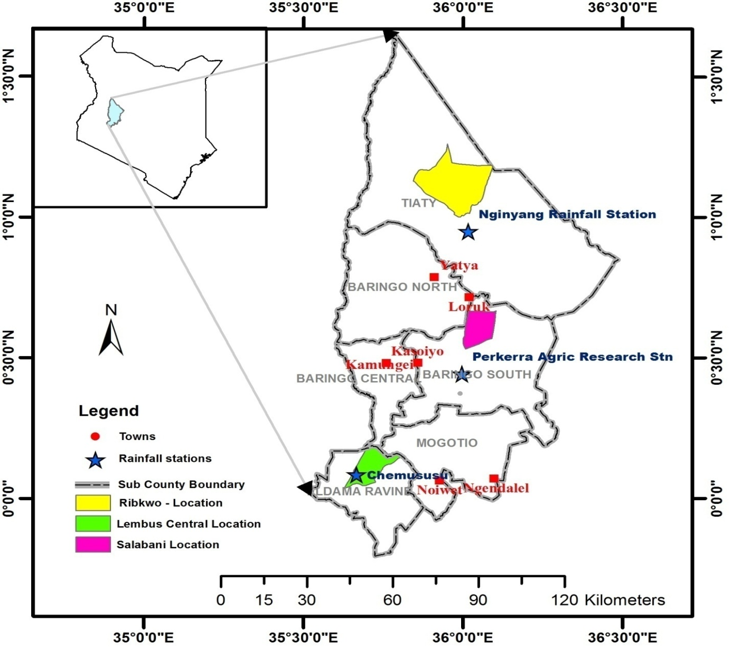
Figure 1: Location of the study area (Baringo County)
METHODOLOGY
The study used purposeful sampling and stratified proportionate random sampling procedures to obtain the sample. Within Baringo County, the locations were stratified according to the agro-ecological zones. These are LM 5 (lower Midland), LH 2 (Lower Highland) and IL 6 (Inner Lowland). Lembus Central, Salabani and Ribkwo locations was purposefully selected for the study. They were selected because of having Agro-ecological zones LH2, LM5 and IL6 respectively to ensure that the researcher picks extreme climates only and ensure proper representation of the respondents within the whole Baringo County area coverage. Lastly, random selection of the respondents within locations was made proportionate to the population of each location as per the household census report of 2009 (KNBS, 2010). The study targeted 376 households which constituted 7.9 % of the total number of households in the three agro ecological zones. The selection of respondents was informed by household population by location level. This information was acquired from the County Development Officer at Kabarnet, the County headquarters. Lembus Central location has a population of 2,668 households, while Salabani has a population of 963 households and Ribkwo 1128 households. These were the three strata where proportional representation was obtained. 211 households in Lembus Central, 76 in Salabani and 89 in Ribkwo location was selected. A total of 376 respondents were selected for the study. Their participation during the interviews was, however, based on random sampling.
Purposive sampling was used to select key informants to be interviewed. These were selected from among meteorologists, NGO officers, chiefs, NDMA officers and water officers based on their positions of authority. These key informants were selected for the interview in consideration that they have insights on the subject of climate and water use of RWHT by the households in the County. The study used both primary and secondary data. Primary data were obtained from households and key informants through personal interviews by use of structured questionnaire and Key Informant Interview Schedule. Secondary data was obtained from past aerial photographs. The study focused mainly on household heads for interviewing to ensure uniformity of data collection process. The questionnaire was used to collect data from households on causes and effects of rainfall variability in Baringo County. The questionnaire was administered to all the 376 households in the study area. Key Informant Interview Schedule was used to collect in-depth data on rainfall variability. Observation was used to supplement and enrich data collected via the interview. Additionally, photographs in the study area were taken by researcher. The photographs have helped to illustrate the effects of rainfall variability. The use of photographs augmented findings from other data collection procedures.
RESULTS AND DISCUSSION
From the results, floods, drought and storms are the common Climate Change Related Disasters (CCRDs) in Baringo County.
Figure 2: Climate Change Related Disasters in Baringo County
Majority of the households (68%) strongly agreed (SA) that drought is one the common disasters in Baringo County.20% agreed (A) and only 12% disagreed (D). The results implied that drought is the most common disaster affecting Baringo County. The area experiences frequent droughts, and drought related losses like any other county situated in the northern regions of Kenya. According to Kaposi & Ndegwa (2014), Baringo is prone to perennial droughts with the majority of its population affected by the recurrent droughts and high poverty levels. The population is experiencing varying levels of vulnerability based on their vulnerability to drought hazard. The drought events are likely related to shifts in warmer sea surface temperatures. Dai (2011) registered the 1970s and 1980s droughts in Western Africa – Sahel and attributed it to southward shift of the warmer sea surface temperatures in the Atlantic and warming in the Indian Ocean. The study further established that agro ecological zones LM5 and IL6 were more prone to droughts than LH2. Temperatures in Baringo lowlands are above 32°C, and the average rainfall of 600mm (RoK, 2013). A study conducted by Ochieng in Baringo showed drier conditions over long time scale in IL6 implying vulnerability of the region to the drought. LM5 was also vulnerable to drought events (Ochieng, 2019). All the key informants interviewed including chiefs, water officers, NGO’s (ACTED) and NDMA officers agreed that rainfall is changing and is no longer as it was years back and that there are shorter rainy seasons.
About 53% of the households strongly agreed that is among natural disasters in Baringo County. The study further established that most of those affected are from lowland (IL6).A view that was also most supported by the key informants. Baringo lowland where Lake Baringo is located has since been identified as the most flash flood prone area in the Rift Valley since 2013 (Omondi et al., 2017). Approximately 2000 households were affected by the heavy rains that lead to an increase of the water level in Lake Baringo. Homesteads and schools were equally affected (Deichsel, 2019) . When the rivers (Molo and Perkerra) that supply Lake Baringo approach lowland, the beds come up due to increased siltation from eroded farms. This makes the water beds rise to the surface of the ground and when it rains the river banks burst; making the flash floods to occur (Deichsel, 2019). Home flash flooding was the most common flood in the area and this occurred during the rainy period. Home flash flooding occurs when runoff water flows directly into someone’s house and cause flash flooding. The researcher observed that lowlands had a flat topography. Nyakundi et al (2010) noted that in flat plains, the gentle slope reduces the velocity of flow leading to the formation of meanders and flood plains. Water in such areas is not transported rapidly and tends to pile up making the low-lying zones more liable to flooding
About 50% of the households strongly agreed that storms are among the climate change related disasters wreaking havoc in Baringo County. The study established that dust storm is the type of storm that occurred in Baringo. Strong dust winds of more than 20m/s hit parts of Kenya and Tanzania from October 1st 2019. Some of this dust storms are feared to have originated from the semi-arid and arid (ASALs) of Kenya (Climate Change Kenya, 2019). According to WMO (2019), dust storm is a meteorological phenomenon occurring in arid and semi-arid regions. It is an essential element of the Earth’s natural processes, but is also caused in part by human-induced drivers like unsustainable land management and water use, and indirectly also by climate change. Dust storms occur when unchecked, strong or turbulent winds combine with exposed loose soil dry surfaces. These conditions are common in semi-arid and arid regions (Shepherd & Gemma, 2016). Dust storms badly affect the state of the environment, health, agriculture, socioeconomic well-being, and livelihood of large populations on Earth, particularly those living on and around a dry belt (WMO, 2019). Storms have become of increasing concern among governments and the international community because of their damaging effects on various sectors of the economy.

CONCLUSION AND RECOMMENDATION.
From the findings presented, the researcher concluded that drought, floods and storms are the climate change related disasters affecting Baringo County and drought is the most common one. Lowlands (IL6) are more prone to disasters than other agro ecological zones. Early warning and monitoring of floods and drought can help to reduce vulnerability. Afforestation and reforestation programs need to be started in this arid and semi-arid land so as to stop the spread of desert and its ripple effects such as dust storms in future

REFERENCES

Asian Development Bank (ADB), 2015. Global Increase in Climate-Related Disasters. ADB Economics working Paper Series

Clark, C. O., Webster, P. J., & Cole, J. E. (2003). Interdecadal Variability of the Relationship between the Indian Ocean Zonal Mode and East African Coastal Rainfall Anomalies. .Journal of Climate.16, 548-554.

Climate change Kenya (2019). Sand Storms Hit Kenya & Tanzania – Is This the Effect of Climate Change? Available at https://climatechangekenya.org/sand-storms-hit-kenya-tanzania-is-this-the-effect-of-climate-change/

Dai, A. (2011). Drought under Global Warming: A Review, Wiley Interdisciplinary Reviews. Climate Change, 2(1), 45-65.

DARA (2012). Climate vulnerability monitor, (2nd Edition): A guide to the cold calculus of ahot planet.
Deichsel, K. (2019a). “Our Lake Is Our Farm”: Local Knowledge of Tugen Fishermen on Environmental Changes of Lake Baringo, Kenya.
Deichsel, K. (2019b). “Our Lake Is Our Farm”: Local Knowledge of Tugen Fishermen on Environmental Changes of Lake Baringo, Kenya.

Guha-Sapir, D., Hoyois, P., & Below, R. (2013). Annual Disaster Statistical Review 2012: The Numbers and Trends. Centre for Research on the Epidemiology of Disasters (CRED). Retrieved from http://reliefweb.int/sites/reliefweb.int/files/resources/ADSR_2012.pdf

Huho, J., Mashara, J and Musyimi, P. (2016). Profiling disasters in Kenya and their causes.Academic Research International, 7(1) pp 290-305.

IPCC (2008). Climate Change and Water, Intergovernmental Panel on Climate Change Technical Report IV. June 2008.

Jaetzold, R., Schmidt, H., Hornetz, B. & Shisanya, C. (2011). Farm Management Handbook of Kenya: Part C, East Kenya, Vol. II. Nairobi: Ministry of Agriculture

Jenny, J., & Svensson, J., (2002). Land Degradation in the Semi-Arid Catchment of Lake Baringo, Kenya. A Minor Field Study of Physical Causes With a Socioeconomic Aspect. Sweden: Göteborg University. Retrieved from http://www.bioenv.gu.se/digitalAssets/1347/1347907_b343.pdf

Kaposi J.K & Ndegwa M.C (2014). Livelihood Vulnerability Assessment in Context of Drought Hazard: A Case Study of Baringo County, Kenya. International Journal of Science and Research (IJSR).Vol 3. Iss 3.Pp 2319-7064

KNBS (Kenya National Bureau of Statistics). (2010). Kenya Demographic and Health Survey 2008-09. Calverton, Maryland: KNBS and ICF Macro

NCEA (Netherlands Commission for Environmental Assessment) (2015).Climate change Profile Kenya.Retrievedfrom http://api.commissiemer.nl/docs/os/i71/i7152/climate_change_profile_kenya.pdf
Nyakundi, H., Mwanzo, I., & Yitambe, A. (2010). Community perceptions and response to flood risks in Nyando District, Western Kenya. Jàmbá: Journal of Disaster Risk Studies, 3(1), 346–366.
Nyeko-Ogiramoi P, Willems P, Ngirane-Katashaya G (2013) Trend and variability in observed
hydrometeorological extremes in the Lake Victoria Basin, J Hydrol. 489: 56-73.
doi:10.1016/j.jhydrol.2013.02.03

Ochieng. R. (2019). Analysis of Drought Trends and Severity Using Standard Anomalies: Case of Baringo County, Kenya. AER Journal Volume 3, Issue 2, pp. 166-178.
Odada, E.O., Onyando, J.O., & Obudho, A. P. (2006). Lake Baringo: Addressing Threatened Biodiversity and Livelihoods. Lakes and Reservoirs. Journal of Research and Management,11(4),287-299.Retrievedfrom http://www.worldlakes.org/uploads/03_Lake_Baringo_27February2006.pdf
Omondi, C. J., Onguru, D., Kamau, L., Nanyingi, M., Ong’amo, G., & Estambale, B. (2017). Perennial transmission of malaria in the low altitude areas of Baringo County, Kenya. Malaria Journal, 16(1), 257.

Muchena, F. N. & Van der Pouw, B. J. A. (1981). The Soil Resource of the Arid and Semi Arid Areas of Kenya. Paper presented in International Workshop on Strategies for Developing the Resources of the Arid and Semiarid Areas of Kenya (4-8August 1981). Kenya: Nairobi.

Parry, J., Echeverria, D., Dekens, J and Maitima, J. (2012). Climate risk, vulnerability andgovernance in Kenya: A review. United Nations development Programme.

ROK (Republic of Kenya). (2010). Kenya National Bureau of Statistics: 2009 Kenya Population and Housing Census, Volume 1A. Nairobi: Government Printers

RoK (Republic of Kenya). (2013). First County Integrated Development Plan 2013-2017 – County of Baringo. Nairobi: Government Printers.

ROK (Republic of Kenya). (2007). Ministry of Water and Irrigation. The Water Act (No. 8 of 2002). The National Water Services Strategy (NWSS) 2007 – 2015. Retrieved from http://www1.chr.up.ac.za/chr_old/indigenous/documents/Kenya/Legislation/The%20Wat er%20Act%202002.pdf

Republic of Kenya. (2006). Kenya Drought Monitoring Bulletin - Baringo District.Retrievedfromhttp://reliefweb.int/report/kenya/kenya-drought-monitoringbulletin-baringo-district

Shepherd & Gemma, (2016). Global assessment of sand and dust storms. Available at https://www.preventionweb.net/publications/view/60415

UNDP (2020) Adaptation to Climate Change in Arid and Semi-Arid Lands (KACCAL).https://www.ke.undp.org/content/kenya/en/home/operations/projects/environment_and_energy/Adaptation_to_Climate_Change.html

United Nations Development Programme (UNDP, 2006) The Kenya Natural disaster profile. Enhanced Security unit, Nairobi, Kenya.

UNECA (2011) Vulnerability and climate change hotspots in Africa – mapping based on existing knowledge. African Climate Policy Centre (ACPC) working paper 2
UNEP (2009), “Kenya: Atlas of Our Changing Environment.” Division of Early Warning and
Assessment (DEWA), United Nations Environment Programme (UNEP) P.O. Box 30552
Nairobi 00100, Kenya

USAID (United States Agency for International Development). (2006). Mara River Basin Kenya/Tanzania. Kenya: United States Agency for International Development. Retrieved from htt://glows.fiu.edu/glows/Projects/MaraRiverBasinKenyaTanzania/tabid/77/Default.aspx.

WMO (World Meteorological Organization) (2019).Sand and dust storms. Available at. https://public.wmo.int/en/media/news/wmo-acts-sand-and-dust-storms

World Bank. (2007b). Project Information Document (PID) – Kenya Adaptation to Climate Change in Arid Lands Project. Washington DC: The World Bank.

