# Implementation of a Scalable Long-Range Wireless Based Model for Water Loss Monitoring.

Stephen KIPKORO1, Kirori MINDO2, Nelson MASESE1

1Kabarak University, P.O. Box Private Bag, Kabarak, 20157, Kenya

Tel: +254 0721627636, skipkoro@ kabarak.ac.ke, +254 0737070029 nmasese@kabarak.ac.ke

2Laikipia University, P.O. Box 1100 – 20300, Nyahururu, Kenya

Tel: + 254 721 864 816, kirori@laikipia.ac.ke

**Abstract**: Water companies experience challenges in detecting water loss and undertaking reliable and efficient water audit. Consequently, mitigation of these incidences of water loss, as well as auditing of water distribution is difficult, largely uncoordinated and inherently cumbersome. A Long-Range (LoRa) based technology prototype is designed and implemented to enable detection of water loss and audits to be performed remotely and affordably. This study enabled the design and development of a long-range Wireless Sensor Network (WSN) model based on IEEE 802.15.4g LoRa standard. This study reviewed the technological challenges, architectural and logical design for the implementation of a scalable long-range model to detect losses in real time. The study used the PPDIOO methodology towards achieving and implementing network design lifestyle. The designs prototypes were set-up in a testbed, monitored, reconfigured and adjusted for efficiency and applicability. The study contributed to the body of knowledge in design of applicable water systems architectures.

**Keywords:** LoRa, PPDIOO, Water Loss.

# 1. Introduction

1. Water companies and other the water service providers continue to run at a loss as they can only manage operation and maintenance cost. The challenges of tenants tampering with supply system and meters, while corrupt agents get compromised is a challenge facing most water utilities (Water Service Trust Fund Report, 2013). The use of technology-based systems to relay information to the central office at real time will reduce incidences of corruption and poor water loss control (Creaco E, 2019).There is also the authorized un-metered consumption of water, used in flushing water mains and in utilities like firefighting (AL-Washali, Sharma, Kennedy, AL-Nozaily, & Hadera, 2019).
   * 1. Water companies and other the water service providers continue to run at a loss as they can only manage operation and maintenance cost. The challenges of tenants tampering with supply system and meters, while corrupt agents get compromised is a challenge facing most water utilities (Water Service Trust Fund Report, 2013). The use of technology-based systems to relay information to the central office at real time will reduce incidences of corruption and poor water loss control (Creaco E, 2019).
2. The American Water Works Association according to their report (2012), water loss occurs in three categories; The Real loss occur if the source of water is not metered, broken line is not repaired and if overflows not prevented. Apparent loss occur in utility operation such as customer meter inaccuracies, billing system data errors, and unauthorized consumption and authorized un-metered consumption challenges and also corroborated by Water Service Trust Fund Report, (2013) Accounted for Water used not properly accounted thus increasing cost of operation hence distorting customer satisfaction patterns. There is also the authorized un-metered consumption of water, used in flushing water mains and in utilities like firefighting (Al-Washali, Sharma, Keneedy, AL-Nozaily, & Haidera, 2019).
3. Piped water connections to premises still the most affordable and safe system of water provision there is need to strengthen service providers to ensure loss are controlled for affordable and quality water provision. Arising from these scenarios there is need for effective technological strategies in water telemetry, most appropriately through a wireless radio system for data transmission within area of jurisdiction to detect measure, reduce or minimize leaks consistently for the growth of water service companies (Darsana P., 2018)

LoRa (Long Range), technology is a digital wireless data communication IoT technology developed by Cycleo of Grenoble, France which enable a very-long-range transmissions (more than 10 km in rural areas) with low power consumption (Semtech, 2012). LoRa being an IoT network deployment is capable to monitor and locate water leaks using low-cost sensors in water distribution systems where Wireless Sensor Network work will collect data in real time (Rabeek, Beibei.H., & Chai.K.T., 2019).

There is need to change the scattered structure and functioning of water loss arising from broken pipes, illegal connection and water theft cases(J.Fikejz, 2018).The current water supply network strategies are costly, inaccurate, time-consuming way of detecting loss(A.Boudhaouia, 2019). Hydrosense is low–cost approaches which provide information on water flow using pressure waves propagated to sensors when valves are open or closed using Bluetooth technology (Lambert.A.O., 2019).

While there are wide range of technologies in remote telemetry; this can improve water balance and water loss control. The LoRa architecture has gateways and nodes which connect thousands of devices with sensors to detect loss for longer distance. The need to have a common smart meter for standard information- sharing remotely using LoRa technology is the best pet despite of many other competing technologies (H.Zhang, 2018) LoRa being an IoT network deployment is capable to monitor and locate water leaks using low-cost sensors in water distribution systems where Wireless Sensor Network work will collect data in real time (Rabeek.S.M., Beibei.H., & Chai.K.T, 2019).

# 2. The Problem

1. The current approach employed by water companies in Kenya to detect water loss, whereby field officers physically check for leaking pipes or illegal connection, inefficient and inaccurate monitoring compromises water accountability. In some cases, field officers are also corrupted by water selling companies, thereby compounding the problem. The daily physical check of water loss is cumbersome in terms of operation cost and is time consuming. Siphoning of water along the main lines continues to be a major challenge to water companies. Identifying and reporting such water loss takes a long time to address both identification and reporting. The extent of such water loss has hindered the availability and accountability of water thus reducing the proceeds of water companies. The massive water loss has contributed to low growth of water companies which no longer supply the water effectively to customers due high operational cost. The customers being supplied with less water which is inadequate for their needs are subjected to seek for alternative water sources. The water suppliers are quite expensive and the water quality standards are also dubious. There is need to design and develop a technological solution that is scalable and cost-effective to solve this problem.

# 3. Objectives

# The main objective of this study was to implement a scalable long-range wireless based model for monitoring water loss so as to reduce inefficiency and inaccuracy. This objective also aided in monitoring, identification and reporting such water loss thus greatly reducing operational cost. As a result, ultimately the availability and accountability of water was improved thus helped in increasing the proceeds of water companies.

**Specific Objective**

To implement a scalable long-range wireless based model for monitoring water loss.

# 4. Literature Review

1. Non-Revenue Water (NRW) is mostly used in developing countries as it’s expressed in terms of system input volume. Although performance indicators (PI) are important it has its challenges which depends on supply time, average operating pressure and level of water consumption. In developed countries the Infrastructure loss Index (ILI) is used as technical performance indicator for real water loss (AL-Washali, Sharma, Kennedy, AL-Nozaily, & Hadera, 2019)
   1. Pressure monitoring is another way to address the water loss strategy. It considers the direct relationship between pressure and loss flow rate. Pressure monitoring involves use of Hydraulic models which are efficient tools to predict the spatial and temporal variations of water pressures in a distribution system. The water velocity, flow rate and pressure by the model can be predicted ((Adedeji, 2018).Other approaches of leak detection include searching leak physically i.e. listening to noise from rods/sticks and observing the temperature. The other technique includes acoustic, thermal, electromagnetic, chemical, use of geophones, Hydrophone, leak noise loggers and correlators and Electromagnetic Field Detection (Sewerrin.Stethophon, 2020).It has its own strengths and weaknesses and cost though smart technology need to be appreciated on monitoring of water loss (De-Araujo.P., Filho, & Rodrigues, 2019)
2. Leak detection algorithms is based on absolute pressure and flow measurements using DMA (District Metered Area) loggers or loggers with a high sampling frequency (>200 Hz) and transient-based leak detection algorithms (Li. W.Liu, 2021)
3. The algorithm permits the detection and estimation of critical segments or branches of the network on higher background loss outflow and network point of where pressure control may be performed (Adedeji, 2018).

# Conceptual Framework



**Smart Meter With LoRa**

**Module**

**Network Server receives**

**LoRa data Readings**

**Water Company**

**Software system receiving**

**,**

**analyzing and detects water loss**

**Network server**

**Receives LoRa data**

**Reading**

**Figure 1.** Conceptual Framework

# 5. Methodology

The research used PPDIOO methodology to design a long-range water distribution monitoring model which will create a wireless Sensor Network for water loss detection. PPDIOO defines the continuous life-cycle of services required for a network (Cisco, 2010) is more agile, risk driven, non-linear or iterative and flexible to add other components.

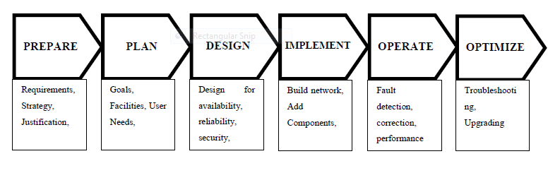

**Figure 2:** Prepare Plan, Design, Implement, Operate, and Optimize Network Design and Implementation methodology (Source: Cisco)

This research design framework thus augments the methodology chosen to undertake this study, which will be mixed types of methods approach, combining both the Proof of concept (POC)

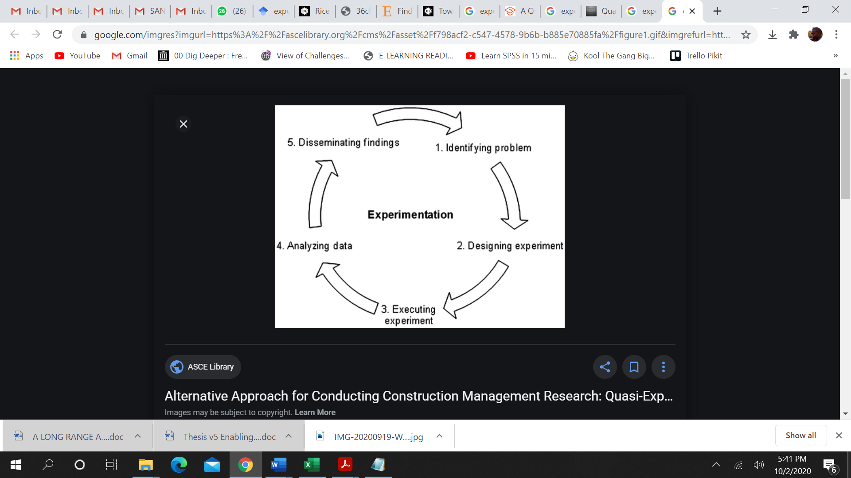

**Figure 3** : Steps in Experimental Research Design

The following set of equipment was used to implement the model. The figure 4 below shows the water flow meter that collects data integrated with a smart LoRa radio that propagates this data to an access point.

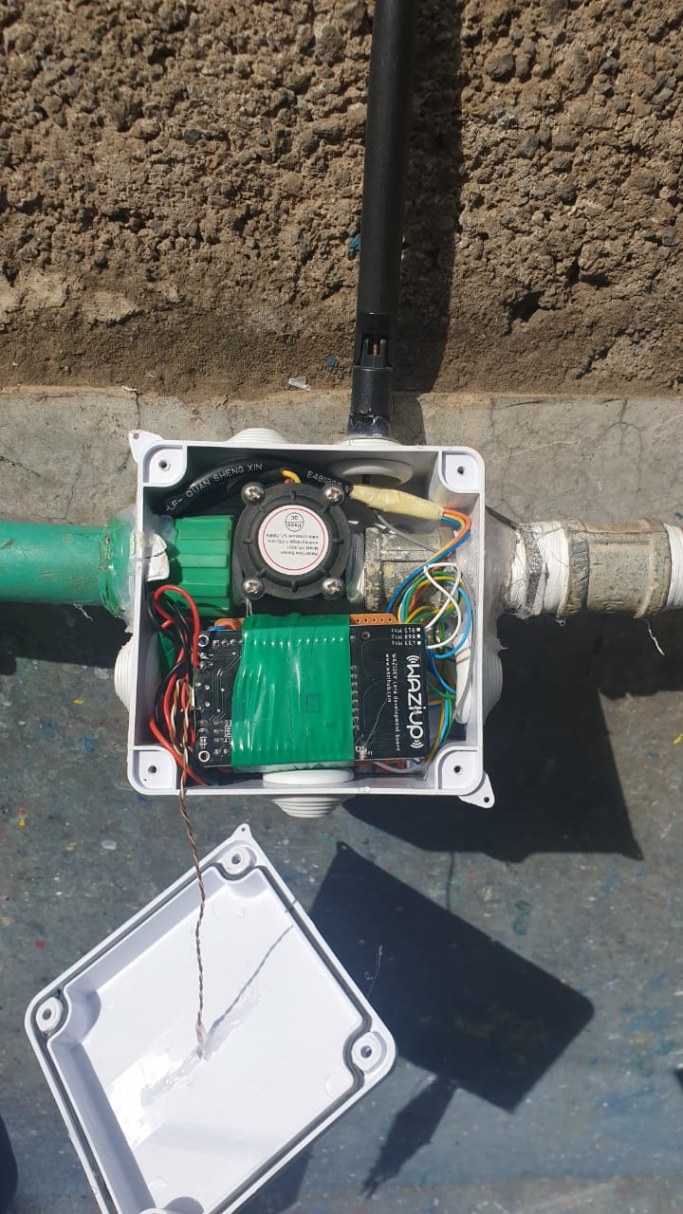

**Figure 4**: A smart flow data collector with LoRa radio

The figure 5, below shows the LoRa radio that receives data from the several LoRa devices for onwards forwarding to the cloud. This radio can support upto 1,000 nodes in its network.

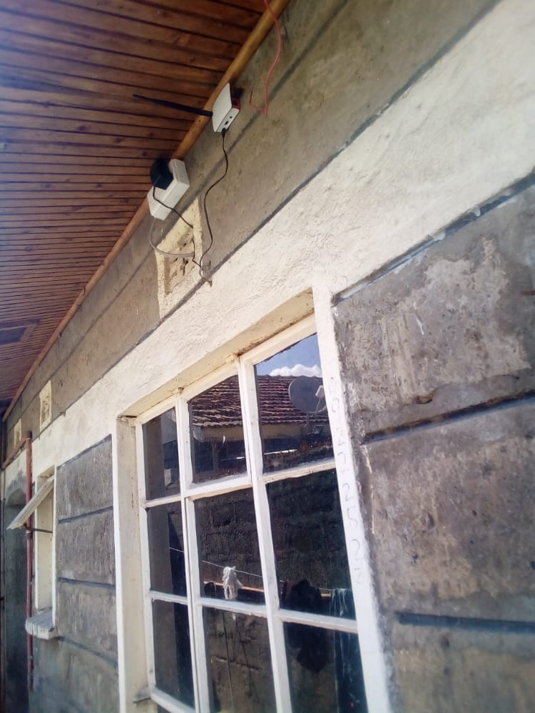

**Figure 5**: A LoRa radio that coordinates the nodes

# 6. Results

# The monitoring was retrieved online through logging into a web portal and the following devices would be accessed and data reviewed as shown in figure 6, below.

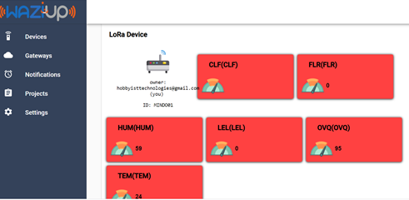

**Figure 6**: LoRa smart devices and calibrations.

The LoRa model successfully propagated data through the LoRa gateways in the network, and thus any rapid and sudden change in water flow and water pressure would be quickly noted and a second review done to ascertain if the change was consistent with normal water distribution. The Figure 7, below shows the various readings captured ubiquitously on the LoRa network.

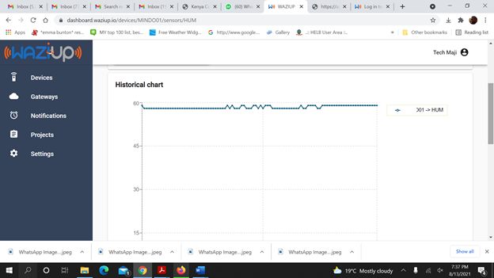

**Figure 7**: Humidity reading on the LoRa network.

The figure 8 below shows the temperature on the LoRa network that changed in accordance with the environmental disposition.

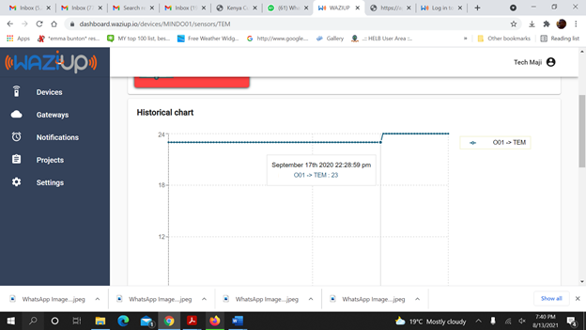

**Figure 8**: Temperature on the Water distribution architecture

Ultimately, the LoRa model proved the ability to remotely review and identify water loss accurately thus proving that there was no need for manual monitoring using employees or field officers. This model also greatly reduced the operation costs for water companies thus showing great potential in enhancing operations, increasing revenue and providing better services to the customers.

# 7. Recommendations and Areas for further study

Water companies should consider the adoption and implementation of LoRa technology in monitoring water distribution so as to identify various aspects of water management like billing, water loss, siphoning, aging infrastructure, accidental bursts and interferences in their water distribution.

There is a huge gap in the study of implementation of machine learning and artificial intelligence in the monitoring of water distribution. Artificial intelligence can play a big role in detecting and predicting patterns in the usage of water.

There is also need to further research in security of LoRa wireless sensor networks.

# 8. Conclusion

During the course of the study, we encountered challenges in accessing equipment used in LoRa networks, and thus had to innovate and improvise various aspects of the study. In some cases, peripherals were bought separately and amalgamated into one functional unit.

However, the study successfully implemented and satisfied the objective set out in the beginning. Thus, a scalable Long-Range wireless based model for water loss monitoring was successfully implemented.

**References**

1. AL-Washali, T.; Sharma, S.; Kennedy, M.; AL-Nozaily, F.; Haidera, M. Monitoring the Non-RevenueWater Performance in Intermittent Supplies. Water Resour. Manag 2019, in preparation.
2. Adedeji, K. B.Y. Hamam, B. T. Abe, and A. M. Abu-Mahfouz. 2018. “Pressure Monitoring Strategies for Water Loss Reduction in Large-Scale Water Piping Networks: A Review.” In Advances in Hydroinformatics, edited by P. Gourbesville, J. Cunge, and G. Caignaert, 465–480. Singapore: Springer.
3. Creaco E, Campisano A, Fontana N, Marini G, Page PR, Walski T (2019) Real time control of water distribution networks: a state-of-the-art review. Water Res 161:517–530
4. De Araujo, P.; Filho, R.; Rodrigues, J.; Oliveira, J.; Braga, S. Infrastrucure for Integration of Legacy Electrical Equipment into a Smart-Grid Using Wireless Sensor Networks. Sensors 2018, 18, 1312.
5. Li, W. , Liu, T. , Xiang, H. Leakage detection of water pipelines based on active thermometry and FBG based quasi-distributed fiber optic temperature sensing   
   (2021) Journal of Intelligent Material Systems and Structures
6. Rabeek, S.M.; Beibei, H.; Chai, K.T. Design of wireless iot sensor node platform for water pipeline leak detection. In Proceedings of the Asia-Pacific Microwave Conference Proceedings (APMC), Singapore, 10–13 December 2019; pp. 1328–1330
7. Sewerin. Stethophon 04—Compact Sound Detector for Water Leak Detection. Available online: https://www.sewerin.com/fileadmin/redakteure/Prospekte/pro_stethophon_04_en.pdf (accessed on 5 November 2020).