Design of an Integrated Model for Public Service Vehicles Overload Prevention Based on Micro-Controller.
James NDUNGU¹, Simon KARUME¹, Kirori MINDO²
¹Kabarak University, P.O. Box Private Bag, Kabarak, 20157, Kenya
Tel: +254 0722337962, jamesnjuguna@ kabarak.ac.ke, +254 0722499397 skarume@kabarak.ac.ke
²Laikipia University, P.O. Box 1100 – 20300, Nyahururu, Kenya
Tel: + 254 721 864 816, kirori@laikipia.ac.ke
Abstract: The load capacity of a PSV vehicle is normally determined by tare weight and not the available cargo space as stated in section 56 of the Traffic act Cap 403, Kenya. Unfortunately, law enforcers on Kenyan roads only check the number of passengers in a PSV vehicle. This can be misconstrued to deem the PSV vehicle as compliant, while in real sense the actual tare weight is above its capacity. There are numerous instances where PSV vehicles are overloaded, and this has a direct contribution to increased road carnage. This study examined the implementation of an integrated microcontroller-based technology to observe and monitor tare weight in the PSV industry and introduced solutions that might resolve the misconception of overloading, while enhancing safety within the industry. This study provides the design of an integrated model for prevention of PSV overloading using a smart microcontroller. The resulting design was tested using Arduino microcontroller environment for purposes of validating applicability and feasibility. The study uses a proof of concept (POC) methodology and contributes to the body of knowledge in automated and integrated micro-controller-based safety monitoring industry.
Keywords: PSV, Tare weight, Overloading, Micro-controller.

1. Introduction
Transport is a major sector of any nation's economy (Rodrigue, J-P et al., 2020). Worldwide, the transport sector is a major employer as stated by Rodrigue, J-P et al. (2020), that an efficient transport system provide economic and other benefits that result in positive multiplier effects such as better accessibility to markets, employment, and additional investments. The Kenyan transport sector has recently expanded due to heavy infrastructure investments by the government and international entities. According to Kenya National Bureau of Statistics (2019), the sector is the second highest contributor to the Gross Domestic Product (GDP) contributing about 8% after agriculture, forestry and fishing at 34.2%.
In spite of its importance in economic contribution, the transport systems can have serious economic costs when they are deficient in terms of capacity or reliability (Rodrigue, J-P et al., 2020). For instance, deficient transport system can result to economic costs such as reduced or missed opportunities and lower quality of life in case of accidents. According to the world health organization Global status report on road safety (2018), Road traffic injuries are a leading cause of death, killing nearly 1.35 million people annually. Approximately 90% of these deaths occur in low- and middle-income countries of which Kenya is included. As stated by Liu G. et al. (2018), there is need for comprehensive research in the causes of road accidents as they are a public health issue worldwide. Further Liu et al. (2018) observed that there is need to pay special attention to extremely serious road accidents (ESRAs). ESRAs are considered to be traffic accidents that causes more than 10 deaths, more than 50 serious injuries, or more than 7.9 million dollars of direct economic losses (Decree of the State Council No.493 China, 2007).
There are various factors that lead to ESRAs. Among these factors as presented by Liu G. et al. (2018),fatigues, over speeding and over loading among others. A research by Zhang G, Yau KKW, Chen G (2013) on Risk factors associated with traffic violations and accident severity indicated that, Overload correlated with other traffic violations presented an increased risk of severe accidents. In Kenya Overload accounted for 5.1% traffic crashes in 1990 according to Odero W, Garner P, Zwi A (1997).
A World Bank report road safety in Africa ranked Kenya as the second after Tanzania in terms of fatalities and casualties per 10,000 motor vehicles (World Bank, 1998) as shown in Figure 1, below.
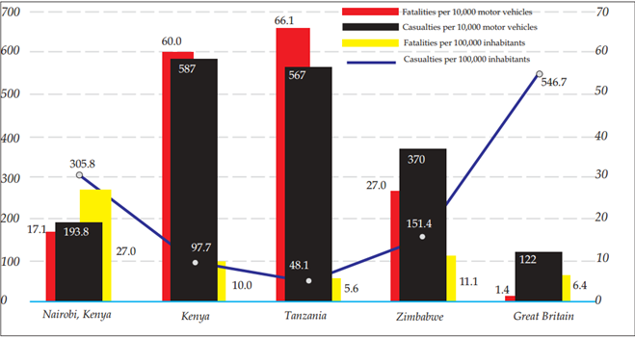
Figure 1: Road safety in Africa.Working paper No.33:an down computations1(Source World Bank (1998)
Figure 2: Overloaded Matatu (Source: www.alamy.com.)
Overloading a vehicle is an illegal offence which occurs when a vehicle’s maximum permissible weight limit is exceeded. Section 58 of the traffic act Cap 403 on penalty for improper condition or overloading states that;
“Any person who drives or uses on a road a vehicle in contravention of the provisions of section 55, 56 or 57 or in accordance with the East African Community Vehicle Load Control Act, 2013, shall be guilty of an offence and liable to a fine not exceeding four hundred thousand or to imprisonment for a term not exceeding two years or to both:”
According to statistics from Kenya Bureau of Statistics, by the end of 2017, the total number of registered vehicles in Kenya was 2,989,788. The number increased to 3,280,934 in 2018, an increase of 291,146 which translates to about 10% increase per annum. This is against the 98,732, law enforcement officers who are meant to ensure compliance President Uhuru Kenyatta, ‘Speech addressed to the national police service’, (16 January 2017 url).

Figure 3: Traffic policeman enforcing traffic rules (Alarmy stock photo)

Going by this rate, the government will be forced to use new strategies and most importantly technology to control overloading in Kenya's transport sector. Where enforcement officers are on the road, they are only concerned with the available space and not the permissible weight. This issue is further compounded by the high rate of corruption among our enforcement officers.

2. The Problem
The load capacity of any vehicle is determined by tare weight and not the available cargo space. Law enforcement officers in Kenyan roads, are mainly and erroneously concerned with the available cargo space instead of the tare weight. This compounds the problem that while a PSV vehicle might carry the right number of passengers in a vehicle, the actual tare weight of the vehicle might be beyond required standards. This misconception has contributed to wrong enforcement and directly caused death and destruction. In addition, excessive tare weight contributes to further wear and tear of the vehicle therefore consuming extra resources. Improper enforcement and monitoring leads to inefficiency and lower incomes due to high operational cost, and as a result inhibiting the PSV owners from giving reliable and quality services to the passengers. The government and general populace also is affected by bad roads whose bad conditions are aggravated by overloaded vehicles. Indirectly the same vehicles are affected by bad roads, and the vicious cycle that continuously affects the quality, efficiency and effectiveness of PSV industry. There is little or insufficient research in this area thus the need to design and develop an integrated model for public service vehicles overload prevention to effectively solve this problem.

3. Research Objectives
The main objective of this study was to design an integrated model for public service vehicles overload prevention. This study designed an integrated model that was validated to ensure ability to monitor, evaluate and effectively reduce overloading of PSV vehicles.
Specific Objective
To design an integrated model for public service vehicles overload prevention.

4. Literature Review
Majority of Kenyans depends on Public service vehicles to meet their travel needs. Manyara, (2016) said that this mode of public transport (Matatu industry) in Kenya is not safe. In Kenya PSVs are supposed to carry between 10 and 50 passengers depending on the category of the vehicle R. of K. (GoK), (2018) but this is not the case on the ground as this rule is mostly disregarded B. Team, (2019). In the event that a traffic accident occurs, the number of casualties and impacted people is increased.
The government has tried, since time immemorial to reduce the bulk of Kenyan lives that are lost on Kenyans roads; starting from the Michuki Rules to the night travelling ban for public service vehicles. Road accidents however remain untamed phenomena in Kenya, whose solution better be found sooner than later before it claims any more Kenyan lives. Bernard Jacoba and Véronique Feypell-de La Beaumelle introduced a weigh-in-motion (WIM) technologies that allow trucks to be weighed in the traffic flow, without any disruption to operations. KenHA has numerous manual weighbridge stations mapped out for the stations include Salgaa, Yala, Mukumu, Malaba, Kitale, Mulot, Kajiado, Emali, Masii, Malili, Kibwezi, Mwatate, Nuno, Bondo and Sabaki. The stations require physical manning to measure, collect and transmit data for analysis thus cumbersome, prone to manipulation and compromise.
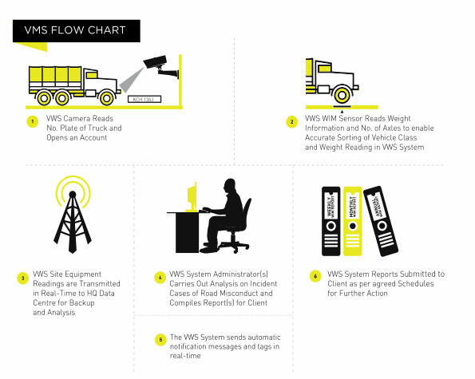
Figure 4: VWS Flow chart: Source (KeNHA October 2017).
WIM technologies allow trucks to be weighed in the traffic flow, without any disruption to operations. This system is not real time as collected data has to be transmitted to a control point where after analysis a decision is made making the system reactive rather than proactive. Furthermore, these stations are specifically designed for Heavy Commercial Vehicles weighing 7 tons and above whereas overloading is not only a problem for larger goods vehicles; but equally a problem for smaller vehicles, such as vans, cars and passenger carrying vehicles.
The technology also does not consider the number of passengers as indicated on the side of the driver cabin. These stations are on specific sections of particular roads and therefore most of the times the overloaded vehicles avoid these stations. The measuring instruments are installed in the concrete of roads to measure the weight of vehicles thus making them hard to maintain. Huang (2019).

Another system was developed in Tanzania to prevent overloading of passengers Namayala et al (2019). In this system, camera is used to capture images of passengers boarding the bus. Then the images are analyzed for determining whether the number of bordered passengers is in compliance with the seating capacity. After analysis the system is then able to make decisions and send messages accordingly. The messages are sent to bus owner and traffic police, display total number of passengers and if seating capacity is exceeded fuel injection is turned off to lock the bus engine and prevent the bus from starting.
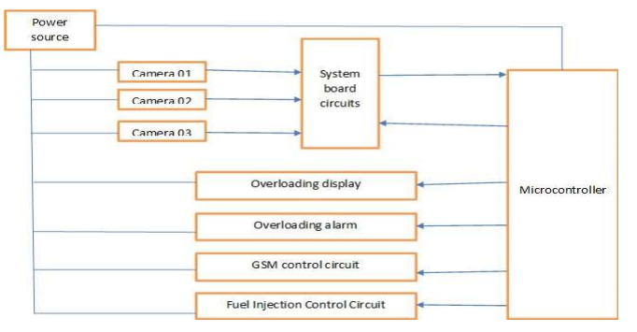
Figure 5: Block diagram for vehicles' overloading control system (Source Namayala et al, 2019)
Overloading should not be determined by number of passengers in the vehicle but the actual tare weight of the vehicle.

Conceptual Framework
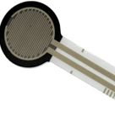
Load Cell.
This is meant to measure the Chassis weight of the car
The Cloud services
Data collected by the micro controller can be uploaded to the cloud for analysis and tabulation
Switch/ Cut -Out
Information on the analyzed data from the transducers is uploaded to the switch. This determines whether the vehicle will ignite or not
Resistive Pressure Sensor
Activated by the exerted pressure on the module. This is picked by the sensor in Kgs
Display
All the information gathered including the Tier weight and Vacant seat is relayed to a display
Figure 6. Conceptual Framework

5. Methodology

This research design framework thus augments the methodology chosen to undertake this study, which will be mixed types of methods approaches, combining both the Proof of concept (POC) and Prepare Plan, Design, Implement, Operate, and Optimize Network Design and Implementation methodology (PPDIOO). The table 1 below, shows the truth table for the logical digital circuit.

No of passengers | weight | Output | State of Engine
0 (No of passengers not exceeded) | 0 (Total weight not exceeded) | 0 ( Both weight and no of passengers not exceeded) | De-activated
0 (No of passengers not exceeded) | 1 (Total weight exceeded) | 1 (weight exceeded but no of passengers not exceeded) | Activated
1 (No of passengers exceeded) | 0 (Total weight not exceeded) | 1 (weight not exceeded but no of passengers exceeded) | Activated
1 (No of passengers exceeded) | 1 (Total weight exceeded) | 1 ( Both weight and no of passengers exceeded) | Activated

In this study strain gage-based load cells were designed since they are the most prevalent type used in the world today. They are inexpensive, very reliable, and available to handle a wide range of force inputs. They are the de facto standard of the weighing industry and provide a full-scale accuracy of 0.25% and better. Four pieces will be used and will be placed under the chassis of the vehicle. The figure 7 below shows the strain gage-based load cells.

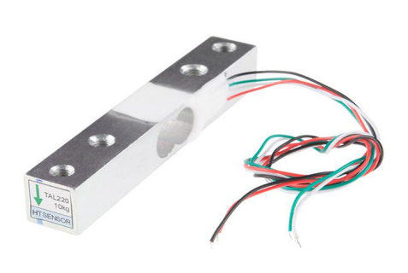
Figure 7: Strain gage-based load cells.

Piezoresistive strain gauges are among the most common types of pressure sensors. They use the change in electrical resistance of a material when stretched to measure the pressure. Placed in every seat and activated by the exerted pressure on the seat when a passenger sits on that seat. This picks the sensor and relays data in kilograms (Kgs). The figure 8 below shows the Piezoresistive strain gauges.
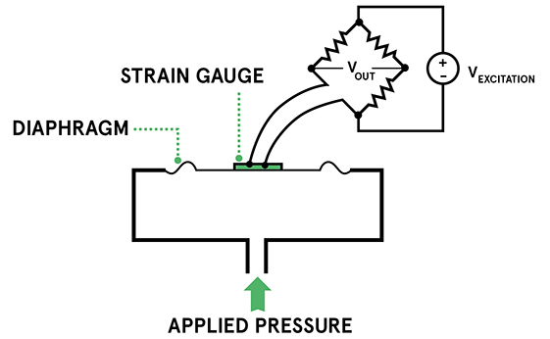

Figure 8: Piezoresistive strain gauges

6. Results
The resulting design was set-up using Arduino for testing and validation, the results were reviewed as shown in figure 9 and figure 10, below.

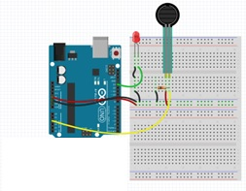
Figure 9: The Arduino set-up Figure 10: Schematic connection

The code snippet below shows the design implementation as tested on the Arduino framework. This successfully captured data from the sensors and relayed the same for monitoring. The LED would switch on whenever the target tare weight was surpassed.

int ledPin = 13; // select the pin for the LED
int sensorValue = 0; // variable to store the value coming from the sensor
void setup() {
// declare the ledPin as an OUTPUT:
pinMode(ledPin, OUTPUT); }
void loop() {
// read the value from the sensor:
sensorValue = analogRead(sensorPin);
// turn the ledPin on
digitalWrite(ledPin, HIGH);
// stop the program for <sensorValue> milliseconds:

7. Recommendations
This study is of great significance to the general public who uses Public Service Vehicles, NTSA, traffic police, matatu Saccos as well as the investors. Deployment of the integrated microcontroller-based model will ensure uniformity and compliance with the traffic rules and the manufacturer recommended weight. This is because the proposed model will take into consideration the number of passengers as well as the permissible weight. The study model will ensure that either the number of passengers or the permissible weight or both are not exceeded and if either or both are exceeded then the cut out will be activated. This is pro-active unlike the current systems which are reactive. This will reduce the number of road accidents and all the negative impacts associated with road accidents.
There is also need to undertake further studies towards security of these smart devices as well as data science to cater for the huge amount of data collected from the vehicles.

8. Conclusion
The integrated model study was successful and proved beyond doubt, that integrated microcontrollers can meet objective for preventing PSV vehicle overload.

References
D. M. Ştefănescu, "Strain gauges and Wheatstone bridges — Basic instrumentation and new
applications for electrical measurement of non-electrical quantities," Eighth International Multi-Conference on Systems, Signals & Devices, 2011, pp. 1-5, doi: 10.1109/SSD.2011.5767428.
Decree of the State Council No.493. “Report of manufacturing safety accident and investigation
processing by law”. State Council of the People’s Republic of China, Beijing [In Chinese]. 2007
KeNHA (2017) Virtual Weighbridge System
Kenya National Bureau of Statistics. Economic Survey 2019. Nairobi: Kenya.
Libguides .https://libguides.wits.ac.za/research-support
H. D. Kattimani, Meghana N R, Nagashree B, Sahana Munegowda, Vijayalakshmi S (2017)
Vehicular Overload Detection and Protection. Phesto Peter, Namayala Sospeter, Iganja Gabriel,
Godfrey kayombo & Peter Kambosha(2019): Development of Passengers Vehicle Overloading
Control System. International Journal of Engineering Research And Advanced Technology, Vol.5, Issue 8, August-2019
I. Kaur 2010 Corpus ID: 16572555)
Kilavo Hassan et al (2013): Overview on passengers overload control in public buses case study: Tanzania International Journal Of Engineering And Computer Science ISSN:2319-7242
Volume2 Issue 8 August, 2013 Page No. 2536-2540
Liu G, Chen S, Zeng Z, Cui H, Fang Y, Gu D, et al. (2018): Risk factors for extremely serious.
road accidents: Results from national Road Accident Statistical Annual Report of China. PLoS ONE 13(8): e0201587. https://doi.org/10.1371/journal.pone.0201587
Manyara (2016) Combating Road Traffic Accidents in Kenya: A Challenge for an Emerging
Economy.

