**SUPERVISION OF POSTGRADUATE STUDENTS: A PERSONAL EXPERIENCE.**

**By**

**Dr. Alice M. Yungungu**

[**aliceyungungu@yahoo.com**](mailto:aliceyungungu@yahoo.com)

**0718875807**

**MOI UNIVERSITY**

**SCHOOL OF EDUCATION, DEPARTMENT OF CURRICULUM INSTRUCTION AND EDUCATIONAL MEDIA**

**Table of Contents**

ABSTRACT 4

**1.0** **Introduction** 5

1.1 Context in Which I Supervise 5

*1.1.1 My academic identity* 5

**1.1.2 Power Relations** 6

**1.1.2.1 Definition of Power Relations** 6

1.1.2.2 Strategies used to enhance power relations 6

2.0 Scholarship 7

*2.1 Strategies used to induct students into an academic community* 7

2.2 Sense of myself as a supervisor (Sense of self) 7

2.2.1 Introduction 7

2.2.2 My own academic identity and its role in my competence as a supervisor 8

*2.3 Conventional and alternative approaches/styles to supervision* 9

2.4 Supervision models 10

2.4.1 Coaching 10

2.4.2 Mentoring 10

2.5 My engagement with the scholarly academic community 11

3.0 Practices involved in being a supervisor 11

*3.1 Definition of practices in supervision* 11

*3.2 Practices in supervision* 11

3.3 Gatfield’s and Lee’s perspective of supervisory skills and application 13

3.4 Roles of supervisors’ and students’ responsibilities and expectations in supervision 13

3.5 Strengths in my supervision 14

3.6 Weaknesses in my Supervision 14

4.0 Supervision processes involved in being a supervisor 15

4.1 Changes I need to adopt 17

5.0 Challenges and possible solutions in supervision 18

*5.1 Introduction* 18

*5.2 Challenges* 18

*5.3 Possible solutions* 19

5.4 How training has transformed my supervision 19

5.5 Conclusion 20

References 21

APPENDICES 23

Appendix 1: Moi University Curriculum Instruction and Educational Media(CIEM) Department Objectives. 23

Appendix 2: An Example of Harsh Comments in Students Work 24

Appendix 3: An Example of Polite Comment in Students Work 25

Appendix 4: An Example of a Coach Training Footballers. 26

Appendix 5(a): A Sighted Person Guiding a Blind Person 27

Appendix 5(b): A Blind Person Familiar with the Environment 28

Appendix 6: An Example of Supervisor Activities to Support and Develop Students Writing. 29

Appendix 7: List of My Published Articles 30

Appendix 8: An Example of a Work Plan by a Supervisee 32

Appendix 9: An Example of Students’ Progress Record Form 33

# ABSTRACT

Supervision can be defined as a dynamic facilitative process that encourages a set of tasks and responsibilities which are performed in different domains. In research context, supervision involves supervisors’ and post graduate students ‘tasks and responsibilities in the supervision process. This paper will therefore concentrate on the four pillars of strengthening post graduate supervision namely: power relations, scholarship, practices and processes involved in being a supervisor. Power relations deal with the relationship between supervisors and supervisees. It focuses on how we go about creating an inclusive and participatory learning environment that enables students to acquire and further develop knowledge, methodological skills and writing practices during the research process. Scholarship deals with the strategies used to induct students into an academic community. It also deals with supervisors’ engagement with the scholarly academic community in order to develop a sense of being an effective supervisor. Practices in supervision refer to roles, responsibilities and activities of supervisors and students that enhance students’ development. Supervision processes involved in being a supervisor focus on the logistics of managing supervision with institutional requirements. The supervisors’ roles and students ‘responsibilities and expectations will be discussed under this pillar. Couching and mentoring in supervision as well as conventional and alternative approaches to supervision will be illuminated. Challenges in supervision and possible solutions will be discussed. Recommendations on how to improve the supervision process will be provided. It is hoped that this paper will shed more light on how supervisors should go about the supervision process. As a result, it is expected that supervisors will engage in effective and meaningful supervision.

1. **Introduction**

Supervision can be defined as a dynamic, facilitative process that encourages a set of tasks and responsibilities which are performed in different domains (Pearson and Kayrooz, 2004). It involves supervisors’ and postgraduate students’ tasks and responsibilities in the supervision process. For the supervision process to be successful, the parties involved must cooperate and show commitment in their work. This paper will therefore concentrate on the four pillars of strengthening postgraduate supervision, namely, power relations, scholarship, practices and processes involved in being a supervisor. Challenges and possible solutions in supervision will also be discussed. Specifically, it will deal with the following key issues: context in which I supervise, strategies to achieve power relations, student engagement with academic community, and sense of myself as a supervisor. Other key issues include supervision models, how I engage with the scholarly academic community, practices involved in being a supervisor, Gatfield’s and Lee’s perspectives of supervision skills and application, roles of supervisors and students responsibilities and expectation of supervision. My strengths and weaknesses in supervision will also be highlighted. Processes involved in being a supervisor and the changes I need to adopt in supervision will be considered. Challenges and possible solutions in supervision, as well as ways in which training in supervision course has transformed my supervision will be illuminated. Finally, a conclusion on the importance of successful and meaningful supervision will be provided.

# 1.1 Context in Which I Supervise

## *1.1.1 My academic identity*

I am a senior lecturer in the department of Curriculum instruction and Educational Media (CIEM), school of education (SOE), Moi University (MU). My area of specialization is curriculum studies. Apart from teaching, I am also involved in research work. Through teaching and research, I have gained skills that have enabled me to improve in my supervisory role. My areas of interest in research include curriculum issues, girls or women education, disability and community development issues. I am a fulltime lecturer in the CIEM department.

There are four main objectives that the department aspires to achieve (Appendix 1). One of the objectives is to promote research among lecturers and students. While the SOE organizes common oral defense sessions for all the postgraduate students in the school, the CIEM department arranges proposal defense sessions for its students. It’s worth noting that before any student presents their proposal or thesis at the departmental or School levels, the documents must have been satisfactorily read, corrected and finally signed by two supervisors. Being one of the largest departments in the SOE, the CIEM department has what we refer to as course coordinators who oversee the smooth running of each discipline under the guidance of the head of department (HOD).

We admit both local and international post graduate students under full time and part time programmes. Majority of them are high school teachers and therefore join the part time programme which is offered in April, August and December when schools are closed. Currently, I am supervising six postgraduate students whose area of specialization is curriculum studies.

**1.1.2 Power Relations**

***1.1.2.1 Definition of Power Relations***

Power relations deal with the relationship between supervisors and supervisees. This theme talks about how we go about creating an inclusive and participatory learning environment that enables students to acquire and further develop knowledge, methodological skills and writing practices during the research process.

### *1.1.2.2 Strategies used to enhance power relations*

In regard to power relations, I treat my students in a professional manner that is, with due respect. However, sometimes I get worked up and become harsh when they do not follow instructions, especially when they repeat the same mistakes two or three times. Generally, I discuss and agree with my students when and where to meet. Most of our meetings take place in hotels or in my house. This is due to lack of enough offices for lecturers in our institution. I allow students to call when they are through with corrections, though not later than 8 P.M. Depending on the magnitude of the corrections, I allow them to suggest deadlines on when to submit their work for marking. I sometimes call them when they take longer than agreed just to find out their progress. When their ideas of a topic are quite raw, I have learnt to listen to them and this gives them the courage to move on. This works positively on commitment and level of independence among students.

Biltzer and Albertyn (2011) advocate for team approach. In this case, I sometimes consult my co- supervisors to agree on an issue before sharing it with the supervisee. I rarely meet my students in groups to discuss but I intend to use this approach in the future. I resolved to do this after reading Biltzer and Albertyn (2011) who emphasize on the use of alternative approaches to supervision. Peer coaching should be encouraged to decentralize power relations and enhance commitment and independence. To enhance power relations, I try as much as possible to make polite comments in their work. I sometimes make very harsh comments especially when students copy paste information in their work. However, there is need for improvement on this issue. I have started changing after attending some training on strengthening postgraduate supervision (Appendix 2 and Appendix 3).

After reading the work of Pearson and Kayrooz (2004), I have purposed to work on my relationship with students. They contend that a firm and positive supervision relationship is essential for the students’ positive experience of postgraduate research. If the student knows that the supervisor is flexible, he/she will be free to work out challenges and progress well. Personally, I avoid delaying feedback but when circumstances force me to do so, I take the responsibility of explaining to the students. However, I try to avoid serious delays. In support of good power relations, Eley and Jennings (2005) assert that a relationship characterized by mutual love, respect and obligation should be developed between the supervisor and the student.

# 2.0 Scholarship

## *2.1 Strategies used to induct students into an academic community*

In order to provide a learning environment that emphasizes on the importance of scholarship, I encourage my students to engage with the academic community. To achieve this, I use strategies such as referring them to curriculum books and titles of dissertations relevant to their topics in the library. I also advise them to read my online published research articles in international journals. Sometimes I give them handouts with relevant literature and encourage them to share their materials in discussion groups especially those with related topics.

It is my responsibility to encourage students to build academic networks with students from other universities and even make a point of visiting their libraries. This gives them an opportunity to access literature that may not be available in the MU library. I advise them to make use of internet to access different websites for literature which they must acknowledge in their work in order to avoid plagiarism. I encourage them to consult widely with my co-supervisors and other experts in the curriculum discipline within and outside the CIEM department. I also request them to attend workshops and seminars related to research; to acquire more knowledge and skills on research, to attend departmental and school oral defense sessions to keep learning from students’ presentations; engage with other researchers online; publish in journals and books; presenting papers in conferences where they are critiqued and improved; and encourage them to share research support services such as editorial services if aware of any, to enable them use good research language. This could even be done by a teacher/lecturer/professor of English who is also a research expert.

Pearson and Brew (2002) support the idea of introducing students to an academic community when they posit that students should be encouraged to be experts in their discipline of specialization. They should be resourceful and able to search what they need to know and use. Eley and Jennings (2005) and Wisker (2006) also recommended networking among researchers because they often experience loneliness and isolation and need to become a part of the academic community.

## 2.2 Sense of myself as a supervisor (Sense of self)

### *2.2.1 Introduction*

Having looked at the context in which I supervise, I now turn to discuss the sense of myself as a supervisor (sense of self) and how this impacts on my supervision either positively or negatively. This will deal with issues of my own growth in supervision, that is, from being an inexperienced to a considerably qualified supervisor. As evidence of growth in supervision, alternative approaches to supervision that I have learnt in the course of my studies used and intend to frequently use in the future will be discussed.

### 2.2.2 *My own academic identity and its role in my competence as a supervisor*

I joined the CIEM department as a fulltime lecturer. My main responsibility was to teach both undergraduate and postgraduate students. However, for professional development and growth, I had to engage in research work as well as other academic responsibilities such as supervision of postgraduate students. Through research I was able to acquire skills that made me more competent in my supervision work. However, being visually impaired (totally blind), I found it quite difficult to balance my time between teaching, research work, supervision as well as family responsibilities. For instance, depending on a sighted reader to read as I listened and prepared lecture notes and research materials was an uphill task for me. This therefore meant that time to supervise my students was limited. Further, as a newly employed lecturer, I had very little experience, if any, on supervision yet I had to do it. As a beginner, I never enjoyed supervision. I found it quite demanding and stressful. Following an open discussion, understanding and consideration with the then CIEM department head, I was able to graduate a few students on time.

For beginners in supervision to do their work competently, higher institutions of learning like universities, schools/faculties, departments and particular disciplines should take upon themselves to induct them on supervisory issues. Through this, we will not end up producing half-baked masters and PhD holders. Additionally, universities should provide visually impaired supervisors with adaptive technology and even sponsor them for training on the same as part of professional development. This will enable them to communicate online with their supervisees just like their sighted counterparts, hence save on time. It will also reduce the supervisor’s overdependence on the sighted reader and writer.

As a beginner, I did not have the necessary expertise and had challenges dealing with some of my supervisees who had high expectations. Zambo (2005) points out that supervision involves a complex and seemingly endless journey. Supervisors and postgraduate students embark on much work at the onset of research study. This results to loneliness which in turn causes supervisors and postgraduate students to often times experience alienation and frustration. This is actually what I went through as a beginner which I believe affected my supervision negatively.

In order to save myself from this ugly situation, I read books such as Mugenda and Mugenda (1999) which clearly gives and elaborates the systematic (structure) followed in developing a proposal and finally a thesis. Reading doctoral thesis in Margret Thatcher library in MU and consulting my colleagues in the department helped improve my supervision skills. Today I feel more confident as I supervise my students and instead of being stressed, I now enjoy supervision.

An effective supervisor has to supervise in a professional manner. For me, I have to work as an expert in the field of curriculum studies. For instance, while I sometimes allow students the freedom to change their topics, they should not take advantage of such opportunities and do it frequently. As an expert, I advise my students on how to come up with researchable topics. I also discourage them from taking too long to submit proposals for marking. If this is not adhered to, it impacts negatively on my supervision. Sometimes students may forget the proposal and thesis writing skills if they disappear for too long. In support of this, Leshem and Trafford (2007) assert that supervisors need to develop sensitivity for indications of unsatisfactory progress. For example, frequent change of thesis topic or planned work, side stepping communication with the supervisor, isolating themselves from the department and avoiding submission of work for review.

I see myself as a guide, facilitator and councilor. I therefore deal with academic as well as social issues of my students in case they arise. As a professional, I try as much as possible to be objective in my supervision, encourage creativity and originality, emphasize on strong academic arguments and a clear voice of the supervisees in their work. As a growing expert in supervision, I take the lead in imparting these skills to my students. As a result of my knowledge and skills, my students are able to analyze information and develop academic arguments and be equipped to organize their research effectively. I also encourage them to always ask questions and research for answers. Moreover, I advise them to have the right attitude to team work and their research.

## *2.3 Conventional and alternative approaches/styles to supervision*

The supervision process requires the use of a variety of approaches. This section looks at some of the styles I have been using as well as new approaches that I intend to apply in future. I have always used the individualized traditional apprenticeship approach or one on one supervision. It argues that a supervisor is a mentor and more superior to the supervisee. However, there should be a good relationship between the two for the supervision process to succeed. Samara (2006) has criticized this approach by claiming that it results to isolation and alienation of the student. The argument goes on to say that support from group members who share the same experience is usually rated very positive by the students in terms of social and academic benefits. In agreement with Samara (2006), Biltzer and Albertyne (2011) and Kiley (2011) assert: “move away from one on one supervision in a private space between the supervisor and the student to a public space namely a panel or co-supervisory system of supervision.”

In order to strengthen postgraduate supervision, alternative approaches to post graduate supervision should be adopted (Biltzer and Albertyne,2011). They talk advocate for group approach which has the advantage of enabling students to produce high quality dissertations. Sometimes the approach combines group discussions with the supervisor and encourages one on one follow up sessions with the supervisor in order to deal with particular students’ needs. It encourages a participatory approach to supervision which enhances self-esteem and confidence among students. The adoption of group supervision by individual supervisors would help to produce better PhD holders than when we mainly use one on one approach.

Team approach is another alternative approach to supervision. Here, experienced academics act as mentors to students and inexperienced academics (Biltzer and Albertyne, 2011) and Nulty, Kiley and Meyers (2009). My comment on this is that we need to appreciate the fact that some of us are lecturers, senior lecturers and full professors. Therefore, in the postgraduate supervision process, supervisors at different levels should be ready to co-supervise, for example a full professor co-supervising with a senior lecturer. In such cases, both of them should be ready to learn from each other. The professor should not undermine the senior lecturer and the senior lecturer should not suffer from inferiority complex. As a senior lecturer, I am sometimes afraid of making comments on students’ work because I may not predict the reaction of my academic superiors on the same. However, I need to change and develop more confidence when making comments because no one is all knowing.

For the approaches to be effectively used, capacity building among supervisors is paramount otherwise academics may revert to the known traditional apprenticeship approach which is considered “safe”.

Through the works of Lee (2007), I am now aware of supervision styles such as: panel supervision where each person plays a particular role; project supervision where a team of doctoral scholars and a team of supervisors work together in a related set of research problems; and cohort supervision where groups who join a programme in a particular year work through the research stages together. These three styles of supervision are not commonly used in MU. The use of these approaches should be encouraged in order to reap the benefits of using an eclectic approach in supervision.

## 2.4 Supervision models

### *2.4.1 Coaching*

Coaching refers to the idea of training. Training can be carried out to teach someone or a group of people a new skill or to perfect a skill. The end result is good application of the learned skill. A supervisor therefore acts as a coach in the supervision process. She/he trains students in the field of writing a proposal and subsequently a dissertation. A supervisor does not only teach research skills but also engages in perfecting them until the student is able skillfully apply them. Sometimes clarifications can be made towards the end of the doctoral journey. At the end of the day, the supervisee becomes competent and writes a good thesis, the same way a coach trains a football team to win a match. An illustration of my imagination of a coach training footballers is provided in Appendix 4.

### *2.4.2 Mentoring*

A mentor in supervision is someone who holds the hands of a student from the beginning to the end of a masters or a doctoral journey. There could be challenges on the way, but the supervisor is always there to assist. The supervisor may sometimes leave the student to walk alone. In my illustration, a supervisor is equated to a sighted guide helping a blind person to get used to walking alone along a path. Though there could be stones and fallen trees on the way, the sighted guide ensures that the blind person is not hurt. However, when the blind person gets used to walking alone along the path way, he/she is able to walk alone. This means that challenges may not be many. In case of any, the sighted guide is always ready to give hand as shown in Appendix 5.

## 2.5 My engagement with the scholarly academic community

To develop a sense of being an effective supervisor, one needs to create and become a part of a learning environment that will ultimately engage the supervisor to the scholarly academic community (Pearson and Brew, 2002). To improve on research on supervision skills, I attend seminars, workshops, and conferences where I sometimes present research papers, consult co-supervisors especially in the curriculum discipline, online collaboration through my sighted reader who assists me to access research materials online. In future, I intend to involve my students in my research project. I also intend to be consulting experienced supervisors in order to learn from them. Consulting the visually impaired supervisors in other universities, especially Kenyatta University where there is an established department for visually impaired students, to find out how they go about challenges in supervision would be of great help. I have always purposed to attend D.Phil. oral defense sessions even when I don’t have a candidate. From this, I learn from experienced supervisors’ and the students’ presentations which impacts positively on my supervision.

In the absence of Braille books in our library especially in the curriculum discipline and research, I depend on my sighted reader to read downloaded materials, books and dissertations in the library. To some extent this limits my speed of growth in my supervision skills. I intend to be more independent by purchasing adaptive computers. This will enable me to even communicate online with my supervisees.

I intend to use inter-vision method to network with my colleagues. Intermission refers to structured contacts between colleagues involving mutual support, giving feedback and learning from each other in a professional manner to network, develop and share specific competencies. The acquired competencies in this case will make me a better supervisor. This should also be encouraged at the departmental level where colleagues in the same discipline can use this method to improve on their supervisory skills.

# 3.0 Practices involved in being a supervisor

## *3.1 Definition of practices in supervision*

Practices in supervision refers to roles, responsibilities and activities of both the supervisor and the student that enhance students’ development.

## *3.2 Practices in supervision*

As a supervisor, some of the supervision practices include advising and encouraging my students in their process of thesis writing. As a visually impaired person, the practice of supervision involves getting a sighted person to read students proposal and theses as I listen and make comments in the hard copy. This is quite involving. To avoid getting stressed up, I give my students appointments to meet at different times. Here we have to discuss and agree on when and where to meet and for what purpose. I encourage my students to write chapter one which I have to look at before they make any further progress. I have to call them to inform them about any progress. It is their responsibility to call me when they are ready to submit their write up. To save on time, I sometimes ask the student to read the document while I listen and discuss the major issues with them.

In order to support and develop my student’s writing, I ensure correct punctuations, teach them how to cite from books, journals, newspapers and articles. I also teach them how to reference using the American Psychological Association (APA) style. For their documents to look professional and attractive to the reader, I advise my students to indent any directly quoted information as long as it is more than three lines. To motivate them, I use reinforcement language, for instance, using terms like good, a good attempt, well done, fair work among others. I read their work to ensure a good flow of ideas, augments as well as correct titles and subtitles. Keen reading helps me to know whether students copy paste downloaded materials which I discourage. I encourage them to subscribe in websites for Portable Documents Format (PDF)materials to enrich their work. I also encourage them to analyze the raw data for themselves. This enhances skill development and ownership of their work.

I help my supervisees to write proposals that have good titles, that is, with both independent and dependent variables (Appendix 6, part A). Objectives of the study must be stated in an open ended style (Appendix 6, part B). Research questions which arise from research objectives should not lead to ‘yes’ and ‘no’ answers. This is because the researcher will not be able to ask any questions in the questionnaires or interview schedules since a ‘yes’ or ‘no ‘answer question is an end in itself (Appendix 6, part C). However, it is worth noting that I advise my students to develop ‘yes’ or ‘no’ answer questions in the research instruments, for example, in a questionnaire which must be followed by a follow up statement (Appendix 6, part D)

When students hand in their proposals, I always request them to give me enough time to mark due to my style of marking through a sighted reader. My students have always given me enough time. However, this does not mean that there are unnecessary delays in giving them feedback. It is my responsibility to call them when I am through with their work. On corrections, the agreement with my students is that they should always submit two copies, that is, a clean corrected copy and the immediate previous copy with my comments. My sighted reader uses the clean copy to confirm minor corrections on my behalf. This may include punctuations, spellings, paragraphing, corrected figures, frequencies and percentages in tables among others. For major corrections like the statement of the problem not being clear or the theoretical framework, the sighted reader has to read the comments in the corrected copy and then again read from the clean copy to confirm corrections. This way, I am able to establish if the corrections were made. To me, one on one supervision has been the order of the day. However, having attended some training on supervision, I intend to be meeting my students in groups especially those with related issues and at the same level of thesis writing.

I help my students to identify their topics through discussions with them to ensure that their topics are researchable. I also advise them to read widely to establish gaps which may form the basis of their topics and clarify difficult areas like theoretical framework and methodology. Other practices include writing reports of the student’s progress for my records which I sometimes submit to the CIEM department when requested to do so. I give students feedback as regularly as possible.

# 3.3 Gatfield’s and Lee’s perspective of supervisory skills and application

According to Gatfield (2005), there are four supervisory skills. These include: Laissez-fare style where the supervisor gives students much freedom with no clear direction. A supervisor who follows a pastoral style reflects understanding but places pure emphasis on structure. In a contractual style, the supervisor focuses on leadership, friendly and helpful behavioral aspects whereas in a directional style, strict rules and controlling behavior are the order of the day.

Looking at these skills, I realize that I use an eclectic approach. This that means that I sometimes use Laissez-fare, directional, pastoral or contractual. This depends on the students I am dealing with and their stage in writing the dissertation. In support of the directional style, Lee (2007) advocates for the use of functional domain in supervision. This domain focuses on practical aspects such as setting ground rules, managing time and monitoring progress. I always discus with my students my roles, their responsibilities, when to do what and how. All these ensure good power relations. However, sometimes this does not work due to commitments. Here, flexibility from either side is required.

# 3.4 Roles of supervisors’ and students’ responsibilities and expectations in supervision

Networking my students to co-supervisors or linking them to supervisors in the research discipline is important. This does not happens occasionally. Lee (2007) supports networking by encouraging the use of enculturation style. Here, the supervisor guides students in becoming members of the academic discipline. The supervisor provide expertise in research resources and specialist opinions. When I refer my students to resources such as dissertations, relevant chapters in books, journals, newspapers and photocopied materials, I do check if such materials have been referred to in their write-ups. However, there is need for improvement on this, otherwise some students may ignore reading the materials. Post graduate rules and regulations is an important resource which I intend to avail to them. This will help them know their responsibilities and timelines in the thesis writing process.

Attending oral defense sessions is another resource that I encourage my students to make use of. However, many students do not attend and only appear during their day of proposal or thesis presentation. Finding out from them whether they attend or not and what they learn from such sessions helps me to ensure their good progress. Further, I encourage them to make use of the SOE Resource Centre which has both Masters and Doctorate theses.

Lee (2007) also talks about thinking critically as a domain. This is where the supervisor teaches students to develop and demonstrate strong academic arguments in their work. Further, emancipatory domain encourages students to change from being dependent to being self-directed through constructing and reframing knowledge, to move from acquiring knowledge and thinking critically to applying experience (constructivism). To develop independence and commitment among students, I encourage them to attend seminars and workshops where they present research papers and network as well as reading widely.

Students’ expectations are quite high and sometimes over imagined. They expect to be spoon-fed. For instance, being given topics, reference materials all the time and being involved in plagiarism without expecting to be questioned. Other unreasonable expectations include: students expecting high grades with minimal efforts in being creative in their research work; expecting little or no pressure from the supervisors and the institution when they do not complete their programmes on time; slow in making corrections but expect immediate feedback when they submit their research work for marking; and submitting their theses late with an expectation to graduate immediately. Moreover, some of them do not adhere to the postgraduate rules and regulations, yet they expect the supervisors to understand and give them an okay to submit their theses for marking. For instance, at times they may not wish to write a letter of intent to submit, which is a requirement. I discourage them from such over imagined expectations I also advise them to read the MU Postgraduate rules and regulations. To reduce these problems, I try to create some independence among my students by taking them through the steps followed in thesis writing, encouraging creativity and originality in their work and attending departmental and school oral defense sessions.

# 3.5 Strengths in my supervision

1. I enjoy reading and discussing major corrections with my students because this way am able to clarify issues.
2. Consistency in a student’s right up makes me feel that I have helped the students to acquire some of the important skills in thesis writing.
3. Hearing the writer’s voice especially in the literature review chapter where gaps are identified is an indication of academic growth which I cherish.

# 3.6 Weaknesses in my Supervision

1. I sometimes feel discouraged when am not able to give feedback on time because this might impact negatively on power relations.

2. I do not communicate online with my students due to lack of adaptive technology.

3. I do not call my students frequently for follow ups due to high workload.

4. I get worked up when some students repeat the same mistakes more than two or three times.

5. I do not frequently consult my co-supervisors.

# 4.0 Supervision processes involved in being a supervisor

Supervision processes refer to the various tasks involved in the supervisory process including attending to institutional requirements. In other words, it involves discussing the logistics of managing supervision with institutional requirements. This section will deal with tasks involved in supervision processes including attending to institutional requirements. Supervisors’ roles and students’ responsibilities and expectations will also be considered.

To me, the supervision process starts when I receive official communication from the HOD CIEM department notifying me of the students to supervise. If I have their contacts I call them but if I do not have I always wait to hear from them. In my first meeting with the students I usually appreciate them verbally for choosing to work with me. I always assure them that if they cooperate in the supervision process they will be able to graduate on time. In other words, being visually impaired will not affect their learning in any way. I believe this gives them confidence to work with me. I always try to establish a rapport with my students. Usually in our first meeting, students express a lot of fear and doubt about how to get a topic and develop a proposal. They talk of inadequate time to read in the library and be able to establish gaps which may form the basis of a topic. This is because most of the postgraduate students are in the part time programme.

As a mentor and councilor, I always encourage them to create time to read widely, discuss among themselves and to consult with other supervisors. I always assure them of my assistance. Students suggest when they feel they can submit a chapter. However, during our second meeting, we usually discuss and agree on a date when the students will submit a refined copy. This time round I exert pressure on them to ensure they beat the deadlines. To avoid student-supervisor conflicts, I encourage discussions with my students about our expectations from each other in the supervision process. This enhances good power relations. However, the supervisor has to remain flexible and emotionally stable especially when things do not work as planned. For instance, when students have family commitments, commitments in their places of work, and sickness among others. I advise the students to inform the supervisor of such challenges otherwise, these challenges may lead to poor power relations and consequently leading to drop out. In support of these challenges, ASSAF 2010 states that risk factors for doctoral attrition include the age of the students at the time of enrollment coupled with professional and family commitments. This therefore means that I have to exercise emotional stability in case of social and academic challenges that may cause delays in the supervision process.

As a professional raising students in curriculum studies, I encourage academic growth among my supervisees. To achieve this, I read widely on curriculum issues. Through this I am able to advise them to read key books in curriculum written by different scholars or even refer them to my own publications in international journals (Appendix 8). If students have issues with understanding tough sections of thesis writing like theoretical framework, conceptual framework and the methodology chapter, I may refer them to read dissertations in the library. This I believe sheds more light on the same.

On steps followed in thesis writing, I advise them to ensure consistency. The topic must lead to relevant objectives and research questions, the theoretical framework must cover the full scope of the thesis. The theory must be reflected in several key areas such as objectives, research questions, literature review, research instruments, findings, conclusions and recommendations of the study. In order to develop confidence in ensuring consistency in the structure, I sometimes take them through the thesis writing steps.

There are concepts and principles in curriculum studies as a discipline that every student in this area of specialization must understand. In this case, a student with a research topic related to curriculum development or implementation of curriculum innovations would be referred to books written by theorists like Tyler (1949, Taba (1962) and Gross et al. (1971). Tyler (1949) explains the components of curriculum, that is, objectives, learning experiences, organization of learning experiences and evaluation. Gross et al. (1971) gives the factors to consider when implementing curriculum innovations. For example, availability of resources, positive attitude, and administrative support among others. These helps to sharpen their skills on how curriculum is developed and innovations implemented successfully. Sometimes I refer them to reading lists that I attach to course outlines in the courses that I teach them. Part of my supervision process is to help my students write a good chapter on literature review. For instance, to identify gaps and ensure that the voice of the writer/supervisee is clear.

Another process is proposal writing. In the CIEM department, each student is allocated two supervisors who guide him/her to develop a research proposal. I guide my students on the choice and application of research designs and methodologies their write ups. I clarify issues on the use of quantitative and qualitative methodologies. Many students are inclined to qualitative approach which is the use of words to thematically and descriptively analyze data. They run away from quantitative approach which is the use of statistics for data analysis. I always try my best to help them understand how to combine the two methodologies. I sometimes advise them to consult my co-supervisors or an expert in research.

Before defending their research proposals at the departmental level, they must have been signed by two supervisors. All lecturers are invited to attend the departmental oral defense sessions. Their role is to listen and constructively criticize students work. If the proposals are approved with minor corrections, I guide the students in making corrections before they proceed to the field. During field work students do most of the work with a few sessions of consultation with the supervisors. Writing chapters four and five by students is never an easy task. Some disappear for years. I sometimes make calls to find out their progress. I keep reminding them to read widely to support their discussions in chapter four with relevant ideas and to avoid referring to the same scholars referred to in the earlier chapters.

Draft reading is the next process. This starts when students submit their first document after field work and analysis. The purpose of reading the final draft two or three times before the final submission is to produce a well refined document. I always ensure proper analysis, interpretation of data and discussion of findings in chapter four. This gives the thesis a good general structure.

I advise students on the submission processes. They are required to write a letter of intent before submission to the post graduate office under the SOE. This enables the school to formulate a board of examiners for each student. The role of the board of examiners is to listen and make constructive comments to improve the students’ work during the final oral defense season. After defending, students make corrections under the guidance of the supervisor. It is a requirement by MU that before submission of any thesis to the post graduate office, two supervisors must append their signature on the document.

The thesis writing process is quite demanding. Therefore, students are advised to develop a work plan schedule as shown in Appendix 8. The work plan may change due to unforeseen circumstances. Throughout the dissertations writing process, I encourage my students to attend oral defense sessions for both masters and doctoral students, attend workshops and conferences relevant to their discipline of specialization and to consult with experts in the department.

On budgeting, my students prefer sending text messages to calling. Though less expensive, I discourage them because I may not read their texts promptly which may interfere with power relations. For effective communication I encourage them to call me. To cut on cost, I have a specific place in town where my students leave there work instead of travelling off town to Moi University where our offices are. Further, for proposals and theses drafts, I am not very keen on double spacing and font size requirements. These cuts on costs too. However, for purposes of oral defense, postgraduate rules and regulations on proposal and thesis writing must be adhered to. I also advise them on time management for effective work progress.

To manage students’ progress, I always have a Braille and a printed copy of the students’ records. When asked to hand in a copy to the department, I always do so though not very detailed. It indicates the following stages of thesis writing: proposal development, defended proposal, in the field, data analysis, submitted for examination and defended thesis. I intend to adopt a more detailed progress record for my students as indicated in Appendix 9.

# 4.1 Changes I need to adopt

1. I need to improve on how I track students’ progress in the project by recording each student’s progress.
2. Throughout the supervision process, I need to improve on consultation with co-supervisors.
3. I need to have more contact sessions with my students especially after data collection and analysis in order to refine the documents.
4. I need to use new approaches such as group and team approaches for sharing and informal discussions about prevailing issues in supervision as well as frequent discussions with my students. This is supported by Samara (2006) who asserts that meeting supervisors reduces nervousness, students feel free, emancipated and hence committed to their work.
5. I intend to be reading through the MU postgraduate supervision guidelines with my students. This will enhance a smooth supervision process.
6. I intend to be meeting students with related issues in their topics at the same time for clarifications.

# 5.0 Challenges and possible solutions in supervision

## *5.1 Introduction*

Having discussed the four pillars of supervision, this paper will be incomplete if challenges faced by supervisors and supervisees are not illuminated, their effects highlighted and possible solutions suggested. To achieve this, I will refer to an article “picking up the pieces: supervisors and doctoral ‘orphans’” by Whisker and Robinson (2009).

## *5.2 Challenges*

‘Orphaned’ supervisors refer to supervisors who loose supervisees due to either positive or negative reasons. Doctoral ‘orphans’ on the other hand refers to supervisees who loose supervisors due to either positive or negative reasons.

Causes of Doctoral ‘orphans’ may include research phobia, domestic problems, anxiety, distress, lack of hope, discouragement and lack of confidence in their work due to breakdowns in their relationship with their supervisors, the loss of supervisors either through neglect and absence or through supervisors retiring, changing jobs or handing the student over to another supervisor without adequate preparation. Additionally, this can be caused by student transfer to another university or supervisor change of job or transfer to a different institution of learning. Further, student choice to change supervisors can be hurting.

Doctoral “orphans” go through stress, they are marginalized, silenced and ignored, anxious and sometimes get sick. These ‘orphaned’ circumstances if well managed, can lead to the development of emotional resilience and a new sense of ownership and empowerment, which feed into enhancement of the conceptual, critical and creative levels of their work. Students are able to once again own their work with confidence and strong hope to successfully complete it.

Sometimes, some supervisors enjoy supervising such students because of the newly established academic relationship that may attract the supervisors and the students. They may feel free with each other; thus the student can ask questions freely as the supervisor responds with readiness to see the student progress successfully. Loss of a supervisee results to the supervisor becoming anxious and wondering what the cause may have been. One feels “drained and misused”, and if the student was problematic, the supervisor feels relieved.

## *5.3 Possible solutions*

Some of the solutions to “loss” would be openness, clear and timely communication, and structured/official communication from the HOD. It would also be important to find out the regulations about termination of the supervisory relationship, transfer, handover and advice the student in the situation in advance and discuss it. The HOD should seek the student’s input about the way forward - stay in touch, who to work with from the department and what other support he/she might need.

Some of the solutions to gaining supervisees who had difficulties with former supervisors would include identification of key issues to address such as; establishing boundaries of work and defining the progress of work; and sensitivity about the person, his/her confusion and disappointment, well-being and need for nurturing.

In supervision transition where one loses or gains, the supervisor deals with the learning process that is the project work itself, personal/professional/self-relationship with others and Institutional/University issues (Regulations & Bureaucracies). Good planning and management as well as negotiations during supervision transition help to reduce anxiety, distress, hopelessness, irritation, loneliness, negligence and builds self-esteem, confidence and hope for success.

As a supervisor, losing supervisees out of their own choice, though hurting, I would take it easy. However, it would be prudent for me to identify the problems and solve them in order to create a conducive working environment for both of us. If lost due to the student change of department or institution, I would allow consultation and the supervisee may have to introduce me to his/her new supervisors. This will give me an opportunity to help the new supervisor understand the entry behavior of the supervisee, hence effective supervision.

Sometimes when I gain new supervisees unexpectedly and especially the slow learners, it becomes an “education / academic burden”. However, this should not be the case. It should be taken positively especially when the causes to this have been communicated and the regulations pertaining to such changes adhered to.

## 5.4 How training has transformed my supervision

1. I now monitor my student’s progress by ensuring that I have their contacts.
2. I have improved on setting ground rules whereby roles and responsibilities are discussed.
3. I emphasize on deadlines as agreed.
4. I have improved on power relations, for example, I am no longer the boss who always makes decisions but I always discuss with the students and consider their views concerning their deadlines and how they address academic arguments in their work. I also make more polite comments than before I attended some training on strengthening postgraduate supervision.
5. In the course of supervision, I now spend some time to establish student background though rarely. This enhances power relations.

## 5.5 Conclusion

Successful and meaningful supervision will contribute largely to mutual satisfaction, pleasure and professional development. It is hoped that this paper will shed more light on how supervisors go about the supervision process. As a result, it is expected that supervisors will engage in effective and meaningful supervision.

# References

ASSAF. (2010). *An Evidenced Based Study on How to Meet the Demands for Higher-Level Skills in an Emerging Economy.* London: Academy of Science Report.

Biltzer, E., & Albertyn, R. (2011). Alternative Approaches to Postgraduate Supervision: A Planning Tool to Facilitate Supervisory Processes. *South African Journal for Higher Education, Volume 25, Issue 5*, 874-888.

Eley, A. R., & Jennings, R. (2005). *Effective Postgraduate Supervision and Mentorship: Improving the Student Supervision Relationship.* Maidenhead Berkshire: Open University Press.

Gatfield, T. (2005). An Investigation into PhD Supervisory Management Styles: Development of a dynamic conceptual model and its managerial implications. *Journal of Higher Education Policy and Management, Volume 27, Issue 3*, 311-325.

Gross, e. a. (1971). *Implementing Organizational Innovation: Sociological Analysis of Planned Education Change.* New York: Basic Books Inc.

Kiley, M. (2011). Developments in Research Supervisor Training: Studies in Higher Education, Causes and Responses. *South African Journal for Higher Education, Volume 36, Issue 5*, 585-599.

Lee, A. (2007). Developing Effective Supervisors. *South African Journal for Higher Education, Volume 21, Issues 4*, 680-693.

Leshem, S., & Trafford, V. (2007). Overlooking the Conceptual Framework: Innovations in Education and Teaching International. *South African Journal for Higher Education, Volume 44, Issue 4*, 93-105.

Mugenda, O., & Mugenda, A. (1999). *Research methods:Quantitive and Qualitative .* New York: New York Press.

Nulty, D., Kelly, M., & Meyers, N. (2009). Promoting and Recognizing Excellence in the Supervision of Research Students: An Evidence Based Framework for Assesment and Evaluation in Higher Education. *South African Journal For Higher Education, Volume 34, Issue 6*, 693-707.

Pearson, M., & Brew, A. (2002). Research Training and Supervision Development: Studies in Higher Education. *South African Journal for Higher Education, Volume 27, Issue 2*, 135-150.

Pearson, M., & Kayrooz, C. (2004). Enabling Critical Reflection on Research Supervisory. *South African Journal for Higher education, Volume 29, Issue 6*, 701-715.

Pearson, M., & Kayrooz, C. (2004). Enabling Critical Reflection on Research Supervisory Practice. *International Journal for Academic Development, Volume 9, Issue 1*, 99-116.

Samara, A. (2006). Group Supervison in Graduate: A Process of Supervision Skill Development and Text Improvement. *Higher Education Research and Development, Volume 25, Issue 2*, 115-129.

Taba, H. (1962). *Curriculum Development: Theory and Practice.* New York: Harcourt, Brace.

Tyle, R. (1949). *Basic principles of curriculum and dimension in curriculum development.* New York: New York Press.

Wisker, G. (2006). *The Good Supervisor.* New York: Palgrave Macmillan.

Wisker, G., & Robinson, G. (2009). Picking up the Pieces: Supervisors and Doctoral “Orphans”. *International Journal for Researcher Development, Volume 3, Issue 2*, 139 - 153.

Zambo, D. (2005). The Promise of Action Research. *Academic Exchange Fall*, 203-209.

# APPENDICES

## Appendix 1: Moi University Curriculum Instruction and Educational Media(CIEM) Department Objectives.

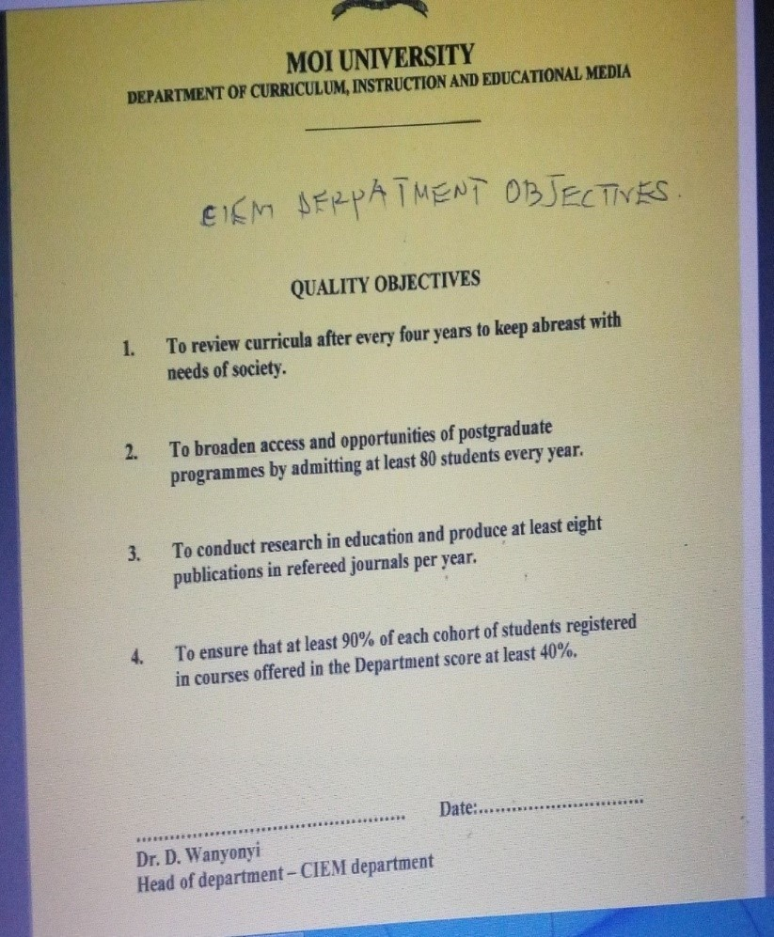

## Appendix 2: An Example of Harsh Comments in Students Work

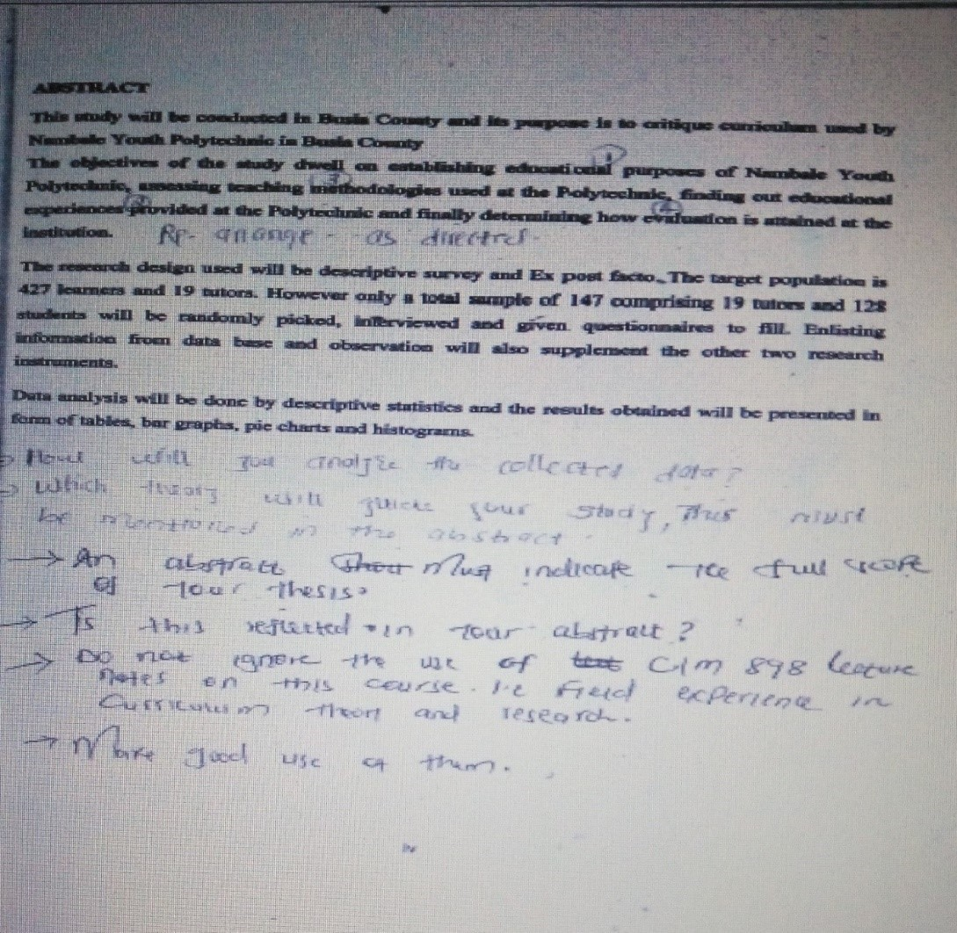

## Appendix 3: An Example of Polite Comment in Students Work

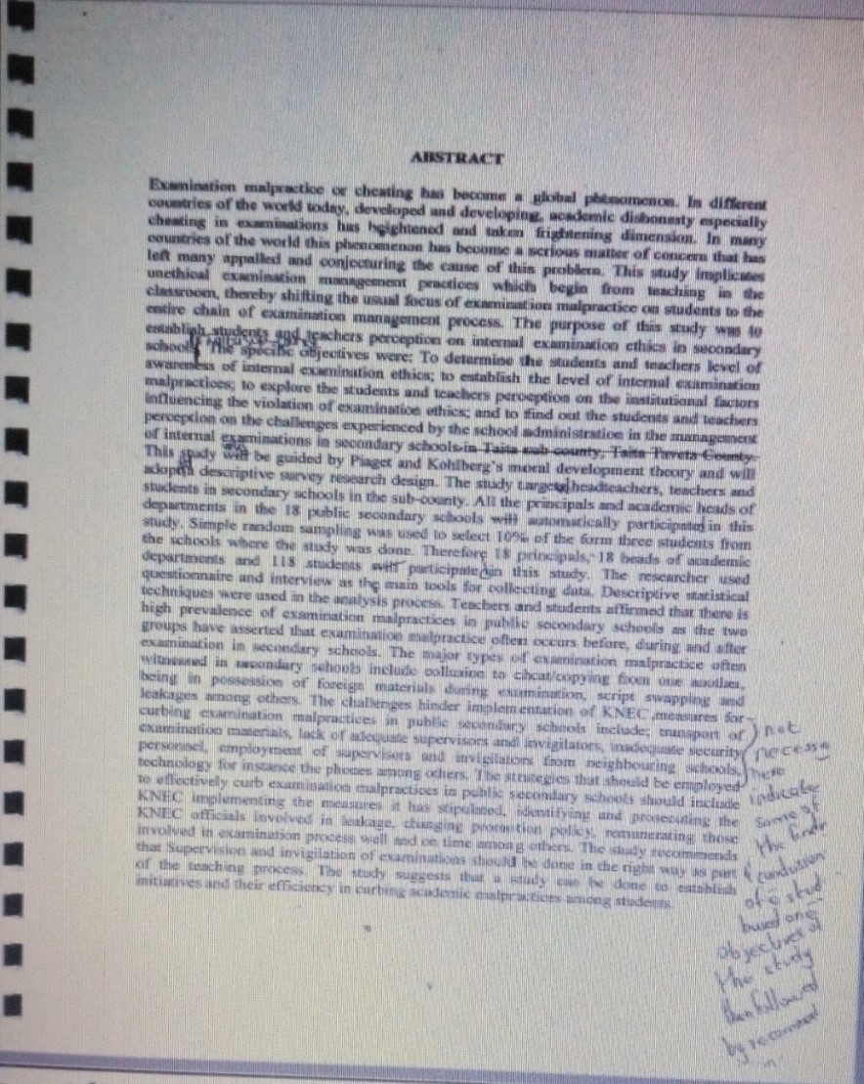

## Appendix 4: An Example of a Coach Training Footballers.

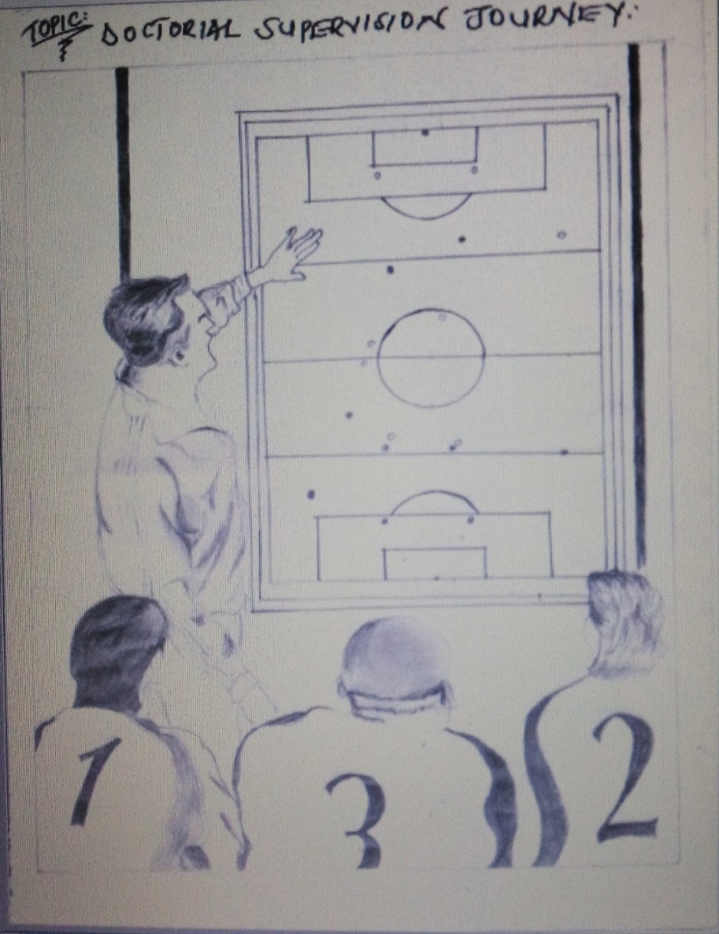

## Appendix 5(a): A Sighted Person Guiding a Blind Person

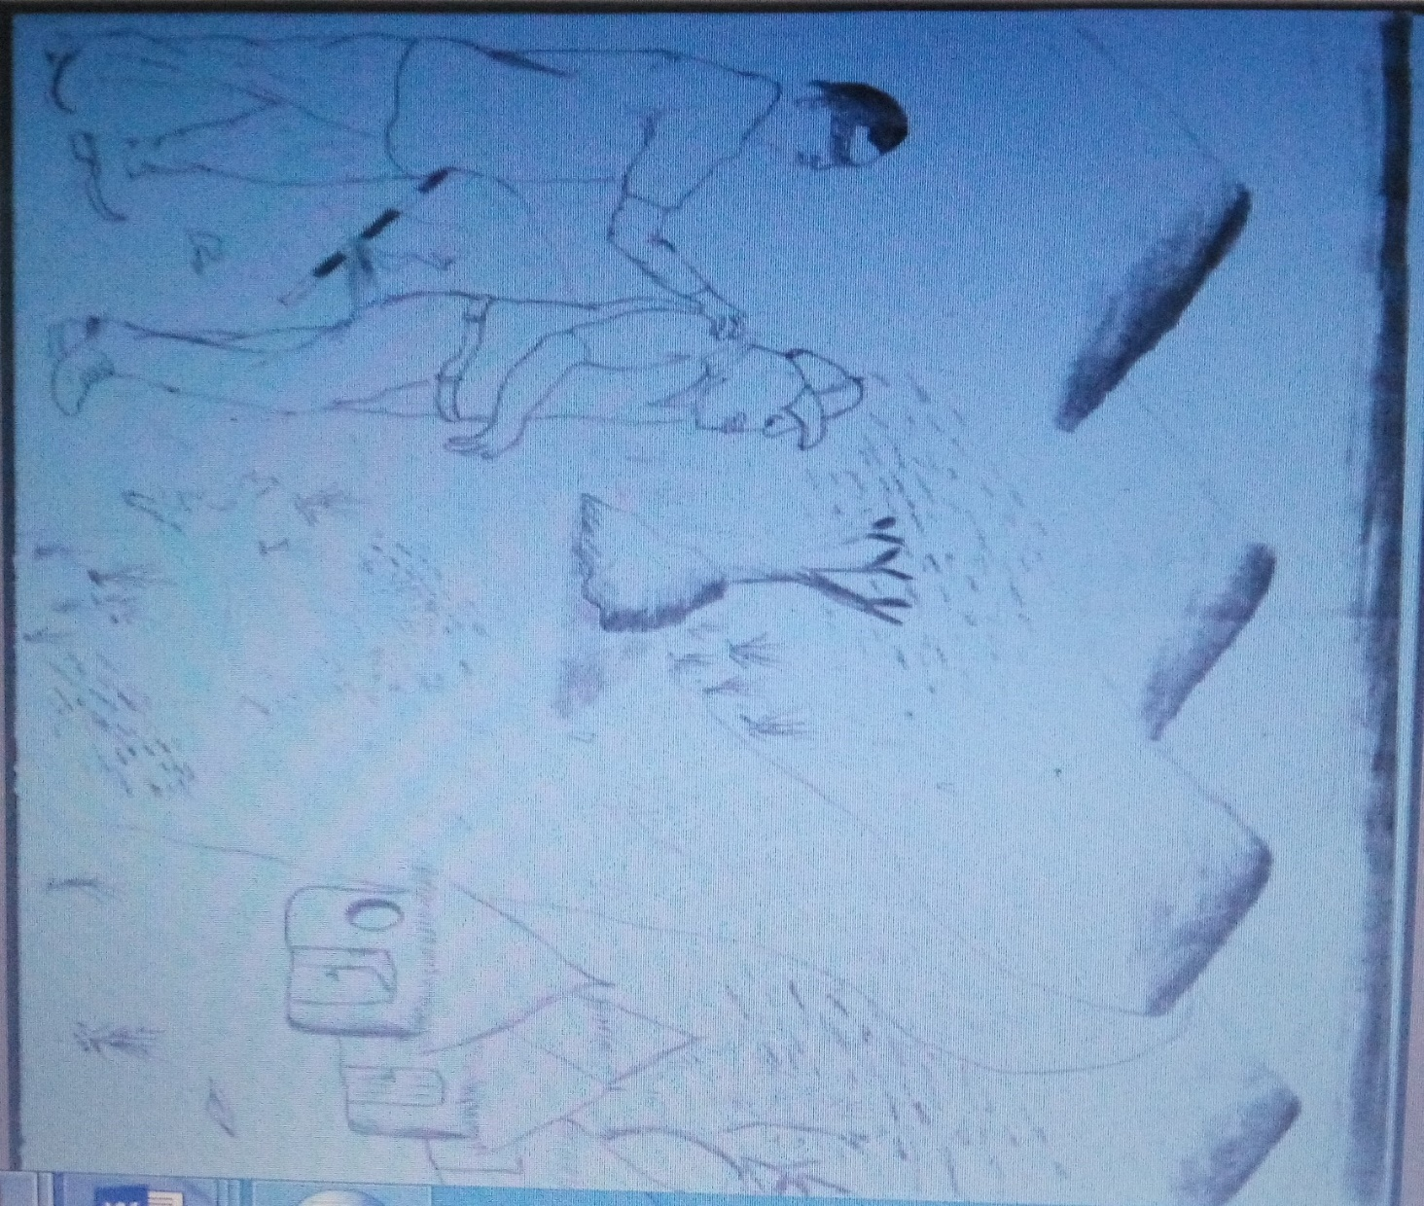

## Appendix 5(b): A Blind Person Familiar with the Environment



## Appendix 6: An Example of Supervisor Activities to Support and Develop Students Writing.

PART A: Title

The influence of discipline on students’ academic performance in secondary schools in Mombasa County, Kenya.

PART B: Examples of Objectives

1. To establish the influence of guidance and counseling on students’ academic performance in secondary schools.
2. To find out the influence of language policy on students’ academic performance in secondary schools.

PART C: YES AND NO RESEARCH ANSWER QUESTIONS

1. Does guidance and counseling influence student’s academic performance in secondary schools?

Yes No

1. Does language policy influence student’s academic performance in secondary schools?

Yes No

PART D: YES AND NO ANSWER QUESTIONS WITH A FOLLOW UP STATEMENT (In a questionnaire).

1. Do you attend guidance and counseling session in your school? Briefly explain your response above.

Yes No

1. Do teachers punish you when you speak vernacular in school? Briefly comment on your response above.

Yes No

## Appendix 7: List of My Published Articles

Yungungu, M.A., et al. (2014). “The Effectiveness of Youth Polytechnics in Training the Youth for Employment in Machakos District, Kenya.” Published in: International Journal of Social Sciences and Entrepreneurship (IJSSE) (ISNN 2307-6305) Volume 1(9) pp, January, 2014.

Yungungu, A. & Ogolla, O. B. (2014). Accessibility and utilization of library services among the visually impaired persons (VIPS) in Kenya and beyond. Published in: International Journal of Social Sciences and Entrepreneurship (IJSSE) (ISSN: 2307-6305) Volume 1(12), pp 380-392 (2014).

Keoro, A.N, Yungungu, A.M & Ogolla, B.O (2015). “Teacher’s Perception of Integration of Computers in Classroom Teaching in Public Secondary Schools in Nyamira Sub-County, Nyamira County, Kenya.” Published in: International Journal of Educational Policy Research and Review (IJEPRR) (ISSN: 2360-7076) Volume 2(10) pp.121-128, December, 2015.

Owino, O.A., Yungungu, A.M., Osman, A., & Ogolla, B.O. (2015). “Relationship Between Motivation and Performance in K.C.S.E Biology in Selected Secondary Schools in Nyakach District, Kisumu, Kenya.” Published in: International Journal of Research and Development Organization (IJRDO) (ISSN: 3855-0154) Volume 2(12) pp. 339-344, December, 2015.

Keoro, A.N. & Yungungu, A.M (2015). “Student’s Perception on Integration of Computers in Classroom Teaching in Public Secondary Schools in Nyamira County, Kenya.” Published in: International Journal of Educational Policy Research and Review (IJEPRR) (ISSN: 2360-7076) Volume 2(8) pp. 98-102, October, 2015.

Owino, O.A, Yungungu, A.M, Osman, A. & Ogolla, B.O. (2015). “The Relationship between Students’ Attitude towards Biology and Performance in Kenya Certificate of Secondary Education Biology in Selected Secondary Schools in Nyakach, Kenya.” Published in: Research Journal of Educational Studies and Review (RJESR) (ISSN: 2449-1837) Volume 1(5) pp. 111-117, September, 2015.

Chelangat, R.J., & Yungungu, M.A. (2015). “Perception of Teachers Towards the Social Studies Curriculum in Public Primary Schools in Kakamega Municipality, Kakamega County, Kenya.” Published in: Merit Research Journal of Education and Review (MRJER) (ISSN: 2350-2282) Volume 3(1) pp. 006-036, January, 2015.

Keoro, A.N., & Yungungu, M.A. (2015). “Constraints in the Integration of Computers in Curriculum Delivery in Public Secondary Schools in Nyamira District, Nyamira County, Kenya.” Published in: Asian Academic Research Journal of Multidisciplinary (AARJMD) (ISSN: 2319-2801) Volume 1(29) pp 80-108,

Wangila, G.M., & Yungungu, M.A. (2015). “Teachers’ Perceptions on the Factors that Influence School Drop-out among Upper Primary School Pupils in Trans-Nzoia East, Trans-Nzoia County, Kenya.” Published in: Merit Research Journal of Education and Review (MRJER) (ISSN: 2350-2282) Volume 3(1) pp. 037-075, January, 2015.

Ogutu, O.A, Osman, A., & Yungungu, M.A. (2014). “An Investigation of Factors that Influence Performance in KCSE Biology in Selected Secondary Schools in Nyakach District, Kisumu County, Kenya.” Published in: Asian Academic Research Journal of Multidisciplinary (AARJMD) (ISSN: 2319-2801) Volume 1(26) pp

Yungungu, A. & Ogolla, O. B. (2014). Accessibility and utilization of library services among the visually impaired persons (VIPS) in Kenya and beyond. Published in: International Journal of Social Sciences and Entrepreneurship (IJSSE) (ISSN: 2307-6305) Volume 1(12), pp 380-392 (2014).

Songok, A., Yungungu, M.A., Mulinge, P. (2013). “Factors that Militate against Effective Guidance and Counseling on Student’s Sexual Awareness, Attitude and Behaviour in Schools.” Published in: American International Journal of Social Sciences (AIJSS) (Print ISBN: 2325-4149, Online: ISSN: 2325-4165) Volume 2(8) pp 167-172

Yungungu, M.A., Songok, A., Mulinge, P. (2013). “Accessibility and Utilization of HIV and AIDS Services among the Visually Impaired Persons in Kenya.” Published in: American International Journal of Social Sciences (AIJSS) (Print ISBN: 2325-4149, Online: ISSN: 2325-4165) Volume 2(8) pp 109-114

Yungungu, M.A., Mulinge, P., & Ogolla, B.O., (2013). “Women Education for Social, Economic and Political Development in Kenya.” Published in: African Journal of Education, Science and Technology (AJEST) (ISSN: 2309-9240) Volume 1(2) pp 153-157, October/November 2013.

Yungungu, M.A. & Kyalo, B.W. (2006). “The Perception of Society on the Education of Girls in Kenya: A case of Secondary Schools in Ainabkoi Division, Uasin-Gishu District”, Published in: The Educator: A Journal of the School of Education, Moi University, Eldoret (ISBN 1817-77654) Volume 1(1) pp. 145-152.

## Appendix 8: An Example of a Work Plan by a Supervisee

|  |  |
| --- | --- |
| **Period** | **Activity** |
| May – June 2015 | Proposal Writing |
| August – November 2015 | Proposal Defending |
| December 2015 | Piloting |
| January – March 2016 | Data Collection |
| April – June 2016 | Data Analysis |
| June – July 2016 | Report Writing and Submission of first Draft |
| August – September 2016 | Marking and Corrections |
| October – November 2016 | Correction and Submission of the Final Draft |

## Appendix 9: An Example of Students’ Progress Record Form

**MOI UNIVERSITY**

**SCHOOL OF EDUCATION, DEPARTMENT OF CURRICULUM INSTRACTION AND EDUCATIONAL MEDIA**

**STUDENT REGISTRATION NUMBER**: _________________________

**NAME OF THE CANDIDATE:** _________________________

**MOBILE NUMBER:**  _________________________

**COURSE CODE:** _________________________

**COURSE TITLE:** _________________________

|  |  |  |
| --- | --- | --- |
| STAGES IN THESIS WRITING | IN PROGRESS | COMPLETED |
| 1. Writing Chapter One |  |  |
| 1. Writing Chapters Two and Three |  |  |
| 1. Refining Chapters One, Two and Three |  |  |
| 1. Improving Chapter and Developing Instruments of Data Collection |  |  |
| 1. Defended Proposal and Making Corrections |  |  |
| 1. Data Collection |  |  |
| 1. Data Analysis |  |  |
| 1. Reading of First and Second Drafts of Thesis (How many times depends on the supervisors) |  |  |
| 1. Submitted for Examination |  |  |
| 1. Defended Thesis and Making Final Corrections |  |  |
| 1. Graduated |  |  |

***N/B – Mark/Tick as appropriate.***